** **



**Designing a Personalized Dietary Recommendation System Harnessing Advanced Machine Learning Algorithms**

**By**

**SOO JIUN GUAN**

**TP068687**

**APD3F2408CSDA**

A report submitted in partial fulfillment of the requirements for the degree of

B.Sc. (Hons) Computer Science Specialism in Data Analytics

at Asia Pacific University of Technology and Innovation.

**Supervised by Ms. Tan Li June**

**2nd Marker: Mr. Usman Hashmi**

**2025**



|  |
| --- |
| First Name: Soo |
| Middle Name (only if applicable): |
| Last Name: Jiun Guan |
| Title of the Final Year Project / Dissertation / Thesis:  Designing a Personalized Dietary Recommendation System Harnessing Advanced Machine Learning Algorithms |
| Abstract: This project presents the development of a personalized dietary recommendation system using unsupervised machine learning techniques. By analyzing a large-scale recipe dataset and allergen information, the system clusters recipes based on their nutritional profiles to deliver tailored meal suggestions that align with individual health goals and dietary restrictions. Extensive data preprocessing, feature engineering, and anomaly detection were performed to ensure data quality. Several clustering algorithms, including K-Means, MiniBatch K-Means, Gaussian Mixture Models, and Self-Organizing Maps, were implemented and evaluated using internal validation metrics such as Davies-Bouldin Index, Calinski-Harabasz Score, Bayesian Information Criterion, and Quantization Error. K-Means with MinMaxScaler preprocessing and seven clusters was selected as the optimal model. The final model was deployed through a Streamlit web application, featuring user profiling, calorie and macronutrient calculations, personalized recipe recommendations, downloadable meal plans, and integration with Google Gemini AI for additional health advice. Through this multi-phase approach, the project successfully delivers a flexible, inclusive, and health-centered dietary recommendation system aligned with Sustainable Development Goal 3. |
| A few keywords associated with the work: *personalized nutrition, machine learning, clustering, personalized nutrition, dietary recommendation, health outcomes, SDG 3* |
| General Subject: Computer Science in Data Analytics |
| Date of Submission: 30 April 2025 |

**ACKNOWLEDGEMENT**

I would like to take this opportunity to express my deepest gratitude to my supervisor, Ms. Tan Li June, for her invaluable advice, guidance, and continuous support throughout this project. Her invaluable expertise and insightful feedback had a great influence on the direction and quality of my work. I am also very grateful to my second marker, Mr. Usman Hashmi, who dedicated his valuable time to marking this project. Special thanks go to my mentor Dr. Dewi Octaviani and Ms. Nur Amira Binti Abdul Majid, whose exhaustive briefings substantially contributed to making this report clear and coherent. Their mentorship has been very instrumental in enabling me to overcome the hurdles that came along during this project. Lastly, thanks for all the encouragement, patience, and understanding to my family and friends. Their encouragement became my constant source of strength and motivation n, helping me remain focused and resilient throughout this journey. I am indeed grateful to all those who have helped in the successful completion of this project and contributed to making it a success.

**ABSTRACT**

This project presents the development of a personalized dietary recommendation system using unsupervised machine learning techniques. By analyzing a large-scale recipe dataset and allergen information, the system clusters recipes based on their nutritional profiles to deliver tailored meal suggestions that align with individual health goals and dietary restrictions. Extensive data preprocessing, feature engineering, and anomaly detection were performed to ensure data quality. Several clustering algorithms, including K-Means, MiniBatch K-Means, Gaussian Mixture Models, and Self-Organizing Maps, were implemented and evaluated using internal validation metrics such as Davies-Bouldin Index, Calinski-Harabasz Score, Bayesian Information Criterion, and Quantization Error. K-Means with MinMaxScaler preprocessing and seven clusters was selected as the optimal model. The final model was deployed through a Streamlit web application, featuring user profiling, calorie and macronutrient calculations, personalized recipe recommendations, downloadable meal plans, and integration with Google Gemini AI for additional health advice. Through this multi-phase approach, the project successfully delivers a flexible, inclusive, and health-centered dietary recommendation system aligned with Sustainable Development Goal 3.

*Keywords: personalized nutrition, machine learning, clustering, personalized nutrition, dietary recommendation, health outcomes, SDG 3*

**SDG Goal 3: Ensure healthy lives and promote well-being for all at all ages**

**Table of Contents**

CHAPTER 1: INTRODUCTION 13

1.1 Introduction 13

1.2 Problem Background 16

1.3 Project Aim 19

1.4 Objectives 19

1.5 Scope 19

1.5.1 Deliverables 19

1.5.2 Constraints 21

1.5.3 What Will Be Done 23

1.5.4 What Will Not Be Done 23

1.6 Potential Benefits 24

1.6.1 Tangible Benefits 24

1.6.2 Intangible Benefits 25

1.7 Overview of the FYP Documentation 26

1.8 Project Plan 27

CHAPTER 2: LITERATURE REVIEW 28

2.1 Introduction 28

2.2 Domain Research 28

2.2.1 Global Dietary Crisis and Its Impact 28

2.2.2 Global Dietary Shifts Towards Processed Food 29

2.2.3 Limitations of Current Dietary Guidelines 30

2.2.4 Relationship of Calories and Macronutrients 31

2.2.5 Total Daily Energy Expenditure 34

2.2.6 Macronutrient Ratio 37

2.2.7 Zig-Zag Diet Plan 41

2.2.8 Distribution of Daily Calories Intake 42

2.2.9 Implementation of Machine Learning in Nutrition 43

2.2.10 Clustering 44

2.2.11 Evaluation Metrics for Clustering 49

2.3 Similar Systems / Works 53

2.4 Technical Research 59

2.4.1 Hardware Requirements 59

2.4.2 Software Requirements 60

2.5 Summary 64

CHAPTER 3: METHODOLOGY 66

3.1 Introduction 66

3.2 Methodology 66

3.2.1 Introduction of Methodology 66

3.2.2 Methodology Choice and Justification 67

3.2.3 CRISP-DM 71

3.3 Summary 80

CHAPTER 4: DESIGN AND IMPLEMENTATION 82

4.1 Introduction 82

4.2 Data Collection 82

4.3 Data Understanding 83

4.3.1 Variables 83

4.3.2 Import Libraries 84

4.3.3 Load and Preview Data 85

4.3.4 Exploratory Data Analysis (EDA) 87

4.4 Data Preprocessing 101

4.4.1 Feature Selection 101

4.4.2 Handling Missing Values 102

4.4.3 Outliers Removal 103

4.4.4 Feature Engineering 107

4.4.5 Data Integration 108

4.4.6 Data Transformation and Standardization 110

4.4.7 Anomalies Removal 114

4.4.8 Data Normalization 117

4.5 Model Building 119

4.5.1 Gaussian Mixture Model 119

4.5.2 K-Means Clustering 122

4.5.3 Mini Batch K-Means Clustering 125

4.5.4 Self-Organizing Map 129

4.6 Summary 133

CHAPTER 5: RESULTS AND DISCUSSION 135

5.1 Introduction 135

5.2 Model Evaluations and Discussion 135

5.2.1 Used Evaluation Metrics 135

5.2.2 Model Evaluations 138

5.2.3 Comparisons and Discussions 145

5.3 Model Deployment 146

5.3.1 Model, Scaler, and Data Saving 146

5.3.2 Loading of Model, Scaler, and Data 146

5.3.3 User Profile Collection Interface 147

5.3.4 TDEE Calculation 148

5.3.5 Optimal Recipe Selection 149

5.3.6 Comparison Between Macronutrient Targets and Recipe Macronutrient Profiles 150

5.3.7 Displaying Recipe Details 152

5.3.8 Download the 7 Days Recipes 154

5.3.9 Integration with Gemini AI 156

5.4 Summary 158

CHAPTER 6: CONCLUSION 159

6.1 Critical Evaluation 159

6.2 Limitation 160

6.3 Recommendation 160

References 162

Appendices 184

Appendix A: PPF 184

Appendix B: Ethics Forms (Fast Track / Full Track) 193

Appendix C: Log Sheets (6 log sheets) 197

Appendix D: Poster 203

Appendix E: Gantt Chart 204

Appendix G: Turnitin Similarity Report 206

**List of Figures**

Figure 1: Project Plan 27

Figure 2: Fast food consumption among 12–15-year-olds by region ((Li et al., 2020) 30

Figure 3: Mifflin-St Jeor Equation (Ferrie & Ward, 2007) 35

Figure 4: Accuracy rates of estimated equations compared to IC (Van Dessel et al., 2024) 35

Figure 5: Bias of estimated equations (Van Dessel et al., 2024) 36

Figure 6: Katch-McArdle Multipliers for Calculating TDEE (Garcia, 2019) 37

Figure 7: Overview of CRISP-DM methodology (Cazacu & Titan, 2020) 71

Figure 8: Import necessary libraries 84

Figure 9: Load dataset from local file path 85

Figure 10: Code and output of preview data 86

Figure 11: Code and output of duplication checking 87

Figure 12: Code and output of inspecting structure and types 88

Figure 13: Code and output of numeric data summary 89

Figure 14: Code and output of checking unique value 90

Figure 15: Code and output for missing values checking 90

Figure 16: Code and Output of visualising missing values relationship 91

Figure 17: Code and output of checking data inconsistencies 94

Figure 18: Code and output of key variables distribution 96

Figure 19: Code and output of allergy distribution 97

Figure 20: Code and output of nutrient correlation heatmap 99

Figure 21: Code of filtering unnecessary column 101

Figure 22: Code of handling missing values 102

Figure 23: Output of checking missing values 102

Figure 24: Code and output of removing noisy data 103

Figure 25: Code of filtering 250-2000 kcal recipes 104

Figure 26: Output of checking distribution of nutrient after removing outliers 105

Figure 27: Code and output of removing data inconsistencies 106

Figure 28: Code and output of calculating macronutrient percentage contributions 107

Figure 29: Code and output of integrating allergen information 108

Figure 30: Output and code of checking distributions of macronutrients after a few data preprocessing steps 110

Figure 31: Code and output of applying data transformation and standardization 112

Figure 32: Code of removing anomalies 114

Figure 33: Output after removing anomalies 115

Figure 34: Code and output of normalizing data 117

Figure 35: GMM Base Model 120

Figure 36: Code of tuning GMM hyperparameters 121

Figure 37: Build K-Means Base Model (Standardized Data) 122

Figure 38: Code of tune hyperparameters of K-Means (Standardized Data) 123

Figure 39: Build K-Means Base Model (Normalized Data) 124

Figure 40: Code of tuning hyperparameters of K-Means (Normalized Data) 125

Figure 41: Build mini batch k-means model using standardized data 126

Figure 42: Code of tuning hyperparameters of Mini Batch K-Means (Standardized Data) 127

Figure 43: Build mini batch K-means base model (Normalized Data) 128

Figure 44: Code of tuning hyperparameters of mini batch K-means (Normalized Data) 129

Figure 45: Build SOM base model 130

Figure 46: Code of tuning parameters of SOM 131

Figure 47: Result of GMM hyperparameters tuning 138

Figure 48: Result of K-means hyperparameters tuning on standardized data 139

Figure 49: Result of K-means hyperparameters tuning on normalized data 139

Figure 50: Elbow method of K-Means on standardized data 140

Figure 51: Elbow method of K-Means on normalized data 141

Figure 52: Result of mini batch K-means hyperparameters tuning on standardized data 141

Figure 53: Result of mini batch K-means hyperparameters tuning on normalized data 142

Figure 54: Elbow method of mini batch K-Means on standardized data 143

Figure 55: Elbow method of mini batch K-Means on normalized data 143

Figure 56: Result of SOM hyperparameters tuning 144

Figure 57: Code of saving model, scaler, and dataset 146

Figure 58: Code of loading necessary components 146

Figure 59: Code of user profile collection 147

Figure 60: User interface form of the web application 147

Figure 61: Code of calculating TDEE 148

Figure 62: Code of choosing the optimal recipe 149

Figure 63: Code of macronutrients comparison between needed and in recipe 150

Figure 64: Comparison chart in web app 151

Figure 65: Code of displaying recipes 152

Figure 66: An example that showing recipes in web app 153

Figure 67: Code of downloading the recipes of zigzag diet plan 154

Figure 68: Button is disable when didn't utilize zigzag diet plan 154

Figure 69: Button is able to use when utilizing zigzag diet plan 154

Figure 70: Configuration of Google Gemini AI API 156

Figure 71: Prompt for Gemini AI 156

Figure 72: Tips from Gemini AI in web app 157

Figure 73: PPF Page 1 184

Figure 74: PPF Page 2 185

Figure 75: PPF Page 3 186

Figure 76: PPF Page 4 187

Figure 77: PPF Page 5 188

Figure 78: PPF Page 6 189

Figure 79: PPF Page 7 190

Figure 80: PPF Page 8 191

Figure 81: PPF Page 9 192

Figure 82: Fast Track Form Page 1 193

Figure 83: Fast Track Form Page 2 194

Figure 84: Fast Track Form Page 3 195

Figure 85: Fast Track Form Page 4 196

Figure 86: Project Log Sheet of 1st Meeting 197

Figure 87: Project Log Sheet of 2nd Meeting 198

Figure 88: Project Log Sheet of 3rd Meeting 199

Figure 89: Project Log Sheet of 4th Meeting 200

Figure 90: Project Log Sheet of 5th Meeting 201

Figure 91: Project Log Sheet of 6th Meeting 202

Figure 92: Poster 203

Figure 93: Gantt Chart of IR 204

Figure 94: Gantt Chart of FYP 205

Figure 95: Turnitin similarity report page 1 206

Figure 96: Turnitin similarity report page 2 207

**List of Tables**

Table 1: Similar works of dietary recommendation system 56

Table 2: Comparison between Methodologies of Data Analysis 68

Table 3: Selected Datasets for This Project 82

Table 4: Description of recipe dataset 84

Table 5: Description of allergens dataset 84

Table 6: Comparison between different models with their best performance configurations 145

# **CHAPTER 1: INTRODUCTION**

## 1.1 Introduction

Poor dietary patterns are increasingly being seen as central causes of an international health crisis, significantly driving the rising disease burden of non-communicable diseases (NCDs). These include severe chronic diseases like cancer, cardiovascular disease, type 2 diabetes, and obesity, which have even emerged as major causes of death and disease globally (Bennett et al., 2018). Elechi et al. (2023) state that NCDs are responsible for approximately 41 million deaths each year, accounting for about 74% of global deaths. These facts highlight the need for taking immediate action on the root causes, many of whose concerns are entrenched deep in poor dietary habits. Diets dominated by high amounts of energy-rich, nutrient-poor foods are now common in most societies, particularly those experiencing fast-paced urbanization (Vogliano et al., 2021). Urbanization has affected the structure of food environments as well as people's ways of life, and this has contributed towards decreased consumption of fresh, whole foods and greater reliance on processed, ready-to-use foods. These trends are diametrically opposite the measures of SDG 3, which places emphasis on healthy lives as well as ensuring well-being for everyone. Such persistence in poor diets negates this target as it enhances preventable disease as well as lowers life expectancy, especially among those in the low- as well as middle-income groups who are often faced with the biggest obstacles in their access to healthy foods (Ruel et al., 2008).

Poor nutrition has adverse effects that reach far beyond the limitations of physiological function, influencing mental and intellectual health as well. Growing literature has established that deficiencies in key nutrients can compromise cerebral function, alter mood, and enhance mental illness such as anxiety, depression, and cognitive impairment (Adan et al., 2019). These impairments are not only detrimental at the individual level of quality of life but are reflected in broader social outcomes, such as higher healthcare costs, poorer productivity, and widening socio-economic inequalities. Psychological distress, often attributable to dietary causes, disproportionately affects disadvantaged groups with poor access to varied, nutrient-dense foods. Poverty and inequality, as noted by Glatzel et al. (2024), form a cycle in which poor health is fueled by malnutrition, locking generations into disadvantage. This cycle undermines even the equitable attainment of SDG 3, which prioritizes inclusivity and the alleviation of health inequality between groups of people. Investments in improving dietary adequacy through equitable access to nutritious foods can thus be key in advancing mental health along with overall welfare, in line with SDG 3 objectives for the alleviation of health inequities.

To meet these increasing health problems, nutrition and dietetics have become key players in the creation of health promotion and disease prevention strategies. Nutrition science investigates the biochemical and physiological functions of nutrients, with an emphasis on how dietary foods affect health at the cellular and organism level. Dietetics, on the other hand, turns this information into usable tactics, designing individual or population-scale dietary interventions for supporting the best possible outcomes in health (Freeland-Graves & Nitzke, 2013). Used appropriately, these fields can prevent the risk posed by NCDs and enhance overall health quality. Unfortunately, conventional methods within these fields have been inadequate in meeting specific needs, preferring broad dietary advice dependent on averages in the population rather than individual circumstances. This one-size-fits-all approach neglects important variables like genetic makeups, metabolic variations, as well as individual dietary intolerances (Jinnette et al., 2021). These measures may not be entirely supportive of SDG 3’s focus on encouraging wellness "for all at all ages” once vulnerable individuals need more adaptive and individualized care measures in support of their particular needs and circumstances. In order for these fields to reach the objectives of SDG 3, it is necessary for them to move toward more tailored measures, those that take cognizance of as well as respond to the singular health profiles, requirements, as well as circumstances of each individual, especially those belonging in vulnerable or marginalized groups.

The limitations of traditional dietary advice indicate the necessity for more technology-led, personalized strategies in dietetics and nutrition. Incorporation of cutting-edge technology, especially based on artificial intelligence and machine learning, promises novel ways forward for the creation of personalized nutrition systems (Abrahams & Matusheski, 2020). These systems take into account the health data of an individual, such as life-style factors and pre-existing health conditions, and provide personalized dietary advice designed to maximize health outcomes for them. In contrast to conventional models, these devices can be dynamically modified in response to variations in an individual’s health status or objectives, thereby increasing their applicability and efficacy. This technological progress empowers individuals with the ability to make better informed dietary choices, sustains long-term behavioral shifts, and enhances lifelong adherence to healthy dietary behaviors. Moreover, digital nutrition solutions that are scalable can provide access to under-resourced communities, filling the gap in preventive healthcare in terms of equity. By facilitating more effective, equitable health promotion, such innovation can significantly support SDG 3’s targets, especially those associated with minimizing early deaths due to NCDs as well as ensuring universal coverage of high-quality healthcare services. As technology advances, its judicious use in nutrition as well as dietetics has the transformative power of achieving healthier populations globally (Limketkai et al., 2021).

## 1.2 Problem Background

In spite of international attempts at healthier eating and enhanced nutrition outcomes, there are some persistent challenges that are undermining the efficacy of dietary interventions. These challenges are not only driving the increasing rates of non-communicable diseases (NCDs) but are also dampening progress towards achieving Sustainable Development Goal 3 (SDG 3): Ensure healthy lives and promote well-being for all at all ages. These key challenges are listed below:

1. **Generic Meal Plans Ignore Individual Needs**

Most current diet recommendation systems offer one-size-fits-all meal recommendations, without considering critical individual parameters such as Body Mass Index (BMI), activity level, and gender, each of which contributes significantly to nutritional requirements (Jinnette et al., 2021). This absence of personalization tends to result in suboptimal or even counterintuitive dietary recommendations, in which consumers receive meals inappropriately matched to their metabolic state or lifestyle needs. For example, an individual with an increased BMI who is seeking weight loss at a slow rate would benefit from meals with finely tuned caloric density and macronutrient balance (Pescari et al., 2024). In contrast, an individual with a low BMI who is highly physically active would best use high-protein meals for recovery and function (Arciero et al., 2015). Even gender differences must be taken into consideration, as men and women tend to have different energy and micronutrient needs due to differences in muscle mass, hormonal profiles, and metabolic rate (Gorini et al., 2025).

If dietary advice ignores such factors, consumers can suffer from energy imbalance, nutrient insufficiency, and poor food choice adherence due to inappropriately sized portions or food items. This discourages long-term health objectives and contributes to preventable conditions such as cardiovascular disease, type 2 diabetes, and obesity. A system that uses BMI, activity level, and gender in its logic delivers healthier, more accurate recipe recommendations matched to specific requirements for an individual's nutrition (De Hoogh et al., 2021). Such an approach facilitates healthier, sustainable, and achievable dietary lifestyles, enhancing user acceptability and long-term well-being. In offering focused, user-specific advice, this model directly supports healthier lifestyles and diet-related non-communicable disease risk reduction in accordance with SDG 3.

1. **Overreliance on Convenience Foods**

Globalization, fast-paced urbanization, and changing patterns of life have significantly reconfigured food environments across the world, with ultra-processed foods and convenience foods at the center of daily meals (Gangopadhyay, 2023). These foods, ordinarily rich in sugar, sodium, unhealthy fats, and artificial ingredients, are aggressively promoted and made widely available, especially among poor communities due to their affordability and convenience (Uluğbekovna & Nabiyevna, 2024). In the case of the LMICs, this is extremely concerning as the insecurity in foods compels households to opt for cheap, caloric, but nutrient-deficient foods. For example, in South Africa, school children in the fast-growing urban fringes increasingly consume fast foods as it is cheap as well as easily accessible (Battersby et al., 2023). This increasing reliance on fast foods is leading toward the co-existence of undernutrition and diet-associated non-communicable diseases in the very communities, directly undermining the paradigms of SDG 3 of ensuring health equity and wellness for all.

Adding to this problem, focused advertising, especially among adolescents and school-going children, deepens unhealthy eating patterns. In the case of Brazil, for instance, research established that about 59.2% of advertisements aired during kids' TV shows promoted ultra-processed snacks, sugary foods, and fast foods at the expense of visibility and desirability of conventional foods, with minimal processing as well as high nutrient content (Costa et al., 2013). All these elements together promote global nutrition crisis, especially among vulnerable communities, and pose an important challenge toward the reduction of NCDs as well as the realization of sustainable, health-focused food systems.

1. **Fixed Calorie Restriction Leading to Weight Loss Failure**

One of the most widely applied weight loss strategies is long-term caloric restriction; however, this method tends not to yield sustainable results due to the intricacies of the metabolic responses of the human organism. When the organism is placed in caloric deficit for extended periods, it responds in ways that slow down the metabolic rate and lower the basal metabolic rate in an attempt at preserving energy (Martin et al., 2008). Concurrently, disruptive endocrine changes take place as the level of leptin declines, lowering the sense of fullness, but increasing the level of ghrelin, stimulating the sensations of hunger (Poston, 2022). Such physiological alterations render it increasingly difficult for an individual to persist on very-low-calorie regimens, particularly in combination with psychological side effects like irritability, fatigue, and severe pangs of hunger. Consequently, people drop their eating regimes, entering the cycle of weight loss and regain, or so-called yo-yo weight loss, for which it is related to increased cardiovascular risk and long-term metabolic damage (Polivy, 2014).

In addition, extended caloric reduction without correctly chosen nutrition plans tends toward the loss of muscle tissue, again lowering metabolic efficiency and making it even harder for the organism to manage weight in the future (West, 2017). In response to such problems, alternative weight loss regimes like caloric cycling and intermittent energy restriction have been growing in popularity (Byrne et al., 2017). These methods introduce occasional episodes of normal caloric intake in order to retain metabolic and hormonal balance as well as enhance psychological compliance. Regardless, in the absence of personalized advice as well as optimal nutrient support, even newer methods at times may prove ineffective or even detrimental. This reflects the main problem: universal, non-variable dietary tools are not fit for the support of enduring weight management or for the prevention of diet-caused diseases. In order to bring significant progress toward SDG 3 with its focus on inclusive health for all, it is evident that what is required is more personalized and adaptive nutrition recommendations directed toward meeting people's variable biological as well as life-style requirements.

## 1.3 Project Aim

To develop a personalized dietary recommendation system leveraging appropriate machine learning techniques to improve health outcomes and mitigate the risks of non-communicable diseases in the context of prevalent poor dietary habits.

## 1.4 Objectives

The objectives of this project are as follows:

1. To preprocess and standardize the recipes and allergens dataset to ensure its suitability for machine learning algorithms.
2. To evaluate and compare the performance of multiple machine learning algorithms to identify the most effective model for personalized dietary recommendations.
3. To deploy the best machine learning model within a web application to deliver personalized dietary recommendations to users.

## 1.5 Scope

This project involves designing and building a personalized food recommendation system that uses machine learning to produce individualized meal proposals based on parameters such as BMI, sex, and activity levels that are unique to each user. End-to-end system development from collecting data to preprocessing, model training, evaluation, and deployment through an easily accessible web application is incorporated in this project. It aims to help users make healthier food choices, which can help prevent non-communicable diseases, with an aim to support SDG 3 health equity targets.

### 1.5.1 Deliverables

The project will produce the following key deliverables:

1. **Data Collection**

The project starts with collecting relevant datasets to support building a personalized nutrition recommendation system. Two main sources of data are drawn upon: one with allergen and ingredient-related information, and another providing rich nutritional details with macronutrient values like calories, protein, carbohydrates, and fat, in addition to entire recipe entries. These sets are carefully analyzed to identify their completeness, accuracy, and applicability to the project goal. Further validation procedures are performed to guarantee consistency among sources of information and their applicability to inclusion in a machine learning pipeline.

1. **Data Preprocessing**

Upon gathering, raw data goes through a process of systematic cleaning and organization to make it ready for use in machine learning. This process involves dealing with missing or inconsistent values, detecting anomalies and their resolution, and converting raw values to suitable forms based on modeling demands. Standardization and normalization methods are implemented to maintain consistency between variables, which is helpful for achieving improved model convergence and understandability. These preprocessing plays a vital role in sustaining data consistency and guaranteeing model reliability.

1. **Data Understanding**

After preprocessing, exploratory data analysis (EDA) is carried out to better understand the dataset. Via graphical tools like histograms, box plots, and correlation heatmaps, patterns and correlations between major nutritional variables are considered. Summary statistics facilitate outlier identification, patterns, and possible anomalies in the data. Through these insights, relevant feature selection and modeling approach are determined to align with user health profiles and nutrition objectives.

1. **Model Selection and Training**

The system uses unsupervised machine learning methods to cluster meals according to nutritional similarity. Various algorithms are considered, such as Gaussian Mixture Model, K-Means Clustering, Self Organizing Map, etc. These models are trained from the processed information to establish cohesive clusters that represent dietary compatibility. Additionally, hyperparameters are optimized in an attempt to enhance clustering accuracy, with feature selection optimized to maximize model performance in providing personal recommendations.

1. **Model Evaluation**

In order to assess the validity of the clustering models, certain internal evaluation metrics like Davies Bouldin Index, Calinski–Harabasz Index, etc are used. These helps measure compactness and separation of clusters, ensuring that clusters are significant and actionable. Best performance modeling is only possible with a model that has high clustering validity if accurate individualized dietary recommendations are to be produced, which is what this project aims for with improved health through personal nutrition.

1. **System Integration and Deployment**

The best-performing model is implemented in a web application developed with Python and Streamlit. Users are presented with an efficient and engaging web interface to receive tailored nutritional advice. Users can provide their BMI, nutritional targets, and allergen sensitivities, which are processed by the system to produce suitable meal ideas. The scaler and trained machine learning model are implemented in the backend for efficient handling of data and classification of the users. This implemented application is the main deliverable of the project, uniting data science with user interaction to enable healthier food habits.

### 1.5.2 Constraints

Several constraints and limitations may influence the development, performance, and overall applicability of the proposed personalized dietary recommendation system:

1. **Data Limitations**

Inconsistent or missing information can result in knowledge gaps about nutrition and less accurate suggestions. Further, if there is insufficient diversity in the dataset like minimal representation of various dietary requirements, cultures, or demographics of users, then there will be a reduced capacity of the system to provide individualized and inclusive recommendations to a large number of users.

1. **Cost Restrictions**

For ensuring accessibility and affordability, this project only employs free and open-source tools, libraries, and platforms like Pandas, Scikit-learn, NumPy, Streamlit, and Jupyter Notebook. While such resources are strong and popularly used, they might not offer scalability, performance, or advanced features like some proprietary solutions. This limitation also restricts the future integration of premium datasets, APIs, or cloud-based machine learning infrastructure.

1. **User Input Accuracy**

The individualization of dietary advice relies upon the accuracy and reliability of information users provide. Input that is correct for height, weight, activity level, sex, and dietary aims is required for relevant advice to be produced by the system. Falsification, misunderstanding, or incorrectness of inputs due to user error can lead to inapplicable or ineffective diets.

1. **Privacy Concerns**

The system will process user-specific information in order to provide recommendations. It therefore must follow general privacy and data protection principles. Legal and ethical threats are avoided by avoiding long-term storing of any personal information and not collecting sensitive identifiers. General data protection principles such as informed consent, data minimization, anonymization are followed across the lifecycle of the system, but full HIPAA or GDPR compliance is not in scope for this project.

1. **Medical Disclaimer**

The system is intended to provide general dietary suggestions and not to serve as a substitute for professional medical, nutritional, or psychological advice. Users with medical conditions, allergies, or dietary restrictions are encouraged to consult with qualified healthcare professionals.

1. **Dataset-Dependent Scope**

The model’s capability to deliver varied and inclusive recommendations is inherently restricted by the scope of the dataset. If certain foods, cuisines, allergens, or nutritional attributes are underrepresented or missing from the dataset, the system may be unable to cater to users with specific cultural, ethical, or medical dietary requirements. Furthermore, the absence of real-time updates means the system may not reflect newly emerging dietary trends or scientific insights.

### 1.5.3 What Will Be Done

The following will be performed under the scope of this project:

1. Preprocess and standardize input data to make it ready for modeling.
2. Explore the dataset by employing EDA techniques to identify relationships and patterns.
3. Train and test machine learning models for recipe categorization.
4. Choose the best model for creating dietary advice.
5. Create and deploy a web application to provide customized recommendations.

### 1.5.4 What Will Not Be Done

Below are some events that are not in scope of this project and will not be covered:

1. It will not offer immediate feedback nor respond in a dynamic way to changing user preference or health over time.
2. It will neither provide medical diagnoses nor treatment recommendations for any health conditions.
3. No integration with any live external API or automated dataset updates will be established.

## 1.6 Potential Benefits

Implementation and establishment of an individualized dietary advice system have a number of advantages that cut across personal health, community well-being, and technological development. They can be classified into tangible and intangible consequences.

### 1.6.1 Tangible Benefits

Tangible benefits refer to measurable and concrete advantages that result from this project. The tangible benefits are as follows:

1. **Optimized Nutrient Intake**:The system brings about meal plans that meet individual nutritional needs, giving just the right amount of macronutrients. Therefore, it prevents nutrient deficiencies and imbalances in the diet that help maintain overall good health and vitality.
2. **Effective Weight Management:** The system enables users to have control over their weight through personalized targets of calorie intake and macronutrient distribution. This tailored approach ensures that individual needs are met, supporting sustainable and healthy outcomes over the long term.
3. **Enhanced Health Outcomes**: Personalized nutrition advice can help decrease the risk of non-communicable diseases such as diabetes, cardiovascular diseases, and obesity. By encouraging healthier eating behaviors, the system enhances improved health and quality of life.
4. **Significant Cost Savings:** The system can save lots of money in health expenditure since it helps users avoid chronic diseases through better nutrition. It benefits individuals and healthcare systems due to reduced rates for medical treatments and hospitalization.
5. **Reduced Reliance on Fast Food:** The system will provide accessible, nutritionally balanced meal plans matched to users' health objectives and thus make it easier to replace fast food consumption with healthier options. This would support a shift toward better eating habits without requiring extensive nutritional knowledge or effort.

### 1.6.2 Intangible Benefits

Intangible benefits are non-measurable advantages that contribute to overall value and impact. The intangible benefits of this project are as follows:

1. **Empowerment and Awareness:** The users gain much knowledge in healthy eating and nutrition and are thus able to make intelligent choices of food that relate to their health and lifestyle.
2. **Sustainability and Social Impact:** By encouraging healthier eating patterns, the system contributes to the attainment of global sustainability goals, reducing health disparities in particular in low-income and vulnerable populations, as outlined under SDG 3.
3. **Innovation and Knowledge Advancement:** The integration of advanced machine learning techniques in personalized nutrition fosters innovation in the fields of health and technology, paving the way for future advancements.
4. **Enhanced Productivity:** Improved nutrition boosts focus, memory, and energy, enabling individuals to perform tasks more efficiently and creatively. Sustained energy levels throughout the day help maintain productivity in both professional and personal life.
5. **Emotional Well-Being:** Healthy eating can improve one's mood, stabilize energy, sharpen mental clarity, and hence diminish anxiety, ensuring psychological well-being. By addressing nutrient deficiencies, it enables a person to a more balanced and positive emotional level.

## 1.7 Overview of the FYP Documentation

**Chapter 1: Introduction**

This chapter introduces the background and motivation for the project, focusing on the global dietary crisis, the shortcomings of generic dietary guidelines, and the necessity for personalized nutrition. It sets the project aim, objectives, scope (including deliverables and constraints), and identifies the potential benefits. It also briefly outlines the project plan.

**Chapter 2: Literature Review**

This chapter provides an in-depth review of domain knowledge related to nutrition science, dietary problems, and machine learning applications in nutrition. It covers global trends, discusses the scientific basis for calorie and macronutrient management, explores clustering techniques, and reviews similar systems. This chapter also discusses the technical research supporting tool and technology selection.

**Chapter 3: Methodology**

Chapter 3 explains the research and development methodology adopted for the project, specifically CRISP-DM (Cross-Industry Standard Process for Data Mining). It justifies the choice of this methodology and describes each stage: data understanding, preparation, modeling, evaluation, and deployment.

**Chapter 4: Design and Implementation**

Chapter 4 presents the design and development of the personalized dietary recommendation system. It details data collection from RecipeData.csv and AllergenData.csv, followed by data understanding through variable inspection and exploratory analysis. Clustering models including GMM, K-Means, MiniBatch K-Means, and SOM were built and tuned in this chapter.

**Chapter 5: Results and Discussion**

Chapter 5 evaluates the developed models using internal clustering validation metrics such as Davies-Bouldin Index, Calinski-Harabasz Score, BIC, inertia, and quantization error. It discusses the performance of each clustering algorithm (GMM, K-Means, MiniBatch K-Means, SOM) and justifies the final model selection. It also covers model deployment, user interface design for the dietary recommendation system, and integration with Google Gemini AI for additional personalized advice.

**Chapter 6: Conclusion**

This chapter offers a critical evaluation of the project's achievements, strengths, and real-world contributions. It outlines the limitations faced during the project, such as data constraints and scope boundaries, and makes recommendations for future improvements, such as incorporating more diverse datasets or expanding functionality with dynamic feedback.

## 1.8 Project Plan



Figure : Project Plan

# CHAPTER 2: LITERATURE REVIEW

## 2.1 Introduction

Chapter 2 sets the background and technical groundwork for this project. It delves into the worldwide dietary crisis, the spread of processed food intake, and the limitations of broad generic diet recommendations, focusing on the necessity of personalized nutrition. Calorie computation, the role of macronutrients, TDEE approximation, and optimized nutrition strategies are the scientific principles highlighted to guide the designing of the system. The chapter reaffirms machine learning methods, specifically clustering methods such as K-Means, GMM, and SOM and the respective evaluation metrics of unsupervised learning. It then discusses similar systems using clustering methods and machine learning-based methods, noting their methodologies, strengths, and weaknesses and putting the selected strategies of the project into context. The chapter also describes the technical infrastructure, explaining the reason for the selection of Python, Jupyter Notebook, and Windows for developing and deploying the system efficiently.

## 2.2 Domain Research

This section explores the critical background necessary to understand the motivations behind developing a personalized dietary recommendation system. It examines global trends contributing to poor health outcomes, such as the rise of processed food consumption and the limitations of generalized dietary guidelines. Scientific principles related to calorie calculation, macronutrient functions, and energy expenditure are reviewed to ground the project in nutrition science. Additionally, the role of machine learning, particularly clustering techniques, in advancing personalized nutrition solutions is analyzed. Together, these insights form the foundation for the system's design and strategic direction.

### 2.2.1 Global Dietary Crisis and Its Impact

In recent years, poor dietary habits have culminated into a critical global health crisis that has driven the rapid rise of non-communicable diseases such as obesity, diabetes, cardiovascular disease, and certain cancers (World Cancer Research Fund International, 2014). Consequences of such disqualified diets are not limited to physical diseases but also contribute immensely to mental health because deficiencies of important nutrients hinder cognitive performance, energy levels, and worsen mood disorders like anxiety and depression (Lachance et al., 2015). Over time, such aggregations result in heavy costs to both individuals and society. For instance, the higher the NCDs rates, the higher demands that get translated in health services, increasing health expenditures with undue pressure from already strained healthcare systems that cannot keep pace with the rising rates of chronic diseases (Isamail et al., 2024). Besides, poor nutrition leads to lower productivity (Asenso-Okyere et al., 2024) because such people with physical and mental problems are less capable of taking part in effective and productive work or education. All these factors create a vicious cycle where economic and social consequences of a poor diet go on propagating health inequalities and stressing out the global healthcare resources.

### 2.2.2 Global Dietary Shifts Towards Processed Food

Unhealthy dietary habits are being driven by a global shift toward highly processed food diets laden with added sugars, unhealthy fats, and sodium (Popkin et al., 2012). Moreover, with the contemporary rhythm of life and abundant variety of foodstuffs offered, one often succumbs to the most available variant: fast food. Thus, the proliferation of fast foods, especially within urbanized and low- and middle-income areas, means that the implications of such dietary changes have globally increasingly become obvious, carrying considerable health, economic, and social burdens.

A study done by Li et al. (2020), underlined the extent of this problem and showed that out of 153,496 adolescents from 54 low- and middle-income countries, the prevalence of fast-food consumption was high, with an estimated 55.2% consuming fast food at least once a week, averaging 2.3 times a week. This proportion was higher compared to that reported in the previous studies, 55.2% versus 49.1%; this means fast food has become a regular component of the current diet for more and more adolescents in the LMICs. Contributory factors for this increase in fast food consumption have been attributed to the greater prevalence of chain restaurants such as McDonald's, KFC, and Pizza Hut, especially with the influence of globalization and modernization. Within the survey, Southeast Asia attained the highest rate of frequent fast food consumption, at 17.7% in the period of 4–7 days per week. This trend coincided with improvements in the socio-economic status because access to fast foods was both easier and more affordable. Contrasting this finding, the Americas had the lowest frequency, standing at 8.3%, probably due to proactive policies promoting healthier food environments through nutrition guidelines and marketing restrictions.

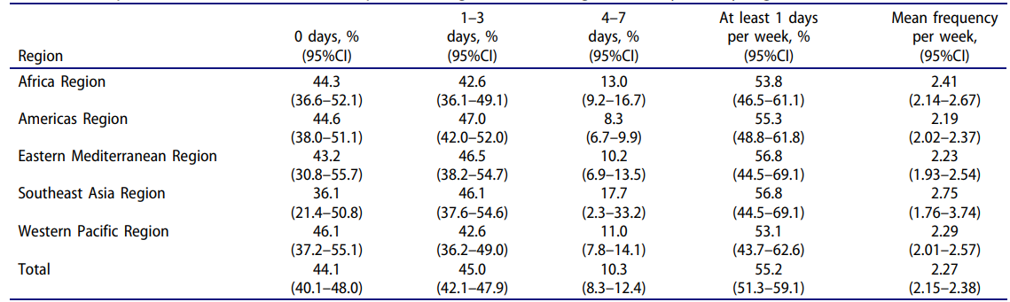

Figure : Fast food consumption among 12–15-year-olds by region ((Li et al., 2020)

According to this study, the most vulnerable populations in LMICs typically depend on accessible and more affordable high calorie processed foods. This exacerbates health inequalities and increases the adverse impacts of diets that are poor in quality. This implies an urgent need for dietary recommendations in order to complement the current rise in fast food consumption and the ensuing health risks.

### 2.2.3 Limitations of Current Dietary Guidelines

Current public health campaigns are based on dietary guidelines developed by using a "one-size-fits-all" approach, drawing from averaged nutrient requirements derived from population-level data (Jinnette et al., 2021). These dietary guidelines broadly recommend types of food, portion sizes, and amounts of nutrients deemed health-promoting to the general public, with goals of lowering the risk of chronic diseases and maintaining general health in the overall population. For example, general recommendations usually include pointing out a diet that is balanced, with loads of fruits and vegetables, whole grains, and lean protein, as well as reduced added sugars, unhealthy fats, and sodium (Snetselaar et al., 2021). This generalized approach assumes these general principles will cater to the health needs for most people and hence is widely applicable and easy to use by the public.

However, it often devoid of specificity to capture an individual's health needs because all these recommendations are based on averages taken from populations. For instance, a person who has obesity and a high percentage of BMI and is considered at risk for type 2 diabetes may require a higher intake of fiber, as this would help in the ideal regulation of blood sugar and weight management (Delahanty, 2024). On the opposite end, someone with a low BMI would require higher caloric intake to avoid malnutrition and to gain weight (Smith & Creighton, 2020). General recommendations do not address these issues.

Moreover, such dietary recommendations have often proved insufficient in the case of individuals with particular dietary needs, such as people suffering from food allergies. For instance, a person who is allergic to cashew nuts should avoid nuts completely; however, in lack of proper identification and highlighting, general dietary recommendations may fail to point out the foods that contain hidden cashew nuts. If healthy dietary guidelines recommend foods that contain cashew nuts as a source of healthy fats and proteins, accidental exposure to such foods might make victims of people with nut allergies through severe health reactions, including death (Tufail et al., 2019). This is an oversight that highlighted how generalized guidelines may result in risk creation for individuals with particular health needs.

Such a reliance on population averages, which is particularly useful for broad public health initiatives, draws a gap in how effectively diverse health profiles are empowered. It therefore becomes important that personalized dietary set-ups accommodate individual health conditions, dietary sensitivities, and nutritional needs; it is necessary for improved health outcomes and safe, more inclusive adherence to healthy eating practices.

### 2.2.4 Relationship of Calories and Macronutrients

Understanding how food yields energy is the foundation of nutrition science as well as everyday food planning. By being able to see how different macronutrients provide caloric value, one can better control their energy balance and make educated decisions in putting together nutritionally appropriate meals. One widely employed procedure for estimating the total energy value of a food product or meal is the following formula:

Total Calories = Carbohydrates [g] × 4 + Proteins [g] × 4 + Fats [g] × 9 + Alcohol [g] × 7

This equation provides a functional, broadly accurate method for estimating caloric value based on macronutrient content. In accordance with the formula, each macronutrient supplies a standard caloric value: carbohydrate and proteins have a value of around 4 kilocalories per gram, fats have a value of 9 kcal/g, and alcohol has a value of 7 kcal/g, even though it is not necessary for essential nutrition (Rome, 2023). These values are based on the Atwater scheme, a widely used model that is the basis of contemporary nutrition labeling by correlating food energy content with its macronutrient content. Nonetheless, actual caloric values will vary minutely based on rounding practices, ingredient variation, and food preparation processes (U.S. Food and Drug Administration, 2013; Moyo, 2024). To correct for such variance, U.S. federal regulation—namely, 9 CFR 317.309(h) and 381.409(h)—permits a tolerance for error on nutrient declaration. According to such allowance, stated values of calories as well as other nutrients are deemed accurate and compliant so long as they do not exceed actual value by up to 20% (Metzger & Nielsen, 2017). This administrative flexibility is designed to ensure that food labeling is both practical and reliable, balancing accuracy with realities of food production and variation.

#### 2.2.4.1 Carbohydrates

Carbohydrates are the body's immediate and first choice for energy, essential for brain functioning as well as muscle activity (Singh et al., 2017). They are classified into simple and complex carbohydrates. Simple carbs present in sweet drinks and processed foods are quickly digested and absorbed, frequently leading to quick peaks and subsequent dips in blood glucose levels (Clifford et al., 2016). Conversely, complex carbohydrates present in whole grains, legumes, and starchy vegetables are digested at an even slower pace, leading to stable energy levels along with better glycaemic management (Krishnan, 2024). The dietary fiber, although structurally a carbohydrate, is indigestible by human digestive enzymes and yields only 1.5 to 2.5 kcal/g via partial fermentation by the colon bacteria (Paeschke & Aimutis, 2011). As a group of complex carbs, fiber has an especial function to help support digestion, increase satiety, along with lowering the risk of chronic diseases, and is sometimes regarded as an independent functional nutrient (Slavin, 2013).

#### 2.2.4.2 Proteins

Proteins, similar to carbohydrates, yield 4 kcal/g but chiefly serve structural and regulatory roles over energy-providing functions. Proteins consist of amino acids and play roles in repair of tissues, muscle building, enzyme and hormone production, and immune responses (Poortmans et al., 2012). They serve to preserve lean body mass especially during times of growth, recuperation, or high levels of activity (Dideriksen et al., 2013). In case of lack of carbohydrate intake like fasting for extended hours or following the low-carb diet, it is possible that the body may start converting protein into glucose via the process of gluconeogenesis (Bhagavan & Ha, 2011). The process is metabolically expensive, however, and can result in muscle wasting if protein intake is poor (Gurina & Mohiuddin, 2022).

#### 2.2.4.3 Fats

Fats are the highest energy-dense macronutrient with 9 kcal/g, with various important roles to play within the body. They are an essential component of cell membrane structure, assist with the development of the brain, and allow for steroid hormone production (Clandinin et al., 1991). The absorption of fat-soluble vitamins (A, D, E, and K), essential for immune function, bone health, and cell repair (Reddy & Jialal, 2022), is facilitated by fats. Fat is stored within adipose tissue as an energy reserve over the long term (El-Zayat et al., 2019). The health outcomes are significantly influenced by the type of fat consumed: unsaturated fats, including foods such as olive oil, nuts, seeds, and fatty fish, reduce the risk of heart disease and inflammatory risk, while trans fats as well as high levels of saturated fats increase LDL cholesterol levels and risk of cardiovascular disease (Coniglio et al., 2023; Dhaka et al., 2011). In addition, essential fatty acids like omega-3 and omega-6 have to be acquired through the diet, as the body is incapable of creating them (Kaur et al., 2012).

#### 2.2.4.4 Alcohol

Alcohol contains about 7 kilocalories per gram, but it is intended to perform no essential physiologic function and yields no essential nutrients to the body. Due to high calories with no nutritional value, alcohol is often described as an “empty calorie” source. It is metabolized primarily once it is ingested, where it is processed by the liver as a toxin and quickly metabolized and eliminated (Lieber, 2003). The process of metabolism can impair regular fat metabolism, frequently resulting in fat accumulation, inflammation of the liver, and, over the long term, severe liver diseases like fatty liver disease and cirrhosis (Patel & Mueller, 2023). In addition to liver injury, regular or excessive drinking has been closely linked to elevated intra-abdominal fat, an increase risk of developing metabolic syndrome, and an elevated incidence of various cancers (Åberg et al., 2022). In addition, alcohol can substitute for foods rich in nutrients within the diet, thus promoting the risk of micronutrient deficiency, especially among those who are at risk (Lieber, 2003). As such, the Dietary Guidelines for Americans 2020–2025 suggest avoiding or reducing the ingestion of alcohol, particularly among those who wish to control their weight, improve diet quality, or reduce chronic diseases (Snetselaar et al., 2021).

### 2.2.5 Total Daily Energy Expenditure

Total Daily Energy Expenditure (TDEE) is the overall calorie requirement a person needs per day to maintain his or her prevailing weight, taking into consideration all aspects of the utilization of energy in daily living (Ostendorf et al., 2019). TDEE consists of four components and thus integrates all major dimensions of an individual's daily needs for calories.

#### 2.2.5.1 Basal Metabolic Rate

The principal component of TDEE is the Basal Metabolic Rate (BMR), which most commonly refers to the Resting Energy Expenditure (REE). BMR is the energy required by the body at rest for basic functions such as respiration, circulation, and replacement of cells. It comprises nearly 60% of one's daily energy expenditure (Levine, 2005). A correct estimation of BMR forms a strong basis for the calculation of daily energy requirements, and the Mifflin-St Jeor Equation is highly preferred for the said purpose. This formula makes estimates of BMR based on age, weight, height, and gender; hence, it is more individualized.

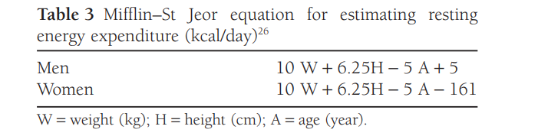

Figure : Mifflin-St Jeor Equation (Ferrie & Ward, 2007)

Several studies have proven the reliability of the Mifflin-St Jeor Equation in estimating BMR, particularly in overweight and obese populations. Such a study was conducted by Van Dessel et al. (2024), comparing 14 predictive equations against Indirect Calorimetry, which is usually accepted as the gold standard for measuring BMR but is highly labor-intensive and expensive. The study population consisted of 731 overweight and obese subjects. Among the results, Henry, Ravussin, and Mifflin-St Jeor equations proved to be the best in terms of accuracy since all three were able to estimate BMR within ±10% of IC values 73% of the time. However, there was no bias (p < 0.05) for both the Mifflin-St Jeor and Henry equations in the violin plot analysis of the overall population. They then concluded that the Henry and Mifflin-St Jeor Equation is indeed practical and a good alternative to IC, particularly in clinical settings where IC cannot apply.

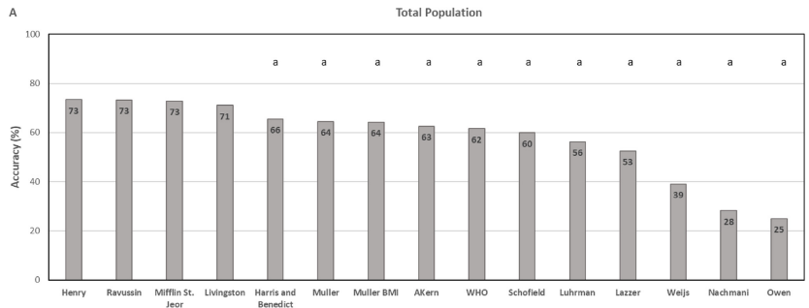

Figure : Accuracy rates of estimated equations compared to IC (Van Dessel et al., 2024)

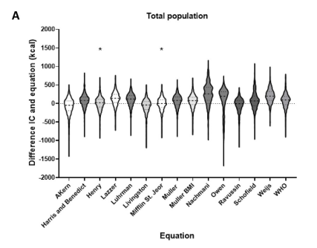

Figure : Bias of estimated equations (Van Dessel et al., 2024)

Another study by Karagun and Baklaci (2024) also confirmed the reliability of the Mifflin-St Jeor Equation. IC was compared with the Mifflin-St Jeor equation, Harris-Benedict equation, and bioelectrical impedance analysis (BIA) in 133 overweight and obese individuals within the study. IC served as the reference standard and had an average of 1581 kcal/day BMR. The Mifflin-St Jeor Equation came closest to the estimates of IC with 50.4% of the values laying within ±10% of the IC measurements, whereas both the Harris-Benedict and BIA methods were only accurate to this extent at about 36% of the time. Moreover, this study showed strong correlations between BMR obtained by IC and body composition indices of fat-free mass and muscle mass, pointing out the role of body composition in the expenditure of energy. Therefore, people are likely to integrate more advanced body composition metrics in the future to provide more precise and individualized energy expenditure estimates.

#### 2.2.5.2 Other Components of TDEE

Aside from BMR, TDEE also involves three other components of NREE, namely Non-Exercise Activity Thermogenesis (NEAT), Thermic Effect of Food (TEF), and Exercise Activity Thermogenesis (EAT) (Trexler et al., 2014). NEAT refers to the energy expended during daily activities other than exercise. It consists of but is not limited to activities that include standing, walking, fidgeting, and other forms of incidental activity (Villablanca et al., 2015). This constituent differs significantly from one individual to another based on a person's individual lifestyle or daily routines and will prove to be a significant determinant of the overall energy requirements. TEF refers to the energy use associated with the digestion, absorption, and processing of ingested nutrients and accounts for approximately 10 % of the total daily energy expenditure throughout the day (National Academies of Sciences, Engineering, and Medicine, 2023). Notably, the digestion of protein- or carbohydrate-rich foods requires more energy compared to fats alone; thus, this implies that a diet rich in proteins and carbohydrates contains a higher metabolic processing cost, which could slightly raise the TEF (Garn, 1990). Last but not least, EAT refers to a deliberate exercise or planned physical activities such as running, weightlifting, and sport events. Energy requirements depend highly on the type, frequency, and intensity of exercise, and thus vary in a wide range (Chung et al., 2018).

#### 2.2.5.3 Formula for Determining Total Daily Energy Expenditure

To have an approximate and detailed calculation of the total daily caloric needs, the BMR estimated by means of the Mifflin-St Jeor Equation is increased by Katch-McArdle multipliers that introduce TEF, TEA, and NEAT (Garcia, 2019). These give a more fine-tuned understanding of energy needs ranging between 1.2 and 1.9 depending on the activity level. The multi-factor approach emphasizes the fact that the mindful variables of daily energy expenditure have gone beyond BMR and further support the move to personalized nutrition recommendations in the hands of the individual lifestyle profile.

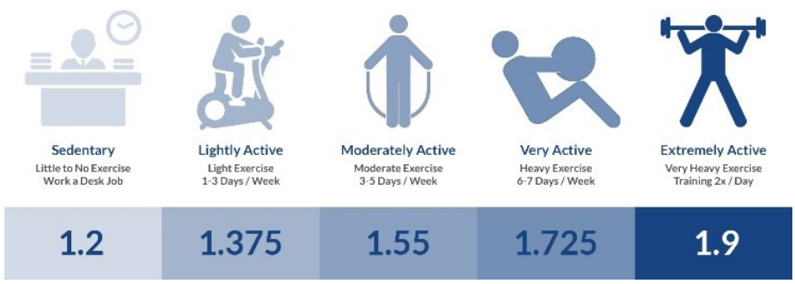

Figure : Katch-McArdle Multipliers for Calculating TDEE (Garcia, 2019)

### 2.2.6 Macronutrient Ratio

The ideal macronutrient proportion is best conceived as an adaptable yet fundamental guideline that plays an essential role in underpinning physiological function, metabolic health, and sustained health. Though caloric equilibrium is still pivotal in weight management, macronutrient proportions have an impact on hormonal function, appetite regulation, energy availability, and nutrient digestion (Smeets et al., 2008). In addition, research again confirms that nutrition plans with balanced macronutrient proportions are more stable and efficient compared to extreme dietary paradigms. By fine-tuning macronutrient consumption in science-based proportions, individuals can improve metabolic performance, provide nutritional adequacy, and achieve optimized health outcomes at all stages in life and for all fitness objectives (Rein et al., 2022).

#### 2.2.6.1 Macronutrient Ratio for Long Term Health

Health maintenance involves eating a diet in which energy consumption is balanced with energy expenditure, while macronutrient allocation favors metabolic efficiency, satiety, and sustainability. Current recommendations such as the Acceptable Macronutrient Distribution Ranges (AMDR) suggested by The Dietary Guidelines for Americans 2020–2025 recommend 45-65% calories from carbohydrate, 20-35% fat, and 10-35% from protein for overall health and weight maintenance (Taylor et al., 2024).

Recent longitudinal research by Seidelmann et al. (2018) further emphasizes that keeping macronutrients in moderate proportions, especially carbohydrate consumption, is crucial. A large-scale cohort study noted that carbohydrate consumption was associated with an inverse U-shape with mortality, with 50–55% carbohydrate consumption being associated with the lowest risk. Extremely high carbohydrate consumption (>70%) as well as very low carbohydrate consumption (<40%) were linked with mortality, indicating that both ends of the carbohydrate spectrum might have an adverse impact on health over the long term. These observations confirm that moderate carbohydrate consumption — in line with dietary recommendations — may be best suited to support both weight maintenance as well as longevity. Such a proportion that supplies approximately 45–55% carbohydrates, with suitable amounts of protein and health fats, thus seems to support life as well as beat disease over the years.

Diets that maintain an even macronutrient profile, such as that used in the Zone Diet, with 40% carbohydrates, 30% protein, and 30% fat have been of interest for their ability to promote metabolic health and mitigate chronic disease risk. A central principle behind the Zone Diet is to maintain an isocaloric amount of 0.75 in terms of the proportion of protein to carbohydrate at every meal. This particular proportion is thought to control the insulin-to-glucagon ratio, which in turn affects eicosanoid metabolism, a system of signaling molecules that play an essential role in inflammation and immune function. Proponents argue that by optimizing this metabolic and hormonal equilibrium, the Zone Diet could play a role in achieving numerous long-term health advantages such as improved immune function, increased physical and mental performance, extended lifespan, and maintained weight control (Cheuvront, 2003).

Also, in 42,192 Korean adults, a cohort study revealed that 50-60% carbohydrate, 30-40% fat, and 20-30% protein macronutrient composition had the lowest risk for all-cause mortality. Any deviations from these percentages, mainly less than 50% or greater than 60% for carbohydrates, or less than 30% or greater than 40% for fat, were related to higher mortality risk. Interestingly, consumption in 20-30% range as protein was related to the greatest warranty for 1% mortality, although there was not an association between proportion of protein consumption and all-cause mortality (Kwon et al., 2020). These results indicate that an equilibrated macronutrient composition in these percentages could play an important role in longevity and health.

#### 2.2.6.2 Macronutrient Ratio for Muscle Building

Muscle hypertrophy is optimized by both an extended caloric surplus and an evenly distributed macronutrient profile. Protein is especially important as it supplies essential amino acids to increase and regulate muscle protein synthesis (MPS). Carbohydrates play an equally crucial role by being used as the body's energy source, topping off glycogen stores, and providing energy for resistance training (Margolis et al., 2020). The International Society of Sports Nutrition suggests that active individuals use about 3–7 grams of carbohydrates per day per kilogram of body weight, which is normally 40–60% of all daily calories (Escobar et al., 2016).

Although fat is needed for hormone synthesis and overall body function, maintaining fat consumption within the moderate range—typically between 20–25% of total calories—provides enough energy for carbohydrates as well as for protein. These two macronutrients play direct roles in training performance, recovery, and muscular adaptation. In contrast, very high-fat, very-low-carbohydrate diets, like strict ketogenic diets, have been found to negatively impact muscle accretion in strength-trained populations (Ashtary-Larky et al., 2021). This could result from decreased training tolerance, diminished availability of glycogen, as well as impaired lean mass retention.

The significance of macronutrient proportionate intake is reinforced by an analysis by Schoenfeld and Aragon (2018), which found that diets with sufficient protein (≥1.6g/kg/day), moderate-to-high carbohydrate consumption, and moderate amounts of fat consistently yielded higher gains in lean body mass with concomitant resistance training. At such an intake, dietary protein supplies approximately 25-30% of the energy in an anabolic diet, which is an affirmation of its pivotal role in hypertrophic adaptation.

Additionally, new evidence is pointing towards muscle growth still being possible at lowered carbohydrate consumption, provided that protein consumption is substantially increased and overall energy is above maintenance. Antonio et al. (2015), for instance, reported that very high protein consumption at about 3.4 g/kg/day, representing about 40-45% caloric consumption, enhanced body composition by maximizing muscle growth while reducing fat accretion, even in the absence of high-carbohydrate content. These results affirm that although carbohydrate and lipids may vary relative to personal needs and tolerances, high enough protein and total energy consumption remains vital for efficient muscle hypertrophy.

#### 2.2.6.3 Macronutrient Ratio for Weight Loss

Weight loss is best accomplished by creating an ongoing caloric deficit, but macronutrient division in that same deficit is central to determining body composition, controlling appetite, optimizing metabolic efficiency, and facilitating compliance to diet in the long term. Among approaches, low-carbohydrate, high-protein diets have been very popular for their potential to support fat loss without losing lean tissue.

Evidence has routinely documented the efficacy of very-low-carbohydrate ketogenic diets, which consist of less than 10% of total calories as carbohydrates, about 30% as proteins, and about 60% as fat. Such diets result in nutritional ketosis, a metabolic condition that improves fat oxidation and reduces appetite. The recent meta-analysis by Dyńka et al. (2025) confirmed that ketogenic diets achieve notably higher short-term decreases in body weight and fat mass compared to higher carbohydrate diets, especially among individuals with insulin resistance or metabolic syndrome.

In addition to ketogenic diets, high-protein, low-carbohydrate diets also showcase superior results for fat loss as well as for maintaining lean tissue. At the more aggressive side of the intervention spectrum, the Protein-Sparing Modified Fast (PSMF) illustrates the impact of aggressively emphasizing protein, quite often in amounts over 40% of total calories consumed while keeping carbohydrate and fat very low (Krebs et al., 2010). Implemented mainly in inpatient settings with medical guidance, this protocol has been found to produce quick fat mass loss with retention of lean tissue (Chang & Kashyap, 2014). As such, these results underscore the imperative role for protein-based, carbohydrate-restricted diets in enabling efficient, sustained, and metabolically favorable weight loss.

### 2.2.7 Zig-Zag Diet Plan

The zig-zag diet is a form of calorie cycling whereby daily food intake is alternated in such ways as to maximize metabolic efficiency, enhance weight loss, and avoid the plateaus commonly seen with constant caloric restriction (Byrne et al., 2017). A study conducted by Amballa (2021) illustrate how one could alternate caloric intake throughout a week to ensure better weight management by preventing the body from adapting to a constant energy deficit. For instance, a person who needs 2,000 calories to maintain weight will have some days with 2,200 calories, which is 10% over maintenance, and other days with 1,800 calories, which is 10% below maintenance. Moderate shifts include days at 2,100 calories, or 5% above, and 1,900 calories, or 5% below, to create an eating style that changes considerably. This approach definitely helps to keep a much higher metabolic rate and minimizes the metabolic slowdown that usually develops during long-term calorie deficit. Promoting sustainable weight management and at the same time decreasing the risk of non-communicable diseases, the zig-zag diet directly helps to contribute to the aim of SDG 3 by reducing premature mortality through effective prevention and treatment.

### 2.2.8 Distribution of Daily Calories Intake

The best daily caloric allocation across meals of breakfast, lunch, and dinner must be balanced according to individual health objectives, be it muscle gain, losing weight, or overall metabolic health. In the case of those on a muscle-building regimen, studies by Hiol et al. (2023) revealed that muscle protein synthesis was by about 25 percent higher where protein allocation across meals was balanced than where it was unevenly spread, even at the same total daily protein intake. A more recent 2024 review corroborates this with the "meal threshold hypothesis," where dividing protein evenly throughout the day facilitates a higher net muscle protein synthesis over 24 hours and results in better body composition (Layman, 2024). These studies concur on balanced caloric as well as protein allocation across meals, with about 30 percent of calories at breakfast, 40 percent at lunch, and 30 percent at dinner to best achieve muscle-building benefits. When the target changes to losing weight, the timing of calorie intake is particularly significant. Ruddick-Collins et al. (2022) found that front-loading calories earlier in the day, for example, eating 45 percent of calories at breakfast, 35 percent at midday, and 20 percent at supper, has been found to increase appetite suppression and is more in tune with the body's circadian rhythms. Such rhythms support optimal metabolic function earlier in the day. The front-loaded strategy has been linked to greater satiety, better glucose control, and improved compliance with dietary recommendations. For people who wish to be healthy overall, including regulating levels of glucose in the blood, portioning meals by both time of day and degree of portioning is equally crucial. Beebe et al. (1990), writing for Diabetes Care, looked at the influence of varying patterns of calories on individuals who have non-insulin-dependent diabetes mellitus. In the study, balanced portioning, with 30 percent of calories at breakfast, 40 percent at lunch, and 30 percent at supper, produced more even glucose and insulin levels throughout the day than eating habits reflecting large suppers.

### 2.2.9 Implementation of Machine Learning in Nutrition

Machine learning (ML) is a subset of artificial intelligence (AI) that involves the development of systems with the ability to improve their performance without explicit programming (Das et al., 2015). This includes the algorithms that would enable computers to make predictions, detect patterns, and perform decisions with iterative improvements. The most important thing in machine learning is that machines can learn automatically from experiences or data and improve over time for better performance (Bharadiya, 2023). Active learning in ML makes nutrition one of the main areas wherein ML offers innovative solutions to problems connected with food recognition, diet monitoring, and personalized health recommendations.

A number of studies on the implementation of ML in recent years have pointed out the transformative potential of the field of nutrition. One highly relevant study combined food recognition with nutritional attribute estimation using machine learning models by Shen et al. (2020). The system shall incorporate the use of fine-tuned CNN models for the quick recognition of wide types of food items, including subcontinental cuisines, while accessing nutrition information through a Word2Vec-based module. The general philosophy of this Client-Server architecture is to assist users in uploading food images and fetching information on food calories and ingredients for easy diet tracking. Although the system has limitations concerning handling mixed dishes and datasets, it can definitely mark the beginning of progress in nutrition monitoring so as to make people lead healthy lives by automation with personalization.

Another strong example is the GlucoGoalie app for type 2 diabetes management, proposed by Mitchell et al. (2021). This application utilized machine learning on data provided by users through meal logs and blood glucose readings to make recommendations concerning personalized dietary goals. The application used a non-parametric ML method known as Attributable Components Analysis, which assesses the relationships between nutritional intake and variation in post-meal blood glucose. These provided actionable recommendations, such as reducing carbohydrate intake for meals where spikes in blood sugar were detected. Examples of specific suggestions included replacing high-carb foods like rice or bread with protein-rich alternatives like chicken or tofu. Fortunately, participants reported better glucose control and a greater understanding of how their food choices impacted their health. However, it also faced some key challenges like users being confused with abstract nutritional terms, such as "carbohydrate choices" and static text-based recommendations. Additionally, several participants referred to a desire to receive interactive or more visually engaging feedback to clarify and make the suggestions easier to act upon​.

In the examples above, researcher know that machine learning is really revolutionizing the nutrition area, making dietary monitoring automatic, personal recommendations, and behavioural change possible. Successful examples, like Food Recognition & Nutrition Estimation and GlucoGoalie, have shown that ML can actually be applied in reality to solve nutritional challenges while showing further areas for improvement. Through analysing complex data, ML is able to build actionable insights that help people make healthier choices and, meanwhile, enable researchers to find new relations between diet and health outcomes. Addressing the limitations of the technology will be important as it continues to evolve toward broader adoption and impact.

### 2.2.10 Clustering

Clustering is a method of unsupervised machine learning whereby a set of data is grouped together, based on similarities within data points. These groups are known as clusters. Unlike in supervised learning, clustering does not involve labelled data or pre-developed categories (Chander & Vijaya, 2021); thus, clustering can be a strong tool for the revelation of hidden patterns of any dataset. Clustering forms groups by analysing the inherent structures in such a manner that data points within a cluster exhibit a high degree of similarity, while those from different clusters are dissimilar (Jain et al., 1999). There are several clustering algorithms, each suited for various types of data and objectives.

#### 2.2.10.1 K-means Clustering

K-Means is a robust and commonly applied partitioning algorithm that clusters data into 'K' separate clusters by allocating every data point to the nearest centroid and iteratively realigning those centroids to achieve minimum WSS (Tarekegn, 2025). Being simple to compute, fast, and highly scalable, K-Means is especially suited to big data. Its simplicity of implementation and interpretation have led to its use as a baseline in many clustering operations and it is one of the best-known procedures in exploratory data analysis (Michalakopoulos et al., 2024).

However, regardless of these benefits, K-Means also has significant weaknesses. It needs the value of the clusters to be predefined, which will not always be easy in the absence of knowledge of the structure of the data set (Michalakopoulos et al., 2024). It also assumes clusters to be of the same size and density and to be spherical in shape, which won't always reflect the reality of the data in the real-world health or dietary context. It also is sensitive to outliers, which will cause cluster centroids to become distorted, and to the choice of initial centroids, which will have an influence on final clustering (Wororomi et al., 2023). Variants such as K-Means++ have since been proposed to address the initialization step and the probability of the algorithm diverging poorly (Gul & Rehman, 2023).

In the realm of personalized diet, K-Means has been effectively implemented to stratify subpopulations of individuals sharing similar diet or metabolic profiles. For example, Hillesheim et al. (2020) applied K-Means to group 207 healthy adults into three different "metabotypes" by using standard metabolic biomarkers like triacylglycerols, cholesterol, and glucose. Each metabotype was associated with a distinct profile of metabolites, e.g., one metabotype had high HDL levels, and another metabotype had high triglycerides. Subsequent group-specific dietary advice, developed by the researchers, had about 83% conformity when compared to fully personalized nutritional advice. This showed that K-Means can also serve as a useful instrument in stratifying individuals into nutritional subpopulations, facilitating more effective and scalable provision of personalized diet interventions.

Another pertinent study by O'Hara et al. (2022) used K-Means to examine meal patterns by grouping the 27,336 measured meals into 63 generic meal types according to similar food constituents and nutrient content. Even though applying this massive dimensionality reduction, estimates of nutrient intake by the clusters did not diverge substantially from the original meal data, the differences being statistically insignificant and 55–92% of the individuals having the same nutrient designation (e.g., high, adequate, or low). This indicates that it is possible to simplify dietary assessment by grouping meals into representative types without the need to compromise on precision. This is of practical utility in the context of digital health, where the participant can choose from standard meal types rather than entering every item eaten, facilitating easier tracking and more tailored advice.

#### 2.2.10.2 Gaussian Mixture Model (GMM)

Gaussian Mixture Model is a probabilistic, model-based clustering technique that models data as being generated by a mixture of multiple Gaussian distributions. In contrast to hard, traditional approaches like K-Means, which allocate a data point to one cluster definitively, GMM will allocate a data point a likelihood of being in every cluster. This soft allocation allows GMM to capture overlap and uncertainty, while present in real-world data, whereas hard approaches might not always capture it (Balakrishna et al., 2023). Every Gaussian component is characterized by a mean and a covariance matrix, and so GMM will detect clusters of elliptical shapes of varying sizes and orientations—providing more flexibility compared to K-Means, which models spherical, equally-sized clusters (Patel & Kushwaha, 2020). GMM models also contain statistical measures like the Bayesian Information Criterion (BIC) and Akaike Information Criterion (AIC) that assist in deciding the best number of clusters, which makes the model more robust and interoperable (Mas’ud et al., 2021).

While it is strong, GMM also has some drawbacks. GMM assumes that the underlying data distributions are Gaussian, a condition that might not always exist in a given dataset. Where the data have abnormal shapes or do not follow normal distributions, GMM will either fit poorly or need a high-dimensional representation in order to capture the true structure to a high degree of fidelity (Kasa & Rajan, 2023). GMM is also initialization-sensitive, and the EM algorithm GMM employs during training might converge to local optima, causing suboptimal clustering (You et al., 2023). GMM becomes also computationally demanding in high-dimensional data sets, since it needs to estimate full covariance matrices per component (Zhao et al., 2018). On top of this, result interpretation grows more complicated if clusters overlap heavily, as points might have almost the same likelihood of being in two different clusters, hence the classification will not always definitely happen (Economou, 2023).

In personalized nutrition, Gaussian Mixture Models (GMM) have successfully captured the multicomponent and overlapping character of the way people eat. Fahey et al. (2012) have applied a type of GMM, a normal mixture model, to diet data from the large-scale European EPIC study. Their model revealed eight distinct patterns of eating in the participants, some of which were replicated in a different sample. Traditional methods that forced everyone into one group no longer applied, as GMM permitted partial membership, so someone's diet might in part belong to more than one pattern. This improved the detection of people who had mixed dietary habits or might have under-reported their diet. By illustrating the likelihood of every person in a specific pattern of eating, the model also improved the way in which diet might relate to outcomes of health, and the consequent advice given could be more precise and personalized.

Another study by Balakrishna et al. (2023) applied GMM in a different manner, not to people but to foods. They applied GMM to group the foods by their content of nutrients, including sodium, carbohydrates, iron, and fats. They, for instance, classified foods into five categories of sodium—from very low to very high sodium—according to the content of sodium in the items. Rather than establishing hard cut-off points, the model gave a likelihood to each food of being in each category. This method enabled the easier handling of those in-between foods and accommodates the natural overlap in the content of nutrients. This method is particularly useful when creating meal plans for people who require special dietary needs, like low-sodium meal plans for people who have high blood pressure. The authors proposed the idea of using this type of food grouping to construct smarter exchange listings so that flexible and personalized substitutions could be allowed while not sacrificing control of the important nutrients.

#### 2.2.10.3 Self-Organizing Maps (SOM)

Self-Organizing Maps (SOM), first proposed by Teuvo Kohonen in the 1980s, are an unsupervised artificial neural network methodology intended to map high-dimensional data into two-dimensional space with the preservation of the data's topological structure (Kihato, 2013). In contradistinction to the conventional clustering algorithm of K-Means, where each input is labeled with one cluster, SOM clusters similar inputs into adjacent nodes, essentially integrating clustering with visualization power. Each grid node is linked to an adaptive weight vector, which is continuously modified following resemblance to input vectors. Gradually, this method identifies patterns, transitions, and outliers within the data (Kohonen, 2001). All these make SOM particularly appropriate for use in personalized nutrition, where data sets hold sophisticated and multifaceted parameters. Interestingly, SOM does not require pre-definition of the number of clusters, and an output like U-matrix visualizations lends it intuitive understanding as well as explanation of results to researchers as well as to end-users (Noor & Hamid, 2016).

Although it has advantages, SOM is by no means without limitation. Its performance is sensitive to various hyperparameters, such as learning rate, size of the map, as well as the choice of neighborhood function, each of which can have an effect on the quality of the formed clusters (Guérin et al., 2024). SOMs are also computationally expensive, especially with large data sets, and they themselves neither automatically identify nor label clusters, requiring additional analysis or an expert-level interpretation. Furthermore, SOM presupposes input features to be necessary as well as sufficient for clustering to be meaningful, potentially causing difficulty when data is noisy or incomplete. However, most of these shortcomings can be reduced by sufficiently pre-processing the data, adjusting the parameters, and utilizing sophisticated SOM variations like adaptive or growing SOMs, providing better adaptability and agility towards sophisticated data sets (Astudillo & Oommen, 2013).

In nutritional research and health, SOM has been highly useful. To illustrate, Lagus et al. (2012) applied SOM to visualize and compare the nutritional and health patterns of 86 nations with regard to diet content and public health indicators. Projecting each nation onto an SOM two-dimensional grid, the authors discerned clusters characterized by similar diet patterns and concomitant health profiles. One cluster represented nations characterized by high animal product and sugar intake, typically related to high levels of chronic diseases and obesity. The second cluster comprised nations with reduced intake of calories and fats, usually related to undernutrition and poor socio-economic status. The method evidenced how SOM can chart global dietary trends as they relate to health status, information equally valid at the individual level for applications to personalized nutrition systems.

Further illustrating SOM’s value in the clinic, Yie et al. (2025) used the method to stratify survivors of breast cancer by combined diet and metabolomic data. The aim was to find patterns of eating related to different metabolic phenotypes with the potential to direct personalized interventions. Participants were partitioned into clusters with similar metabolically related and dietary patterns using SOM. A high fruit and vegetable intake with healthy metabolic indices, for example, was typical of one cluster, while high levels of processed foods with elevated inflammatory markers marked another. The application served to underscore SOM’s ability to identify subtle interactions between diet and metabolism so that more effective and personalized nutrition advice could be given. Together, these studies reflect SOM’s ability to process sophisticated nutritional data to enable personalized nutrition approaches both through analytical specificity and visual intuition.

### 2.2.11 Evaluation Metrics for Clustering

Clustering evaluation is critical to measure the efficiency and effectiveness of clustering algorithms since it is a way to quantify the quality of the clusters formed based on certain measures. Internal measures like Davies–Bouldin Index, and Calinski–Harabasz Index are usually used to measure clustering results, especially in unsupervised contexts where the true labels are not known. Each of them looks at different facets of the quality of clusters—compactness, separation, or cohesion—offering the multi-faceted insight into the efficiency with which the data have been separated by the algorithm. It should be noted, however, that the validity of each of them can be highly dependent upon the presence of irrelevant features. Parsons et al. (2004) point out that such features create noise that can interfere with the clustering structure and mislead the measures. Hence, knowing the sensitivity of the validation tools with respect to irrelevant or noisy data becomes critical to ensure robust and reliable cluster analysis.

#### 2.2.11.1 Davies–Bouldin Index

Davies–Bouldin Index (DBI) is a measure of internal clustering validity that aims to measure clustering performance against the trade-off between compactness and distinctness of clusters. For every cluster, a measure of similarity between its internal dispersion and proximity to the most similar neighboring cluster is calculated. Averaging the maximum similarity ratings over all clusters produces the overall index. A lower measure of the DBI indicates a better clustering solution with more compact groupings and more distinctions between clusters (Awong and Zielinska, 2023). This measure is computationally efficient and easily comparable over a large number of clustering configurations, especially in finding the optimal amount of clusters. However, the assumption of approximately spherical and equal-sized clusters reduces the applicability of the DBI to more complex cases with clusters of different shapes or density (Ikotun et al., 2025). In addition, the measure is affected by aberrant or poorly constructed clusters since a single outstanding measure of similarity disproportionately contributes to raising the overall index (Nowak-Brzezińska and Gaibei, 2022). In spite of these drawbacks, the Davies–Bouldin Index is popular because of its ease of use, scalability, and ability to measure the quality of a clustering without labeled data.

#### 2.2.11.2 Calinski–Harabasz Index

The Calinski–Harabasz (CH) Index (calso called the variance ratio criterion) is a clustering internal validation criterion that measures clustering quality by computing the ratio of the dispersion between clusters to the dispersion within clusters (Ikotun et al., 2025). Without a specified cutoff value, a high CH index merely implies better-separated and more compact clusters, making it a convenient method to choose the number of optimal clusters for techniques such as k-means clustering or hierarchical clustering (Saitta et al., 2008). Its sum-of-squares computations make it efficient computationally, even for high-dimensional or large datasets. Its simplicity, easy interpretation, and strong empirical performance have placed a high value on the CH index (Ikotun et al., 2025). Its freedom from the need for external parameters as well as requirements for data distribution makes it popularly applied in fields such as image segmentation, market research, as well as bioinformatics (Hassan et al., 2024). Its assumption of spherical, similar-sized clusters may limit its effectiveness against datasets with elongated, randomly shaped, or overlapping clusters (Ikotun et al., 2025). Additionally, its outlier vulnerability to outlier contamination as well as its underestimation of significant patterns in intricate data underscore its necessity for application with other validation indices for a more comprehensive clustering evaluation.

#### 2.2.11.3 Bayesian Information Criterion for Gaussian Mixtures

Bayesian Information Criterion (BIC) is a popular internal model-based clustering validation method, especially with Gaussian Mixture Models (GMMs). It assesses models by weighing goodness of fit against simplicity, imposing a penalty for models with a larger number of parameters to avoid overfitting (Ikotun et al., 2025). Lower BIC scores represent a superior tradeoff of accuracy for complexity, rendering it a pragmatic method to determine the ideal number of clusters without a separate validation set (Ben Shatwan et al., 2024). BIC works efficiently if data are fairly representative of the supposed model, but its precision suffers if clusters are uneven, non-Gaussian, or overlapping, tending to select the wrong number of clusters (Lago-Fernández et al., 2019).

#### 2.2.11.4 Inertia for K-Means Clustering

Within-cluster sum of squared errors (SSE), a measure of data point proximity to their respective assigned centroids, is what we mean by inertia under k-means clustering. Lower inertia means more compact, tight clusters, and as the minimization of SSE is what we want with k-means, inertia is a perfectly natural, widely applied goodness-of-fit criterion (Abdelazeem et al., 2024). It is easy, efficient to calculate, and can be applied to all clustering algorithms with centroids. It only measures compactness of clusters, without differences between clusters, however, so it will always prefer more clusters unless a threshold cut off is implemented (Haidar, 2022). It is therefore routinely applied together with the "elbow method," where inertia is plotted vs. varying number of clusters to identify where changes are becoming increasingly trivial (Bekri, 2023).

#### 2.2.11.5 Quantization Error for Self-Organizing Maps

Quantization error (QE) quantifies how accurately the map prototype vectors (neurons) describe the data set by averaging the distance from each data point to its best matching unit (BMU) (Rahaman et al., 2021). Lower QE corresponds to tighter mapping with less lost information(Tú, 2015). As a basic and easy-to-grasp metric, QE was a common method for determining SOM quality, enabling practitioners to monitor training, compare varying map configurations, as well as identify anomalies when inputs have exceptionally high errors. While there are some caveats: QE always declines with more neurons, which can result in overfitting, as well as solely measuring data-to-prototype distances without regard to cluster spread (Tú, 2015).

## 

## 2.3 Similar Systems / Works

The following table displays the existing dietary recommendation systems that utilize different advanced technologies.

|  |  |  |  |  |  |  |
| --- | --- | --- | --- | --- | --- | --- |
| **Research Topic** | **Author(s)** | **Technique Used** | **Description** | **Findings** | **Strengths** | **Limitations** |
| **Food Recommendation System Based on Nutritional Needs and Preferences** | Jasim & Hamid (2022) | Modified K-Means, Silhouette Algorithm | Developed a system combining user preferences with nutritional needs using clustering for personalized food suggestions. | Achieved 96% accuracy in recommending nutrient-rich foods. Used silhouette scores to determine optimal clusters. | 1. Integrated nutrient needs and taste preferences.  2. Optimized clustering with silhouette evaluation.  3. High system accuracy in trials. | 1. Lacks consideration of medical or chronic conditions.  2. Ignores demographic differences (age, gender, etc.).  3. Dependent on dataset quality for accurate clustering. |
| **Nutritional Phenotyping via K-Means** | Ramyaa et al. (2019) | K-Means Clustering | Clustered postmenopausal women based on dietary intake and physical activity to predict weight. | Cluster-specific models reduced prediction error to ~1.1 kg compared to 6–7 kg in general models. | 1. Improved predictive accuracy using cluster-specific modeling.  2. Demonstrated value of behavioral/dietary clustering.  3. Real-world application using a large cohort. | 1. Dependent on self-reported data (potential inaccuracies).  2. Focused only on women—limited demographic generalizability.  3. Assumes clusters are spherical and equally sized. |
| **Meal-Based Clustering for Nutrient Intake** | O’Hara et al. (2022) | K-Means, PAM | Clustered ~27,000 meals into 63 generic meal types to simplify nutrient tracking and personalization. | Nutrient estimates based on clustered meals had 55–92% agreement with original intake logs. | 1. Reduced logging complexity for users.  2. Preserved accuracy in nutrient analysis.  3. Applicable to meal-based recommender systems. | 1. Limited to short-term dietary tracking (4 days).  2. Might exclude less common or ethnic meals.  3. Does not incorporate health personalization. |
| **Comparing K-Means vs. GMM for Dietary Patterns** | Greve et al. (2015) | K-Means, Ward’s, Gaussian Mixture Model | Compared clustering methods to identify dietary patterns in children (IDEFICS cohort). | GMM captured flexible and irregular dietary clusters better than heuristic methods. | 1. Rigorous comparison of clustering algorithms.  2. GMM captured uneven and correlated intake profiles.  3. Revealed meaningful child dietary patterns. | 1. GMM is computationally more intensive.  2. Results sensitive to distributional assumptions.  3. Complex interpretation of probabilistic outputs. |
| **Metabotyping for Targeted Dietary Advice** | Hillesheim et al. (2020) | K-Means Clustering | Clustered 207 adults by metabolic biomarkers (e.g., glucose, cholesterol) to deliver metabotype-based diet advice. | Metabotype-based plans matched 83% of fully individualized diet plans. | 1. Tailored advice using objective biomarker data.  2. Practical for scalable group-level nutrition plans.  3. Maintained high overlap with personalized plans. | 1. Requires clinical biomarker data (blood tests).  2. Limited to healthy adults in a small sample.  3. Does not account for dietary preference or behaviour. |
| **Identifying Dietary Patterns Using Mixture Models** | Fahey et al. (2012) | Gaussian Mixture Model (Normal Mixture Model) | Used GMM to analyse dietary intake data from the European EPIC cohort, allowing partial membership in multiple dietary patterns. | Identified 8 dietary patterns; allowed nuanced classification and better association with health outcomes. | 1. Captures uncertainty and overlapping dietary habits.  2. Enables probabilistic classification for improved outcome analysis.  3. Useful in identifying potential under-reporting or mixed habits. | 1. Complex model interpretation.  2. Requires large, clean datasets.  3. May perform poorly if data doesn’t match Gaussian assumptions. |
| **Food Grouping by Nutrient Profiles Using GMM** | Balakrishna et al. (2023) | Gaussian Mixture Model (Univariate) | Clustered food items based on individual nutrient content (e.g., sodium, carbs, fats) using GMM for probabilistic classification. | Created probabilistic food classes (e.g., high-sodium, low-fat), allowing better dietary planning and flexible substitutions. | 1. More flexible than hard thresholds.  2. Accounts for overlapping nutrient distributions.  3. Supports dynamic, user-specific food exchanges. | 1. Only used univariate GMM, nutrient interactions not captured.  2. May need refinement for mixed or composite foods.  3. Requires well-structured nutrient databases. |
| **Hybrid Food Recommender using Clustering** | Rostami et al. (2022) | Graph Clustering, Deep Clustering | Two-phase system: clusters recipes (ingredient/nutrient similarity) and users (preference patterns). | Hybrid model improved recommendation accuracy, especially under cold-start conditions. | 1. Integrated user and item clustering for personalization.  2. Addressed cold-start and sparsity issues.  3. Scalable and tested on a real-world dataset (AllRecipes). | 1. Requires large datasets for training deep models.  2. Doesn’t explicitly optimize for health factors.  3. System complexity may limit lightweight deployment. |
| **Deep Community Detection for Group Recommendations** | Rostami et al. (2024) | Deep Clustering (Neural Community Detection) | Detected user communities (social + dietary) for group food recommendations balancing preference and nutrition. | Enhanced satisfaction and dietary health scores in group settings. | 1. Combined health with group taste preferences.  2. Enabled personalized nutrition at the group level.  3. Applied to social food networks. | 1. Complexity grows with group size and social diversity.  2. Needs detailed user history and social linkage.  3. May not generalize across cultures or cuisines. |

Table : Similar works of dietary recommendation system

Several current systems demonstrate the effectiveness of clustering in supporting personal nutrition recommendations. One of the most widely used methods is the K-Means clustering method, shown to be practical and efficient. As seen in the case of Ramyaa et al. (2019), K-Means clustering may be employed to classify postmenopausal women according to their food intake and physical exercise. Cluster-specific models were employed to enhance weight estimation accuracy. The prediction error reduced from 6–7 to about 1.1 kg within clusters. The outcome indicates the role of clustering in personalizing predictions per user category. Another robust example is that of Hillesheim et al. (2020). They employed K-Means to classify into different metabolic types or "metabotypes" by clinical biomarkers such as glucose and cholesterol. The metabotype in each case had corresponding group-specific diet recommendations. These customized recommendations matched as many as 83% of fully customized recommendations. This research emphasizes the utility of clustering for scalable personalization of health recommendations. In a similar vein, O’Hara et al. (2022) employed K-Means to aggregate more than 27,000 meals into 63 typical food types. Even after aggregation, their model had good consistency with actual nutrient data, with 55–92% consistency with initial logs. These experiments validate that K-Means performs effectively in handling large-scale food data.

Another valuable method is Gaussian Mixture Models (GMM). Unlike K-Means, GMM provides probabilities rather than definite labels. This is more flexible, particularly for individuals with habits that don’t strictly belong to one category. Fahey et al. (2012) used a normal mixture model to analyze food intake data in the EPIC study. Their approach found eight overlapping diet patterns. This helped them to account for individuals that had a combination of characteristics from multiple groups. GMM proved helpful in better manage real-life variation in diet. Another use of GMM was that of Balakrishna et al. (2023). Rather than grouping individuals, they grouped food into nutrient classes such as sodium, carbohydrate, and fat. A probability of association of each food to different nutrient classes was determined. A food can be 80% "low-sodium" and 20% "medium-sodium," as a case in point. A flexible food substitution in preparing diet plans is possible using this method. Hard cutoffs are avoided, and the meal plan can be adaptive.

Some recent work also investigated hybrid and deep clustering approaches. Rostami et al. (2022) proposed a two-phase system. Initially, they clustered recipes according to ingredients and nutrients. Then, they clustered users in relation to their preferences. The hybrid model promoted higher accuracy in recommendations, particularly with limited available user data. Rostami et al. (2024) later advanced this with a deep clustering system. User communities were discovered based on nutrition and social as well as diet behavior. The system generated the recommendations based on groups with the capability of balancing nutrition and taste preferences. These methods are more complicated but display high performance when handling dense datasets.

For the project, with its emphasis on clustering recipes by macronutrient requirement, K-Means is a good option. Based on prior work, the literature indicates that it performs well as a method for clustering similar foods. It is computationally quick, scalable, and easy to understand. The researcher can also look to GMM in handling overlap in the nutrient composition, perhaps useful when meals don’t obviously belong to a given category. Performance evaluation methods, including silhouette scores, can be used to verify the performance of clusters. If the intention is to extend the system in the future, deep or hybrid clustering methods create interesting possibilities. These can be used to incorporate preferences, feedback, or social interactions of the users. Yet for the scope of the project now, established methods such as K-Means and GMM are practical and well-supported in the literature.

## 2.4 Technical Research

The technical foundation of this project is paramount to successful development, deployment, and scalability. The selected tools, platforms, as well as the chosen hardware must be capable of supporting efficient machine learning processes, data processing pipelines, and user interface application deployment. This section elaborates on the technical aspects at length, such as the hardware infrastructure, the programming languages, the development environments, and operating systems.

### 2.4.1 Hardware Requirements

With the data-intensive, compute-bound nature of this project, particularly at the stage of data analysis and model training, there is the need to use a high-performance hardware setup. It should be able to process large-scale data workflows at low latency to facilitate rapid model iterations and efficient deployment of machine-learning services.

#### 2.4.1.1 Processor

A strong processor is the foundation of this setup. A multi-core, high-speed processor like the Intel Core i7 (at least the 10th generation) or AMD Ryzen series is most favored. These processors boast high base (unchanged) and turbo (in heavy loads) clock rates, which are generally above 3.5 GHz, to ensure the fast processing of heavy computations. Having up to eight or more physical cores and sophisticated threading technologies like Intel Hyper-Threading or AMD Simultaneous Multithreading (SMT), such processors excel at parallel computations and multitasking (Maxtang, 2024). It is very crucial to train machine learning models, as well as to run backend data transformations, where performance bottlenecks can hinder productivity substantially.

#### 2.4.1.2 Memory

Memory is also crucial to ensure efficiency of the system. A minimum of 8 GB of memory is necessary to facilitate primary functions, but it is highly recommended to upgrade to 16 GB or 32 GB to ensure the best performance. Higher capacity enables the system to cache large data sets into the memory while training to eliminate disk access time, thus serving to prevent the introduction of latency or degradation of performance (GeeksforGeeks, 2024). This is particularly crucial in the execution of sophisticated analytical processes that require rapid response time.

#### 2.4.1.3 Storage

In terms of storage, a 1 TB Solid State Drive (SSD) has been chosen based on the significant performance benefits it has over traditional Hard Disk Drives (HDDs). SSDs provide much quicker boot times and application loading, along with fast access to data for model training and retrieval of saved outputs. The higher I/O throughput of SSDs further enables effective management of read/write-oriented tasks, such as frequent logging, caching of temporary data, and constant streaming of data (*SSD Vs HDD - Difference Between Data Storage Devices*, n.d.). With the availability of 1 TB of storage, the system can readily hold large volumes of diverse data, such as raw data, preprocessed files, model artifacts after training, system log files, and user-generated data, along with having enough room to grow.

### 2.4.2 Software Requirements

The choice of the proper software tools and platforms is critical to facilitate the entire lifecycle of this project, such that it can handle data preprocessing as well as the creation of machine learning models, up to the deployment of the systems. This section explains the rationale behind the selected programming language, the tools for the integrated development environments, and the operating systems, each having been properly assessed based on their functionality, compatibility, and scalability for data-driven projects.

#### 2.4.2.1 Programming Language

For capabilities in statistical analysis, machine learning, and integration into systems, multiple coding languages were assessed. Options analyzed included R, SAS, and Python, each with specific strengths but each having corresponding weaknesses based on the type and scope of the project.

R is well known to be superior at statistical computing, along with data visualisation, with it being highly suitable in research settings, along with projects that involve stringent statistical modelling. Visualization is supported via packages like ggplot2, data manipulation has the support of dplyr, while the support of machine learning comes via the caret package, thus making R the analyst/statistician favourite (Jonna, 2024). R’s emphasis on statistical functions, however, does not make it the best choice where any kind of application development is required, more so where the end user needs to interface systems that are real time, or where web-like interfaces are involved. Lastly, the rigidity involved to integrate R with technologies not native to it decreases the applicability of R towards full-stack application development projects (*R Language Definition*, n.d.).

SAS is another high-profile tool, specifically with enterprise-class sectors where handling large datasets securely is imperative. Its native support for enterprise-level data governance and strong statistical analysis make SAS a good foundational platform to use with regulated environments (Weka, 2023; *SAS Health Analytics Framework*, n.d.). SAS does, however, have significant drawbacks to this particular project. It is proprietary with very high licensing fees, further adding to the financial load of the project (GeeksforGeeks, 2023). Additionally, its fairly inflexible design, limited ability to add current open-source machine learning algorithms, and steep learning slope make it less user-friendly and scalable to use with a smaller to mid-size group that does not possess large volumes of SAS experience (Boudreau, 2024).

Finally, Python was chosen as the most appropriate coding language to use for this project, thanks to its unmatched versatility, wide ecosystem, and potential to handle the whole machine learning development pipeline. It processes all stages efficiently, from data preprocessing to model training, then evaluation, then deployment, making it the best to use for the development of complete data-driven solutions. Core libraries like Scikit-learn, NumPy, and Pandas deliver strong tools to use for machine learning, numerical computing, and manipulating data, while data display libraries like Matplotlib and Seaborn facilitate clear, insightful, and neat displays of the data (Alok, 2025). Moreover, deployment frameworks like Streamlit and FastAPI make it easier to develop interactive apps and APIs, facilitating user friendliness and integration (Pykes, 2023). Python’s simple syntax lessens the learning process, paving the way for seamless collaboration between multidisciplinary teams, and the open-source nature of Python negates the cost of licensing, thus affordable, compared to proprietary languages like SAS (GeeksforGeeks, 2023). With the support of the large, worldwide community, Python has ongoing library updates, good documentation, and trustworthy trouble-solving materials, so highly powerful, highly scalable, and affordable to use for the demanding, dynamic nature of this project (Adam, 2024).

#### 2.4.2.2 Interactive Development Environment (IDE)

For machine learning algorithm development, data analysis, and experimentation using models, the project will employ Jupyter Notebook as the primary interactive development environment. Jupyter is designed specifically for data science applications and presents an extremely intuitive, cell-based interface to write and run code in modular chunks. This makes the process more efficient in the workflow, allowing step-by-step algorithmic testing, visualization of the preprocessing steps, and real-time measurement of model performance (Codecademy, n.d.). Part of Jupyter's greatest strengths lies within the support of rich outputs that include dynamic plots, statistical tables, markdown annotations, and HTML-rendered visuals. These aid developers and data scientists to immediately interpret model diagnostics and complex data trends, which is the case where transparency and iterative optimization are required, consistent with the project's workflow (Quantum News, 2024).

To further enhance the usefulness of Jupyter, it is integrated into the software suite of the Visual Studio Code (VS Code), an all-around code editor that harmonizes experimentation, debugging, and production-level coding under one platform (Backlinkworks, 2024). VS Code natively supports Jupyter kernels, enabling the writing of notebooks inside the IDE platform while still utilizing this powerful IDE feature like code version control via Git, code linting, integration with the terminal, and multi-language coding support (Paul, 2024). This dual setup ensures that exploratory data analysis can smoothly translate to system-level coding and application deployment, enhancing overall project management and coding efficiency.

#### 2.4.2.3 Operating System (OS)

The operating system is an imperative element in driving stability, performance, and supportability towards various development tools. Windows 10 (64-bit) or higher is chosen for this project, with the suggestion to utilise Windows 11 Pro (64-bit). Windows is an accessible operating system with wide support towards hardware and software, hence ideally platformable towards machine learning, web development, etc. Its integration with the most prominent tools like Python, Jupyter, Docker, and Visual Studio Code means that can enjoy seamless, uninterrupted workflows that greatly reduce the risk of compatibility issues, setup complications, etc.

Other operating systems were considered, too. For instance, MacOS has a slick interface and superior support from developers, but it is limited to the platform of Apple, which raises the cost of projects and restricts access. Compatibility with some third-party machine learning software and deployment platforms further makes macOS the less practical option for this project (*Windows OS Vs Mac OS: Which Is Better for Your Business*, n.d.). Linux distributions, including Ubuntu, were also explored based on performance and open-source adaptability. Although Linux does exceptionally well under server-side use and with scripting, the higher learning curve and absence of consistent hardware support can be user-deterrent, particularly to less proficient individuals or interdisciplinary teams (Waraich, 2024; Mohan, 2019).

Ultimately, Windows was chosen to be the most suitable operating system based on the balance of performance, convenience, versatility, and integration capabilities it offered. It provides an assured base for both deployment and development, minimizing setup, support, and systems maintenance overhead.

## 2.5 Summary

Chapter 2 provided a comprehensive overview of the domain, scientific, technical, and methodological foundations critical to the successful development of the personalized dietary recommendation system. It began by addressing the global dietary crisis, highlighting how poor nutrition and the widespread consumption of processed foods have led to a sharp rise in non-communicable diseases. This section underscored the limitations of generalized dietary guidelines and demonstrated the growing necessity for personalized, nutrition-sensitive interventions.

Scientific principles vital to personalized dietary planning were then explored, including calorie calculations based on macronutrients, the specific roles of carbohydrates, proteins, fats, and alcohol, as well as strategies for estimating Total Daily Energy Expenditure (TDEE). Evidence-based macronutrient distribution models for various health goals—long-term wellness, muscle building, and weight loss—were discussed in detail. Concepts like the zig-zag diet plan and meal timing strategies were introduced to optimize both metabolic health and dietary adherence.

The chapter then transitioned into the technical realm by examining the application of machine learning in the field of nutrition. It reviewed how machine learning models have been used to automate food recognition, predict health outcomes, and personalize diet plans. A strong focus was placed on clustering methods such as K-Means, Gaussian Mixture Models (GMM), and Self-Organizing Maps (SOM), explaining their mechanics, strengths, weaknesses, and suitability for unsupervised nutritional data classification. Evaluation metrics—such as Davies-Bouldin Index (DBI), Calinski-Harabasz Score (CH), Bayesian Information Criterion (BIC), Inertia, and Quantization Error (QE)—were also discussed to establish the standards for assessing clustering model performance.

A critical review of similar systems was conducted, highlighting notable research works. These included systems that achieved high recommendation accuracy through clustering methods like K-Means, GMM, and deep clustering approaches. For example, studies demonstrated how cluster-specific modeling could significantly reduce prediction error in dietary studies, and how GMM offered flexible classification of overlapping dietary patterns. From these results, valuable insights were drawn for the project’s design: K-Means was identified as a strong, practical choice for clustering recipes based on nutritional profiles, while GMM was considered a useful alternative for cases involving overlapping cluster characteristics. The review affirmed the importance of scalability, personalization, and careful validation in the system’s construction.

Finally, Chapter 2 detailed the technical infrastructure selected to support system development. Python was chosen as the primary programming language for its flexibility and vast library ecosystem. Jupyter Notebook and Visual Studio Code were selected as the development environments to support interactive coding and production-level scripting. Windows 10/11 was selected as the operating system due to its compatibility, stability, and wide-ranging support for development tools. The chosen hardware setup (multi-core processors, 16–32 GB RAM, SSD storage) ensures sufficient computational power for large-scale data processing, model training, and real-time user interaction during deployment. Altogether, Chapter 2 laid a robust theoretical, practical, and technical foundation, equipping the project for effective system implementation in the next stages.

# CHAPTER 3: METHODOLOGY

## **3.1 Introduction**

Chapter 3 outlines the methodology adopted to build the personalized nutrition recommendation system. It begins by introducing the concept of research methodology, comparing several prominent data analysis frameworks, and justifying the selection of the CRISP-DM approach for this project. Each phase of CRISP-DM: Business Understanding, Data Understanding, Data Preparation, Modeling, Evaluation, and Deployment is detailed, demonstrating how they guided the project's progression.

## **3.2 Methodology**

### **3.2.1 Introduction of Methodology**

Methodology is the systematic, theoretically performed investigation of methods applied in any study or area of research (Patel, 2019). A well-outlined methodology provides guidelines on how to conduct a piece of research or solve a problem in a manner that is orderly and reliable. It includes principles, procedures, and techniques that a researcher or practitioner executes to collect, analyze, and interpret information. This further involves choosing the methods of research (qualitative, quantitative, or mixed), how the study will be designed, what instruments or tools are to be used to gather data, and the data analytics technique to be employed (Sreekumar, 2024). The intent of methodology is to ensure that the outcomes of a study or project are appropriate and reliable (Bouchrika, 2024). Different fields may use different methodologies based on their objectives, ensuring that the approach is appropriate for the context and goals of the inquiry (Sreekumar, 2024).

### **3.2.2 Methodology Choice and Justification**

#### 3.2.2.1 Comparison of data analysis methodologies

The following table (table 2) provides a comparison of various data analysis methodologies, highlighting their phases, advantages, and disadvantages.

|  |  |  |  |  |
| --- | --- | --- | --- | --- |
| **Methodology** | **Description** | **Phases** | **Advantages** | **Disadvantages** |
| CRISP-DM (Cross-Industry Standard Process for Data Mining) | A widely used methodology for data mining, emphasizing flexibility and iterative processes (Talaviya, 2023). | 1. Business Understanding  2. Data Understanding  3. Data Preparation  4. Modeling  5. Evaluation  6. Deployment | 1. Strong focus on the business objectives, Minimizing the risk of unmet business objectives (Sridharan, 2024).  2. Its iterative and flexible process allow for continuous refinement and improvement throughout the process (Lobov & Lastra, 2007). | 1. Ongoing iteration and refinement can be time-consuming.  2. Heavy documentation requirements may slow the team’s delivery of increments (Hotz, 2024). |
| KDD (Knowledge Discovery in Databases) | A broader framework for discovering useful patterns and knowledge from large datasets (Fayya et al., 1996). | 1. Selection  2. Preprocessing  3. Transformation  4. Data Mining  5. Interpretation/  Evaluation | 1. Focuses on extracting insights from large datasets to help organizations make better decisions (GeeksforGeeks, 2023).  2. Automates repetitive tasks to prepare data for analysis, saving both time and money (GeeksforGeeks, 2023). | 1. It is a complex and time-consuming process that requires specialized skills and expertise to execute effectively (Jodha, 2023).  2. Often handle massive datasets, reaching petabytes, as the organization collect data from various sources (Emb, 2024). |
| SEMMA | A methodology developed by SAS Institute for data mining and predictive modeling, focusing on technical steps.  (Dubetcky, 2024) | 1. Sample  2. Explore  3. Modify  4. Model  5. Assess | 1. Clear and systematic, with a strong emphasis on modeling and evaluation (Bandaru, 2023).  2. Provides a straightforward, step-by-step process from raw data to actionable insights (Chumbar, 2023). | 1. Skipping the Business Understanding phase and starting with data sampling may result in disregarding organization objectives (Ahmad et al., 2022).  2. SEMMA's reliance on SAS Enterprise Miner limits its flexibility, making it challenging to use in open-source or non-standard environments (Palacios et al., 2017). |

Table 2: Comparison between Methodologies of Data Analysis

#### 3.2.2.2 Justification for Chosen Methodology

After considering a number of well-established data analysis approaches, the Cross-Industry Standard Process for Data Mining (CRISP-DM) has been identified as the most fitting framework for this project. The formal but versatile structure of CRISP-DM, combined with its high focus on aligning technical implementation with business objectives, makes it particularly well-suited to developing a personalized dietary advice system. The six well-defined, iterative phases of CRISP-DM: business understanding, data understanding, data preparation, modeling, evaluation, and deployment, fully cover the life cycle of a data science project and guarantee that the results remain valid and actionable. The upfront emphasis on business understanding is particularly beneficial for this project, as it serves to define and align technical work with user-focussed objectives like presenting personalized, practical, and health-focused dietary advice. The alignment will guarantee that not only do the models perform well statistically, but they also translate to valid, real-world recommendations for users.

CRISP-DM's greatest strength is its iterative, flexible character. When new data is acquired or as new discoveries are made during the process of developing a model, the methodology invites constant iteration across any of its stages. This looping back capability is particularly relevant for use in machine learning, where both model tuning, enrichment of data, and feedback cycles play a part in developing accurate and tailored predictions. Another strength of CRISP-DM is its scalability, which makes it well-fitting for projects that need to manage large, complex datasets, appropriate for this project. The platform-agnostic character of CRISP-DM further makes it compatible with the tools available for use on this project, including Python machine learning libraries and web development frameworks. This makes it easier for the methodology to integrate seamlessly with the development environment itself, hence smoothing out project implementation.

In comparison to other approaches, CRISP-DM is more comprehensive in its guidance of a project. Although the successful use of KDD for pattern detection within large datasets makes it powerful, it focuses more on technical discovery than practical use of findings. It is not explicit about phases for mapping data findings to user needs or business value, a limitation for use within this project. In the same vein, SEMMA, a process created by SAS, is a streamlined, technically oriented workflow from data sampling through to model evaluation. It is not, however, preceded by an up-front stage for business understanding, and it is tightly integrated with commercial SAS tool sets, decreasing its flexibility within open-source settings where Python, Jupyter, and Streamlit are being employed.

In summary, CRISP-DM is the most effective and practical methodology for this project because it has a well-structured but flexible framework, a focus on business alignment, iterative development support, and alignment with both the goals of the project as well as the technical stack that has been selected. Its integrated approach not only enables accurate development of a model but it also means that the resulting system produces actual value for users through robust, personalized dietary advice based on solid data science and aligned with health goals.

### **3.2.3 CRISP-DM**

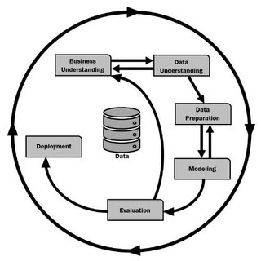

Figure : Overview of CRISP-DM methodology (Cazacu & Titan, 2020)

The CRISP-DM process was the guide for the effective completion of this nutrition recommendation system. With the intricacies of dealing with large-scale nutritional data sets, allergen detection, the use of multiple clustering algorithms (Gaussian Mixture Models, K-Means, MiniBatch K-Means, and Self-Organizing Maps), and the deployment of a working web application, a rigorous and iterative process was crucial. CRISP-DM’s six structured phases: Business Understanding, Data Understanding, Data Preparation, Modeling, Evaluation, and Deployment facilitated the systematic advancement of the project such that goals were achieved with lucidity and strength.

**Phase 1: Business Understanding**

The Business Understanding phase served as the foundation of this project, ensuring that all technical efforts remained closely aligned with practical business needs (Vanegas et al., 2023). Rather than hastily proceeding to data exploration or modeling, significant effort was first dedicated to fully understanding the underlying business problem and defining a clear path forward. The primary objective was to promote healthier dietary habits among users by recommending recipes that are both nutritionally balanced and free from specific allergens. To ensure clarity and actionability, this overarching goal was refined into precise data mining objectives using the SMART framework (Specific, Measurable, Achievable, Relevant, and Time-bound) (Donato_TH, 2023). For instance, the broader ambition of encouraging healthier eating was concretely restated as clustering over 500,000 recipes into distinct nutritional profiles to facilitate personalized dietary recommendations.

Drawing on this basis, a wide-ranging project plan was created that included a detailed timeline, a structured resource plan, a set of measures for managing risks and a set of clearly articulated success criteria (Sidik, 2024; McCormick & Salcedo, 2017). Specific consideration was paid towards the anticipation of challenges like inconsistency of the quality of the data, existence of nutritionally invalid recipes and the intricacies of precise detection of allergens. All the challenges were addressed anticipatively at the planning level for the smooth execution of later stages.

Also, the project was positioned carefully within a wider social context by connecting its goals to Sustainable Development Goal 3 (Good Health and Well-Being) of the United Nations' 2030 Agenda. Recognizing that unhealthy eating and uncontrolled food allergies are significant drivers of non-communicable disease worldwide, the system was created to have a wider reach than individual recommendations. By providing individualized, allergen-conscious meal recommendations, the project both improves user experiences and informs and enables both public health measures and preventive health initiatives as well as supports inclusivity. In this process, the impact of the project extends significantly beyond technical success and contributes to tangible social progress as well as long-term health benefits among diverse populations.

**Phase 2: Data Understanding**

The Data Understanding stage played a pivotal role in discovering, harvesting, and examining the data to determine its appropriateness towards meeting the objectives of the project (Hotz, 2024). The process yielded initial insights about the shape, quality, and relevance of the data required to resolve the business issue (Elkabalawy et al., 2024). It started by involving initial data harvesting and exposure, as well as steps towards revealing quality issues, finding initial patterns, and separating significant subsets for advanced examination (Wirth & Hipp, 2000). Building on the business purposes, this stage was particularly concerned about two principal datasets: RecipeData.csv consisting of more than 500,000 recipes complete with the detailed nutrition facts and AllergenData.csv consisting of 184 food entries and the respective allergens. Initial explorations through the application of the .head(), .info(), and .describe() methods revealed a rich albeit flawed landscape of the data pointing towards missing values across key columns of nutrients, inconsistencies within reported calorie values, and missing allergen labels.

Extensive Exploratory Data Analysis (EDA) was a focal point, making use of descriptive statistics (mean, median, mode, standard deviation) and visualization tools (histograms, scatter plot, box plot, missing value heatmaps using Matplotlib, Seaborn, and Missingno) to summarize and gain a deeper understanding of the data (Takyar, 2023; Biswal, 2024). The analyses revealed key trends: the nutrient variables such as Calories, FatContent, and CarbohydrateContent were extremely skewed and featured extreme outliers prone to distorting clustering results unless handled carefully. Correlation analysis was also conducted to cross-examine the relationships between variables and ensure features later selected would be sensible and non- redundant. Meanwhile, allergic data varied, topped by common allergies such as nut and dairy dominating the dataset while less common allergies such as tannin or salicylate appearing intermittently. Such results were key to defining subsequent strategies and particularly feature engineering and filtering strategies within the personalized diet recommender model. On completing the Data Understanding stage, a complete appreciation of the datasets' strengths and weaknesses had ensued and readiness for the subsequent Data Preparation stage was achieved as a clear, informed way forward was established. Should any significant gaps have arisen, iterative backtracking to the Business Understanding stage would have ensued as a means of remapping goals (Brown, 2016).

**Phase 3: Data Preparation**

The Data Preparation step was the most intensive and rigorous part of this project due to the scale, complexity, and variability of the RecipeData.csv and AllergenData.csv datasets. The task required a systematic, diligent process of transforming raw data into a usable form for effective clustering and personalized diet recommendations. The initial significant step was missing value handling. Non-critical features such as CookTime, RecipeCategory, and Images were imputed using neutral placeholders (e.g., ‘NA’ or ‘None’) to maintain the dataset's integrity without infusing artificial bias. For key features such as allergen information, the policy was stricter: missing allergen rows were completely dropped to maintain the reliability and safety of the allergen-sensitive recommendation model.

Aside from missing values, considerable attention was placed on cleaning nutritional values. Recipes containing logically inconsistent values such as non-zero calorie indications along with zero grams of all the three macronutrients (FatContent, ProteinContent, CarbohydrateContent) were excluded. Recipes that indicated vastly different calories from the values calculated from the macronutrients (calories = FatContent + (ProteinContent + CarbohydrateContent)) were also excluded on the basis of biological plausibility. Recipes were also limited to a plausible caloric range of between 250 and 2000 kcal/serving. These constraints excluded far-out values that might disrupt clustering operations or provide unreasonable recommendations for common consumers.

Feature engineering was a pivotal development within the preparatory process. Rather than applying absolute macronutrient values — which differ as a function of serving sizes — three new features based on proportions were formulated: Carb_%, Protein_%, and Fat_%. These measures represent each of the macronutrients' contribution towards total caloric value, allowing for equal comparisons across recipes of varying sizes and types. Normalization of the nutrition profiles was crucial for meaningfully clustering recipes by diet pattern and not by indiscriminate serving sizes.

Data integration was another central area of attention at this stage. The ingredient lists were parsed and cross-correlated against the AllergenData.csv database via regular expressions, allowing dynamic allergen detection on a per-recipe basis. Through this process, each recipe was tagged dynamically with its related allergens, allowing the recommender system dynamically filter unsafe recommendations based on a user’s allergy profile, a feature crucial towards establishing trust and accessibility within the application.

Prior to the modeling stage, exhaustive scaling procedures were conducted to accommodate the requirements of various clustering methods. Standardization was also done using StandardScaler for the purpose of having zero mean and unit variance for GMM and K-Means when they were tested using standardized features such that distance-based clustering becomes less sensitive to differences in feature magnitude. At the same time, MinMaxScaler normalization was also utilized for scaling features within a [0,1] range, especially for the sake of preparing the data for the use of Self-Organizing Maps (SOM) as well as for experiments involving K-Means and MiniBatch K-Means on the normalized features. The dual scaling did not just enable scaling comparison between the two methods but also improved the clustering outcomes of feature distribution-sensitive algorithms.

Finally, a rigorous anomaly detection process was implemented employing both the Isolation Forest and Local Outlier Factor approaches. The recipes that were identified by both as being outlier were the ones that were dropped from the dataset, carefully pruning the unusual or nutritionally extreme values. Having this two-stage validation enhanced the homogeneity of the dataset without losing its diversity. Due to this strict preparing pipeline, a clean, nutritionally balanced dataset of more than 300,000 recipes was obtained that is free from any kind of anomaly and allergens and ready for modeling.

**Phase 4: Modelling**

The Modeling step was a fundamental turning point within this task, centered on clustering recipes according to their nutritional content to enable very personalized and informative dietary advice. Due to the problem being unsupervised and having no predefined labels, a variety of clustering methods were carefully chosen for the purpose of revealing the inherent nutritional structures within the dataset.

K-Means clustering was performed on standardized and normalized percentage features of macronutrients (Carb_%, Protein_%, Fat_%) to evaluate the impact of varying scaling on the clustering. Standardization enabled the features to contribute equally according to variance while normalization scaled feature values into a range of [0,1] for ensuring equality in distance calculations. In addition to K-Means, MiniBatch K-Means was utilized for effective handling of the big dataset size by updating cluster centroids progressively by using random mini-batches and thus considerably lessened the computation load without any diminution of the quality of the clustering.

To encapsulate more variable and complex interactions between recipes, the Gaussian Mixture Model (GMM) was used, allowing soft probabilistic assignment whereby recipes might have blended nutritional attributes. Also used was the application of Self-Organizing Maps (SOM) on normalized values to map the high-dimensional feature space into a two-dimensional structured grid such that a visual and intuitive appreciation of the distribution of varying nutritional profiles was presented.

Hyperparameter tuning was central during the modeling stage to maximize each algorithm's behavior. Parameters like number of clusters for K-Means and MiniBatch K-Means and covariance types and number of components for GMM, as well as grid size for SOM, were adjusted systematically for optimum clustering structure. Such careful hyperparameter tuning enabled each model to pick up on the actual variation within the dataset and facilitated the overall aim of forming clear, nutritionally significant groups of recipes. The synergy between careful modeling strategies and hyperparameter tuning united the dietary recommendation system on the basis of robust, well-structured clusters ultimately making the system offer very targetted and allergen-sensitive meal recommendations suited to the needs of each individual user.

**Phase 5: Evaluation**

The Evaluation stage comprehensively tested the performance of each clustering model designed during the entire project against the initial business goals. Since the task was unsupervised learning where there were no predefined labels, measures like the internal validation of the Davies-Bouldin Index (DBI), Calinski-Harabasz Score (CH), Inertia, Bayesian Information Criterion (BIC), and Quantization Error (QE) were utilized to quantitatively evaluate the quality of clustering objectively.

During the tuning process, the K-Means model tuned on MinMax normalized datasets with seven clusters recorded the top overall performance. It garnered a minimal DBI value of 0.8362, a superior CH value of 224,119.29, and a minimum inertia of 5,919.56, signifying compact and densely packed as well as well-separated clusters. In comparison, the GMM models were tested using the BIC method for model complexity-adequacy balance; the top GMM model, having seven components and a spherical covariance model, recorded a respectable BIC value of 214,478.85 while its clustering quality was just below that of K-Means. For SOM, the top 3×2 grid setting recorded a low Quantization Error (QE) value of 0.1377, reflecting satisfactory mapping quality, but its overall compactness of clusters as well as cluster separation was marginally weaker than K-Means. MiniBatch K-Means was shown to have satisfactory clustering quality as well, scoring good values of DBI and CH while having a significantly shorter computation time, especially suitable for larger-scale or even real-time applications. Though its cluster compactness was marginally lower than regular K-Means, MiniBatch K-Means was revealed as a good alternative where computational

Lastly, K-Means clustering of MinMax-scaled data for seven clusters was adopted as the ideal model because of its excellent trade-off among cluster compactness and separation, interpretability, and computational feasibility. The experiment verified the stability of the ultimate clustering system as it was able to achieve effective nutritional clustering and provide the foundation for safe, personalized, allergen-conscious recipe proposals ready for release.

**Phase 6: Deployment**

The culmination of the project was achieved in the Deployment phase, where all developed components were integrated into a fully operational, user-friendly Streamlit web application. The finalized K-Means clustering model, trained on MinMax-scaled data, along with the corresponding MinMaxScaler object and the cleaned and enriched recipes dataset, were serialized using joblib and efficiently loaded at runtime. This setup allowed the system to instantly match users to recipes based on their nutritional requirements without the need for retraining or additional computations during application use.

The web application was designed with a clear, intuitive user flow. Upon launching the app, users were invited to enter personal profile details such as age, weight, height, gender, activity level, specific health goals (e.g., weight loss, maintenance, or muscle gain), and any known food allergies. Based on this information, the system dynamically calculated the user's Total Daily Energy Expenditure (TDEE) using the Mifflin-St Jeor Equation and adjusted the caloric intake according to the selected health goal. Personalized macronutrient targets were then derived and used to guide recipe selection.

Once the user profile was established, the system scaled the user’s target macronutrient distribution using the loaded MinMaxScaler and predicted the appropriate cluster using the K-Means model. Recipes within the matched cluster were filtered to meet the user's caloric needs and allergen restrictions. This two-tiered filtering first by macronutrient alignment, then by allergy safety ensured that users received highly relevant and health-conscious recommendations tailored to their personal needs.

The application offered several interactive features to enhance user engagement and decision-making. Macronutrient comparison charts were generated for each recommended recipe, allowing users to visually assess how closely the meal matched their dietary goals. Detailed recipe pages presented essential information such as caloric values, macronutrient breakdowns, ingredient lists, and step-by-step cooking instructions in a clean and easily digestible format. Users could explore individual recipes or, if desired, download a personalized 7-day meal plan that incorporated variations like calorie cycling (zigzag diet) to support more advanced nutritional strategies.

To further enrich the user experience, Google Gemini AI integration was incorporated. After generating a meal plan, the system prompted Gemini AI to deliver personalized health advice, practical meal planning tips, motivational support, and even a categorized grocery list based on the selected recipes. This feature added a human-like, supportive interaction layer to the application, promoting positive behavioral change beyond mere food selection.

In summary, the Deployment phase successfully transformed a complex data clustering and recommendation engine into an accessible, professional-grade application that empowers users to make healthier dietary choices. By combining dynamic nutritional profiling, allergen-safe recipe matching, and AI-powered support, the project fulfilled its goal of promoting better eating habits in a personalized and actionable way, directly contributing to broader public health objectives aligned with Sustainable Development Goal 3 (Good Health and Well-Being).

## **3.3 Summary**

Chapter 3 systematically described the methodology adopted to develop a personalized dietary recommendation system, structured around the CRISP-DM framework. After comparing different data analysis methodologies, including CRISP-DM, KDD, and SEMMA, CRISP-DM was selected due to its strong business focus, iterative flexibility, and ability to guide projects from conception to deployment, ensuring alignment between technical development and real-world objectives.

The project began with a deep Business Understanding phase, clearly defining the goal of promoting healthier eating habits through personalized, allergen-safe recipe recommendations. SMART objectives were established, and a comprehensive project plan was devised, considering potential risks like data inconsistency and allergen complexity. In the Data Understanding phase, two main datasets (RecipeData.csv and AllergenData.csv) were explored, revealing missing values, nutritional inconsistencies, and skewed distributions. Extensive Exploratory Data Analysis (EDA) using visualization and statistical techniques enabled the team to uncover key patterns and prepare strategies for later stages.

The Data Preparation phase involved rigorous cleaning: missing non-critical fields were imputed, critical missing allergen-related entries were dropped, and implausible nutritional records were filtered out. Feature engineering transformed absolute nutrient values into standardized macronutrient percentages (Carb_%, Protein_%, Fat_%), making clustering based on nutritional balance possible. Dual scaling (StandardScaler and MinMaxScaler) was performed to suit different clustering algorithms. A two-stage anomaly detection using Isolation Forest and Local Outlier Factor helped remove outliers, ensuring dataset robustness.

During the Modeling phase, multiple clustering techniques were applied, including K-Means, MiniBatch K-Means, Gaussian Mixture Models (GMM), and Self-Organizing Maps (SOM). Hyperparameter tuning was carried out systematically—adjusting cluster numbers, covariance structures, and SOM grid sizes—to optimize model performance. Internal evaluation metrics like the Davies-Bouldin Index (DBI), Calinski-Harabasz Score (CH), Inertia, Bayesian Information Criterion (BIC), and Quantization Error (QE) were used to assess model quality objectively. K-Means with seven clusters on MinMax scaled data achieved the best results with a low DBI of 0.8362, a high CH score of 224,119.29, and low inertia of 5,919.56. GMM and SOM showed competitive but slightly less optimal performance, while MiniBatch K-Means proved to be a computationally efficient alternative.

The final Deployment phase involved integrating the trained K-Means model, the MinMaxScaler, and the cleaned recipe dataset into a user-friendly Streamlit web application. Users could input personal health profiles (age, weight, activity level, allergies, goals) to receive personalized meal recommendations aligned with their macronutrient needs and allergen restrictions. The system dynamically filtered recipes based on nutritional alignment and safety. Features like macronutrient charts, detailed recipe displays, and 7-day meal plan downloads enhanced the application. Integration with Google Gemini AI provided users with motivational health advice and personalized grocery lists, enriching the overall user experience.

Ultimately, Chapter 3 demonstrated that through a methodical, iterative, and user-centered approach, the project successfully translated complex data analysis into a practical system promoting healthier dietary behaviors, directly supporting the objectives set out in the Business Understanding phase and contributing to public health initiatives aligned with SDG 3 (Good Health and Well-Being).

# **CHAPTER 4: DESIGN AND IMPLEMENTATION**

## **4.1 Introduction**

Chapter 4 covers the full data acquisition, understanding, and preparation process critical for building the personalized dietary recommendation system. It begins by describing the selection of two complementary datasets: RecipeData.csv and AllergenData.csv, which sourced from Kaggle. It then outlines a thorough exploratory data analysis (EDA) to evaluate the datasets' structure, content, and quality, including duplication, missing values, inconsistencies, and distribution analysis. Following this, the chapter details rigorous preprocessing steps such as missing value handling, outlier removal, feature engineering, allergen detection integration, normalization, and anomaly detection to ensure high-quality, machine-learning-ready data. Finally, it presents the construction of multiple clustering models (GMM, K-Means, MiniBatch K-Means, and SOM), alongside hyperparameter tuning strategies to optimize their performance for clustering recipes based on macronutrient profiles.

## **4.2 Data Collection**

|  |  |  |  |
| --- | --- | --- | --- |
| **Dataset Name** | **Description** | **Source** | **Dataset Link** |
| RecipeData.csv | Dataset from Food.com and contains over 500,000 recipes with comprehensive details. | Kaggle | <https://www.kaggle.com/datasets/irkaal/foodcom-recipes-and-reviews/data> |
| AllergenData.csv | A comprehensive dataset of food items and their corresponding allergies. | Kaggle | <https://www.kaggle.com/datasets/boltcutters/food-allergens-and-allergies> |

Table 3: Selected Datasets for This Project

Recipes.csv and allergens.csv were selected due to their complementary strengths in building a comprehensive dietary recommendation system. Recipes.csv offers a very large collection of over 500,000 recipes with nutritional information, while allergens.csv provides crucial allergen information, allowing the system to easily accommodate diet-restricted individuals. Taken together, these datasets will enable a personalized system that not only ensures safety and inclusivity but also delivers practical and nutritionally meal recommendations, aligning with SDG 3 on improved dietary habits and healthy living.

## **4.3 Data Understanding**

### **4.3.1 Variables**

recipes.csv:

|  |  |
| --- | --- |
| **Variable** | **Description** |
| RecipeId | Unique identifier for the recipe |
| Name | Name of the recipe |
| AuthorId | Unique identifier for the recipe's author |
| AuthorName | Name of the recipe's author |
| CookTime | Time taken to cook the recipe |
| PrepTime | Time taken to prepare the recipe |
| TotalTime | Total time required to prepare and cook the recipe |
| DatePublished | Date when the recipe was published |
| Description | Textual description of the recipe |
| Images | URLs or paths to images associated with the recipe |
| RecipeCategory | Category under which the recipe is classified |
| Keywords | Relevant keywords associated with the recipe |
| RecipeIngredientQuantities | Quantities of the ingredients required |
| RecipeIngredientParts | Names or parts of ingredients required |
| AggregatedRating | Average rating score given by users |
| ReviewCount | Number of reviews the recipe has received |
| Calories | Caloric value per serving |
| FatContent | Total fat content per serving |
| SaturatedFatContent | Saturated fat content per serving |
| CholesterolContent | Cholesterol content per serving |
| SodiumContent | Sodium content per serving |
| CarbohydrateContent | Total carbohydrates per serving |
| FiberContent | Dietary fiber content per serving |
| SugarContent | Sugar content per serving |
| ProteinContent | Protein content per serving |
| RecipeServings | Number of servings the recipe yields |
| RecipeYield | The yield amount of the recipe |
| RecipeInstructions | Step-by-step instructions to prepare the recipe |

Table : Description of recipe dataset

allergens.csv:

|  |  |
| --- | --- |
| **Variable** | **Description** |
| Class | Broad classification of the food |
| Type | Specific type or form of the food item |
| Group | Nutritional or allergen-related grouping of food |
| Food | Name of the food item |
| Allergy | Type of allergy or allergen associated with the food |

Table : Description of allergens dataset

### **4.3.2 Import Libraries**

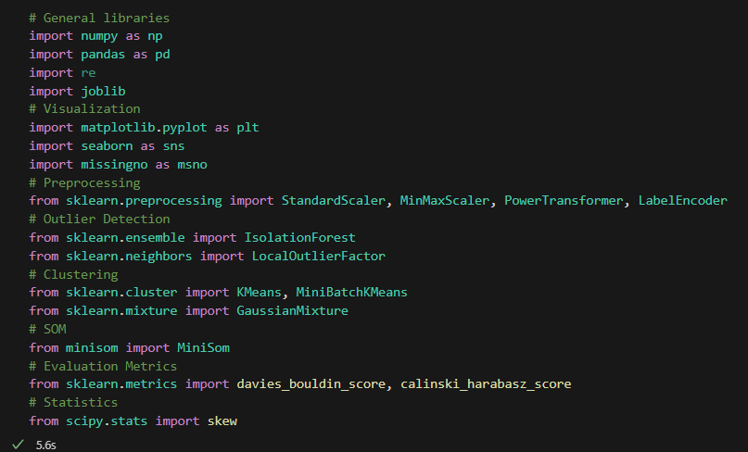

Figure : Import necessary libraries

In preparation for data analysis, a comprehensive set of necessary libraries was imported. NumPy and Pandas enable numerical operations and data manipulation, whereas Matplotlib, Seaborn, and Missingno are employed to visualize data and detect missing values. Preprocessing tools of Scikit-learn, including StandardScaler, MinMaxScaler, PowerTransformer, and LabelEncoder, were added to perform data normalization and encoding to make the datasets machine learning-ready. In addition, the skew function of SciPy was utilized to evaluate data distribution symmetry, and is essential to identify whether data transformation is necessary.

Robust algorithms like LocalOutlierFactor and IsolationForest were used to identify anomalies in the data. Flexibility in clustering operations is made available by algorithms like MiniBatchKMeans, KMeans, and GaussianMixture, enabling the grouping of recipes by nutritional or ingredient similarity. As the second main modeling technique, Self-Organizing Maps (SOM) were applied with MiniSom, an effective unsupervised learning technique that can project high-dimensional nutritional data to lower dimensional representations with hidden patterns and dietary structures. As a finishing touch, evaluation measures like the Calinski-Harabasz Score and the Davies-Bouldin Index were incorporated to measure the cohesiveness and separation between the created clusters to validate the effectiveness of the clustering models.

### **4.3.3 Load and Preview Data**



Figure : Load dataset from local file path

After the analysis platform was established, two main datasets were imported with the help of read_csv(). Both datasets are fundamental in allowing the system to provide safe and inclusive food suggestions based on personal dietary limitations.

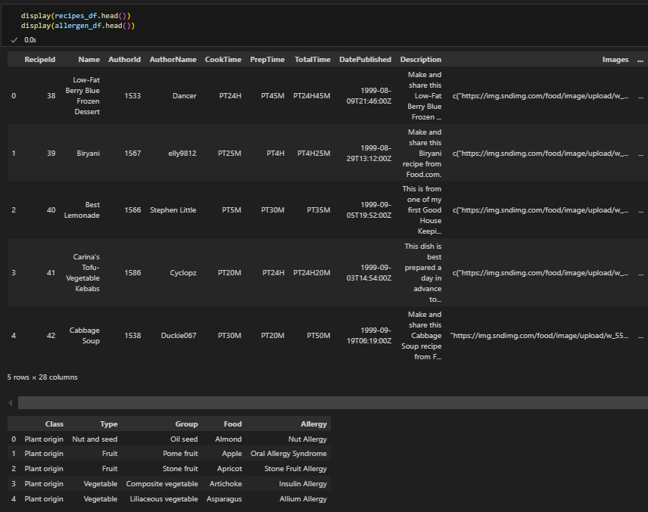

Figure : Code and output of preview data

In order to guarantee correct format and data reliability, the initial rows of every dataset were checked using the .head() function. This initial test confirmed that both data sets were properly loaded, properly formatted, and include the variables needed for subsequent processes. With this test done, the data are now prepared to undergo cleaning, transformation, and modelling in the personalized diet recommender system.

### **4.3.4 Exploratory Data Analysis (EDA)**

#### 4.3.4.1 Duplication Rows Checking

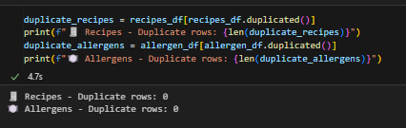

Figure : Code and output of duplication checking

For maintaining data integrity and quality, both the recipes_df and allergen_df datasets were checked for duplicates with the duplicated() function. This will detect exact duplicates of prior entries. The output, displayed with formatted strings, indicated there were no duplicates in either dataset. This step is important since duplicates will bias analysis, mislead the training of models, and result in incorrect recommendations.

#### 4.3.4.2 Inspect Structure and Types

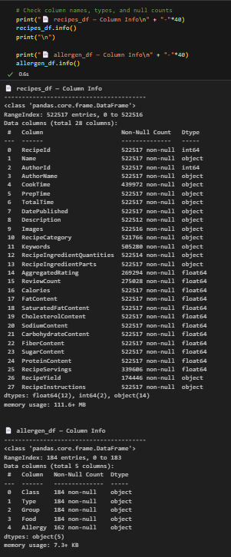

Figure : Code and output of inspecting structure and types

In order to have a general overview of the data structure of the datasets, the .info() function was applied to both recipes_df and allergen_df. This function gives basic metadata such as column labels, non-null values, and data type. The recipes_df consists of 28 columns and 522,517 rows with a diverse mix of object, float64, and int64 data. Whereas a majority of columns are appropriately filled, some like ReviewCount, AggregatedRating, RecipeServings, and RecipeYield have missing values to be taken care of in preprocessing. In contrast, the allergen_df is less populated with only 184 entries and five columns: Class, Type, Group, Food, and Allergy. Even though the majority of fields are full, the field named Allergy has 22 missing values. This can lead to lower sensitivity in detecting possible allergens since the lack of full information can cause the system not to recognize all allergenic food types completely.

#### 4.3.4.3 Summary of Statistics

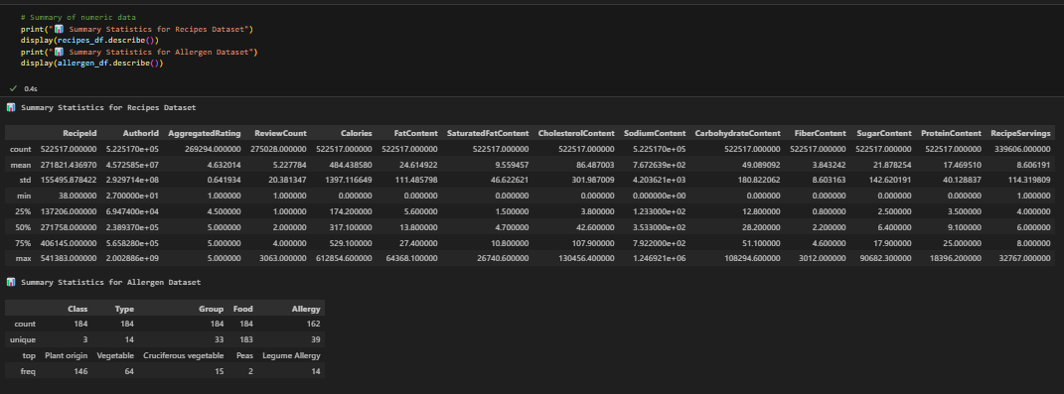

Figure : Code and output of numeric data summary

To understand the numerical and categorical nature of the data better, the .describe() function was applied to both data sets. For the recipes_df, this produced descriptive measures of all numerical columns, such as central tendencies (mean and median) and dispersion (standard deviation) and range (min-max). Important variables related to nutrition like Calories, FatContent, SodiumContent, CarbohydrateContent, and ProteinContent have high variances, reflecting wide nutritional heterogeneity across the recipes. For example, calorie measures vary between 0 and more than 600,000, and this probably involves some outliers or errors that will have to be rectified at preprocessing. Likewise, both the Upper bounds of the SodiumContent and SugarContent are extremely large, and this necessitates scaling by normalization or outlier removal to get better-performing models.

In the allergen_df, due to the majority of columns that are categorical, the summary consists of count, number of distinct values, top category by frequency (top), and its frequency (freq). For instance, "Plant origin" is the topmost food class (146 entries) and "Vegetable" is the topmost food type. The column Allergy with 162 non-null values over 184 consists of 39 distinct allergy types, with “Legume Allergy” having the highest occurrence. This analysis emphasizes the presence of some allergen types and food classes, and this will be essential in designing an accommodative recommend system that excludes common allergens.

#### 4.3.4.4 Unique Value Checking

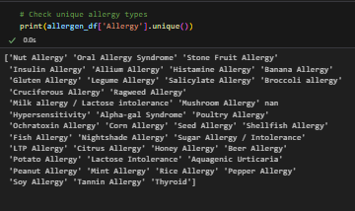

Figure : Code and output of checking unique value

The .unique() function was used on the Allergy column of the allergen_df dataset to determine the different types of allergies that have been recorded. The result indicated a wide array of allergy types spanning from general ones like Nut Allergy, Gluten Allergy, and Lactose Intolerance to special conditions like Alpha-gal Syndrome, Tannin Allergy, and Salicylate Allergy. A missing value (nan) was also found, and this could restrict the capability of the system to identify certain allergens and should be handled at preprocessing. This insight informs the breadth of allergens that need coverage to make the dietary recommendation system inclusive and responsive to a full spectrum of dietary prohibitions.

#### 4.3.4.5 Missing Value Checking

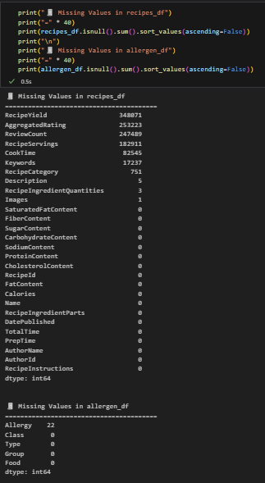

Figure : Code and output for missing values checking

Missing values were checked in both data sets via .isnull().sum().sort_values(ascending=False) to test data completeness. In the recipes_df, a lot of columns have considerable gaps with the highest missing values in RecipeYield at 348,071, followed by AggregatedRating, ReviewCount`, and RecipeServings with more than 180,000 missing values each. Other columns like CookTime, Keywords, and RecipeCategory also have significant incompleteness. But fundamental nutritional fields like Calories, FatContent, and CarbohydrateContent, and essential metadata like Name, RecipeIngredientParts, and RecipeInstructions are completely filled in, a positive indication of the stability of the dataset. In the allergen_df, only the column with missing values is `Allergy` with 22 blank entries out of 184 records. Such gaps underscore the necessity of preprocessing where missing data in essential columns should be cared for by imputing missing values or by discarding incomplete entries to ensure the completeness and reliability of the dietary suggestion system.

#### 4.3.4.6 Relationship between Missing Values

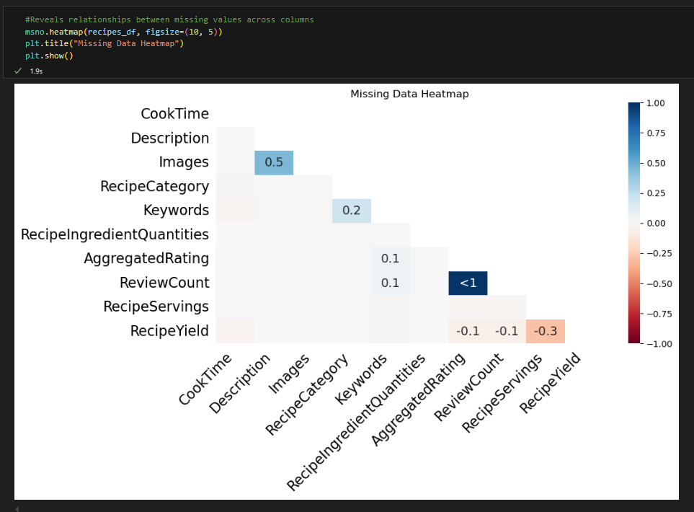

Figure : Code and Output of visualising missing values relationship

The above missing data heatmap generated using Missingno’s functions, provides a transparent visualization of how missing values are distributed and intercorrelated by column in the recipes_df dataset. This reveals hidden data collection patterns or structural dependencies by disclosing that some fields have a tendency to be missing simultaneously. Perhaps most striking is nearly perfect correlation for missing values in AggregatedRating and ReviewCount, suggesting these fields are almost invariably missing or have values simultaneously. This is not surprising since recipes with zero user review counts are less likely to have an aggregated rating as well, either standard in new submissions or among less popular ones.

Most missing values in other columns seem to be more random, with a few weaker or moderate correlations evident. For instance, a moderate correlation (0.5) is evident between Images and Description, indicating that similarly missing textual descriptions also have missing image data, perhaps as a result of incomplete uploads or less extensive recipe submissions. A weaker correlation (0.2) is evident also between Keywords and RecipeCategory, and this implies that less documented or simpler recipes have both missing structured categorization as well as descriptive tags. A few low-level correlations include ones such as between Keywords and ReviewCount as well as AggregatedRating at about 0.1, and also a low negative correlation between RecipeYield and RecipeServings (-0.3) and with review fields at -0.1. These correlations, though mild, also provide further context as to what is missing in the dataset.

While most missing columns like Description and Images are not explicitly utilized by the clustering model and do not directly impact the accuracy or fairness of clustering results, they are still potentially useful in future applications such as content-based filtering or recipe presentation attributes. While their omission does not have an effect on the modeling process at this point, it is still worth noting these missing values for future development. Happily, key modeling features such as FatContent, CarbohydrateContent, and ProteinContent are largely filled out, and thus the group formation process is solid. However, finding and charting these modes of missing values is an important preprocessing step to ensure data quality and avoid inconsistencies in any eventual uses.

#### 4.3.4.7 Data Consistency Checking

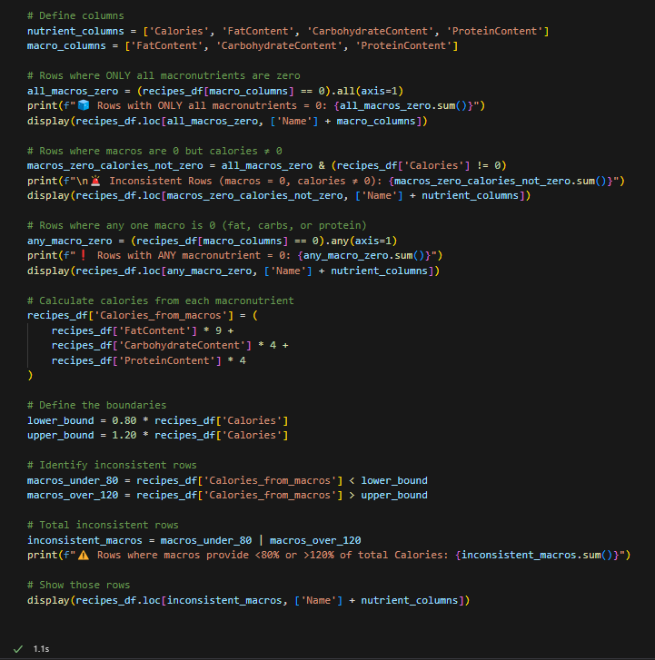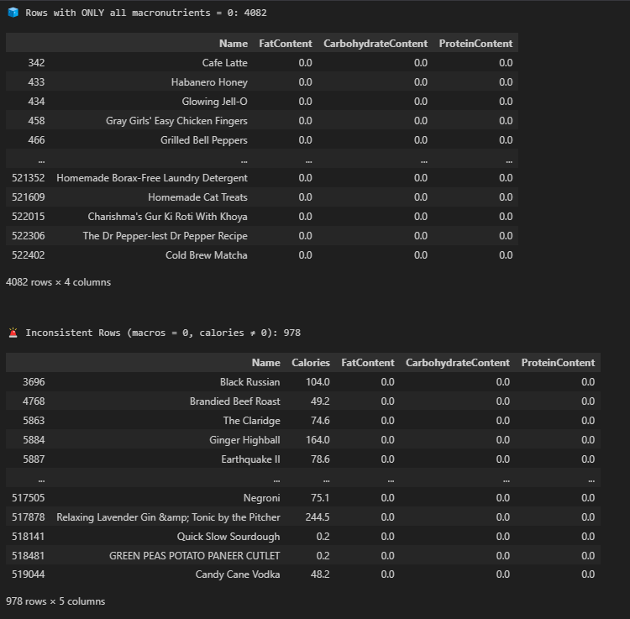

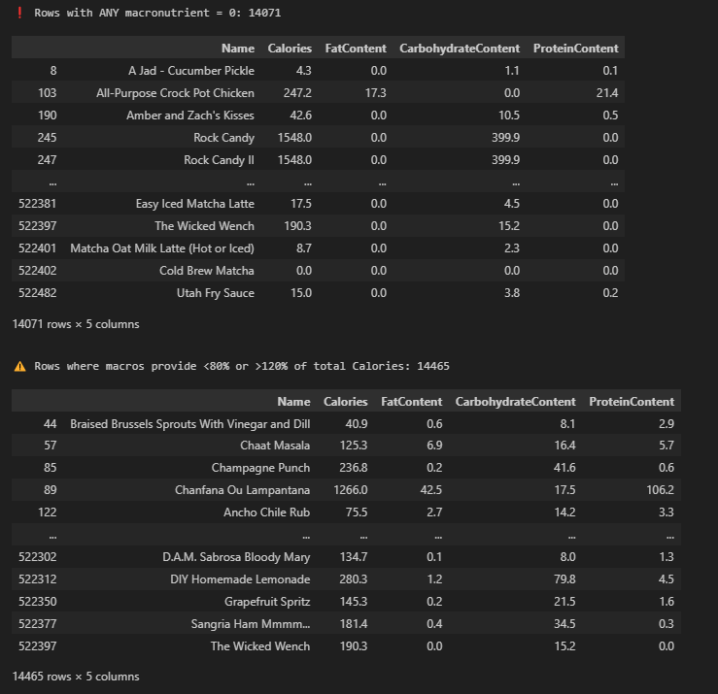

Figure : Code and output of checking data inconsistencies

In order to evaluate the validity of nutritional data, rows were checked for completeness in all calories and the three primary macronutrients: FatContent, CarbohydrateContent, and ProteinContent. This wide-ranging filtering and validation process is essential before clustering, as erroneous or biologically improbable entries would skew learned groupings and diminish dietary recommendation model efficacy. A total of 4,082 rows were detected with all three macronutrient values as zero. These entries like "Homemade Borax-Free Laundry Detergent" and "Cold Brew Matcha" most likely represent non-food items or mis-recorded recipes and are inappropriate for dietary modeling.

There were also an additional 978 rows with non-zero calorie values with all three macronutrients listed at zero. This is logically inconsistent because calories come from these macronutrients, and reports of energy with zero measurable macronutrient content compromise these entries' credibility. Such is the case with recipes like "Black Russian" and "Ginger Highball" and can likely indicate data entry mistakes or incomplete labeling.

Further, there were 14,071 rows where one or more macronutrients were zero while others existed. Such cases are not in themselves defective because there may indeed exist such dishes with zero macronutrients, e.g., fat-free or low-carb foods. Nevertheless, they still need to be scrutinized with care for context correctness.

For further consistency checks, macronutrient-derived calories were calculated based on established energy conversion factors for macronutrients (fat: 9 kcal/g, protein and carbohydrates: 4 kcal/g). The calculated values were compared with the reported Calories field to identify inconsistencies. Recipes were marked as inconsistent when calculated macronutrient-derived calories were less than 80% or more than 120% of reported total. This boundary accounts for slight rounding or reporting discrepancies while still capturing major differences. Consequently, 14,465 rows fell outside these ranges, suggesting discrepancies between listed calories and macro-derived energy—presumably because macronutrients have been left out, there has been rounding variation, or non-caloric contributors such as alcohol or fiber have been included.

#### 4.3.4.8 Distribution of Key Variables

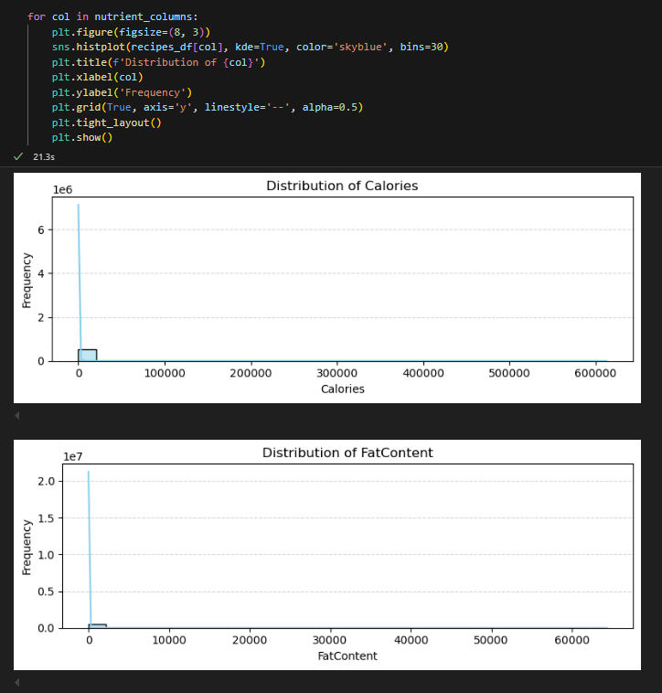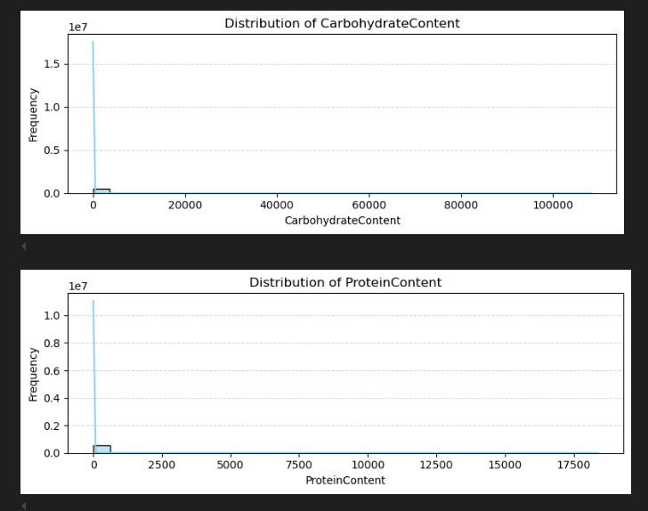

Figure : Code and output of key variables distribution

Distribution plots were created to evaluate spread and shape of the leading nutritional variables within the recipes_df. Applying Seaborn’s histplot() with KDE (Kernel Density Estimate) active, we can see all four nutrient variables are highly right skewed. Most data points are bunched together at lower levels, with fewer extreme values spreading way out to the higher levels. For instance, the majority of calorie values are bunched below 1,000, but some extreme values push well above 600,000. The same patterns occur with macronutrients, where highly unlikely values like more than 10,000 grams of Fat, Carbohydrates, or Protein are seen. Such anomalies point to data entry errors or mislabeling and, if not cleaned, will degrade the performance of the model. Therefore, more preprocessing to normalize distributions and deal with extreme outlier values is needed so that the data are clean and trustworthy to be passed to downstream clustering and recommendation operations.

#### 4.3.4.9 Distribution of Allergy

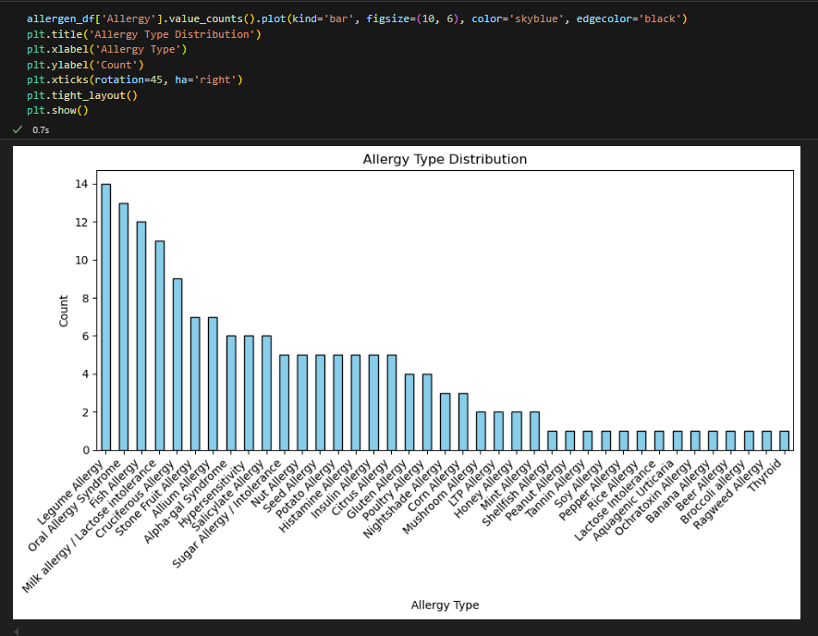

Figure : Code and output of allergy distribution

The above bar chart indicates the occurrence of each distinct allergy, reflecting the most and least common allergen entries. In the 39 different allergy types noted, the most common ones that occur more than 10 times include Nut Allergy, Oral Allergy Syndrome, Stone Fruit Allergy, and Fish Allergy. Such concentration signifies that the allergens are more distributed in the dataset and can necessitate more focus when producing allergen-sensitive meal suggestions. In contrast, a number of others like Ragweed Allergy, Broccoli Allergy, and Thyroid occur just once, meaning that they are less common. This visual makes it easier to tell which allergens are more influential in dietary personalization and supports the necessity of precise allergen labeling in meal suggestions.

#### 4.3.4.10 Noisy Data Checking



The above code snippet examines how many of the recipes in the dataset recipes_df are within a reasonable and nutritionally appropriate calorie range. This is done by applying a filtering condition that only returns the rows where the 'Calories' column is above 250 and below 2000. The count of such rows that fulfill both conditions is then returned by the use of the .sum() function. The returned value of 304,964 shows that a considerable percentage of the dataset includes recipes within this moderate calorie range. This subset is especially valuable to health-oriented applications, since this is meals that are not too little to be of nutritional value or too much in energy to be unrealistic, and therefore in the majority of dietary suggestion contexts.

#### 4.3.4.11 Correlation Analysis on Nutrient Columns

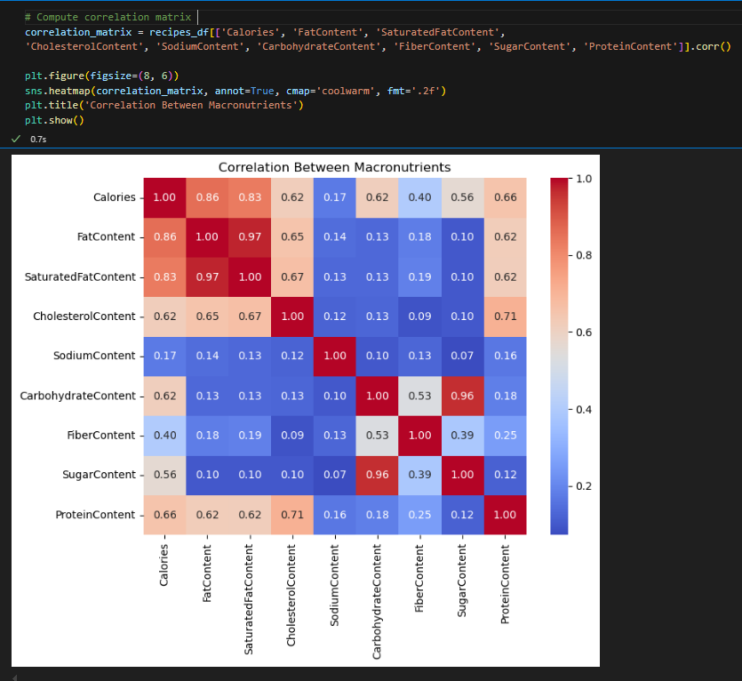

Figure : Code and output of nutrient correlation heatmap

The correlation heatmap gives a transparent overview of how macronutrients relate to one another, as well as to total calorie values, and an important context for choosing suitable features to model. Knowledge of these interrelations ensures that features chosen for clustering provide independent and orthogonal nutritional insights. Of all variables, most correlation is shown by FatContent with Calories (0.86), supporting fat's established position as most energetic macronutrient. This is further underlined by its almost perfect correlation with SaturatedFatContent (0.97), as saturated fat is primarily part of total fat. Although CholesterolContent has moderate correlations with fat and calories, it is not included in feature choice because it does not directly contribute to energy, and as such has little value in caloric-based clustering.

ProteinContent exhibits moderate correlation with Calories (0.66), validating its significant albeit secondary function as a contributor to energy compared to fat. The structural and metabolic roles of protein warrant its inclusion as a prime characteristic in distinguishing dietary patterns. Conversely, SodiumContent, while nutritionally interesting in health outcomes such as hypertension, is not very correlated with caloric variables and is not a contributor to energy. Its variation by recipe may indicate levels at which it is processed or seasoned, but in terms of calories and clustering, it is not a factor and is thus eliminated.

CarbohydrateContent is also highly significant, supported strongly by its high correlation with SugarContent (0.96), suggesting that sugars are a very significant fraction of total carbohydrates in most recipes. Given that carbohydrates supply 4 kcal/g and have considerable variation from recipe to recipe, they are an important aspect to model energy distribution. Conversely, FiberContent, although chemically a carbohydrate, has a different role than other types of carbohydrate. It has only a weak relationship with Calories (0.4) and an imperfect correlation with CarbohydrateContent, mainly because it is poorly digestible and has a low caloric contribution of only 1.5 to 2.5 kcal/g, as opposed to 4 kcal/g for digestible carbs such as sugars and starches. Fiber is generally added to total carbohydrate values in nutrition databases, but because it has less energy, the addition will introduce inconsistencies. High-fiber-containing recipes will have an apparent higher energy value than they actually contain when calories are calculated based on standard macronutrient conversion factors. Given that lower energy contribution by fiber and its erratic availability can cause such inconsistencies, it is left out in modeling.

## **4.4 Data Preprocessing**

### 4.4.1 Feature Selection

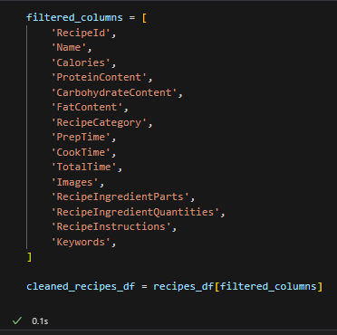

Figure : Code of filtering unnecessary column

During beginning of the data preparation, a filtered subset of columns from the original datasetrecipes_df was utilized to create a cleaner and narrower version, saved as cleaned_recipes_df. This was accomplished by having a defined filtered_columns list that contains key variables determined from the previous data understanding phase. These columns include key nutritional characteristics like ProteinContent, CarbohydrateContent, and FatContent, previously noted as major contributors toward caloric value and then selected as modeling variables for use with clustering. Fields pertaining to time such as PrepTime, CookTime, and TotalTime are also included, as these can provide useful context toward user-focused enrichment for recommendation. Instructional and subject-based features like RecipeInstructions, Images, and RecipeIngredientParts are also kept for consideration due to potential use in recipe description enrichment. By including only these useful columns, the dataset is prepared for efficient preprocessing and analysis.

### 4.4.2 Handling Missing Values

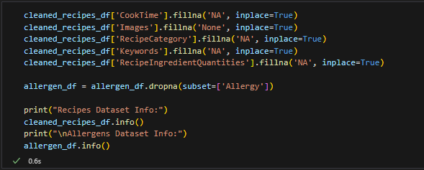

Figure : Code of handling missing values

This pre-processing step addresses missing values in both cleaned_recipes_df and allergen_df datasets, following the previous data comprehension and missing value evaluation. For the recipes dataset, certain non-mandatory columns with missing values like CookTime, RecipeCategory, and Keywords are filled with 'NA', and Images, potentially absent by design for some entries, is filled with 'None'. This leaves no null values in these columns, which would otherwise interfere with the display of recipes. By contrast, the allergen_df sees a more conservative method: rows with missing values in column Allergy are dropped as a whole with dropna(). Since Allergy is a critical column for dietary filtering as well as for allergen-sensitive modeling, only maintaining complete records serves to avoid misclassification or inadvisable recommendations.

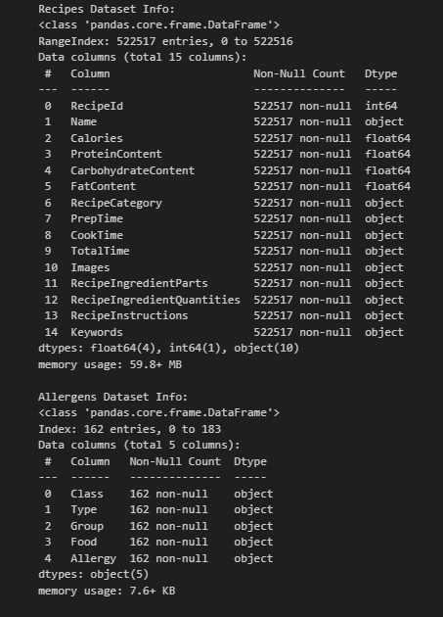

Figure : Output of checking missing values

Based on the output, it is evident that missing value handling was successful with both dataframes. In cleaned_recipes_df, all 522,517 records now have complete values on all 15 columns chosen. Incomplete fields such as CookTime, Images, RecipeCategory, Keywords, and RecipeIngredientQuantities have placeholder values in them now. The same is true for allergen_df as it now contains 162 records with no missing values in its five columns, including incomplete Allergy field previously. This suggests that dropna() successfully removed rows without allergy information. Ensuring complete and cohesive datasets here is in line with goals recognized during data understanding as it also enhances overall data quality for modeling and developing recommendations.

### 4.4.3 Outliers Removal

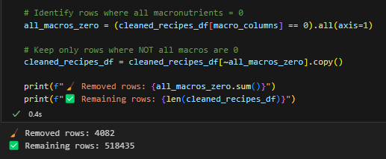

Figure : Code and output of removing noisy data

The above code snippet is centered on data quality with a view to eliminating recipes with no macronutrient values across the key macronutrients. In particular, it eliminates rows in the cleaned_recipes_df data with all three major macronutrients equated to zero. Such rows (4,082 in total) are by nature invalid or uninformative for clustering and nutritional analysis, as they do not reflect real, edible food items. By filtering such non-nutritive entries from the dataset, it is left with 518,435 rows that are valid and informative. This is an important step in ensuring correctness for downstream modeling such that it is built on data points with real macronutrient value.

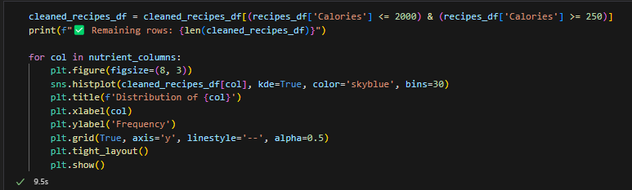

Figure : Code of filtering 250-2000 kcal recipes

The above snippet filters out the dataset to make it statistically reliable as well as plot-wise intelligible before passing it on to modeling, particularly for those cluster algorithms that may prove sensitive to outliers and shape in distributions. The dataset cleaned_recipes_df is first filtered to include only rows where Calories range between 250 and 2000. The range excludes outliers such as meals with very low or very high calorie counts that may skew distribution plots or confuse cluster models. The filtering is also nutritional-based because mostnormal meals will fall in this range, leaving behind more representative dietary items. Following this, there is a distribution analysis done with Seaborn’s histplot() method with KDE enabled. This visualizes the distribution shape in every column with a macronutrient. By iterating over nutrient_columns, a histogram and a smoothed density plot are drawn for every variable with standardized styling. From the visualization, it is possible to evaluate if the variables are skewed, normally distributed or need transformations for modeling.

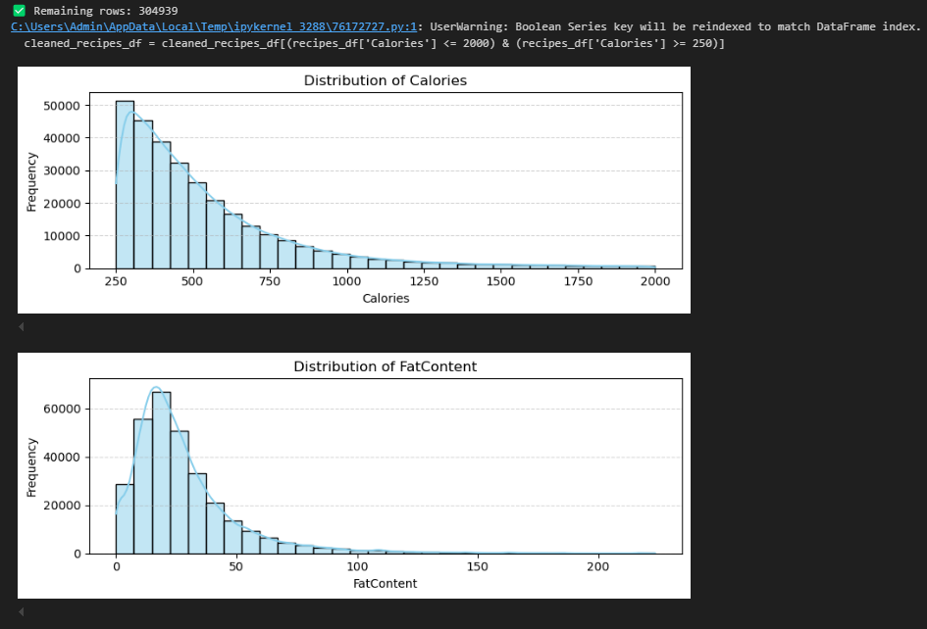

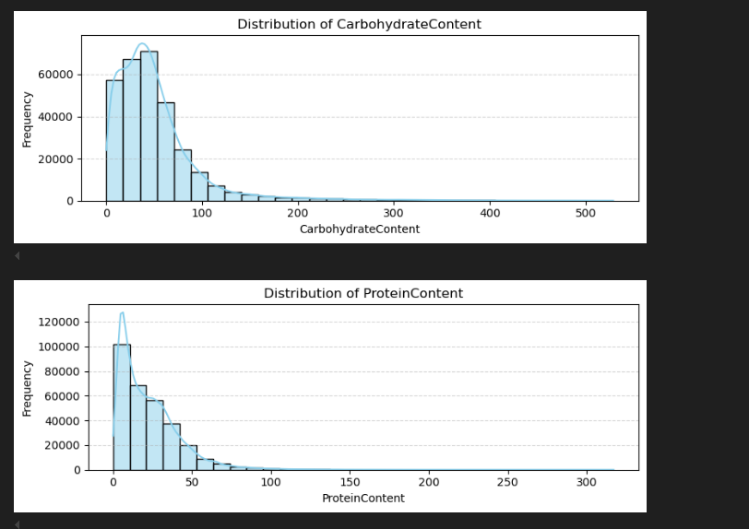

Figure : Output of checking distribution of nutrient after removing outliers

A total of 304,939 rows remains after filtering the dataset to include only recipes with calorie values between 250 and 2000. As seen from the histograms, there still remains significant right-skew in all four variables even when outliers were removed. Calories have most frequent values in lower-mid range (300–500 kcal), corresponding to typical single-serve meals or snacks. There are spikes in FatContent and CarbohydrateContent with long tails stretching towards higher values, indicative of certain dishes having much higher fat or carb contents, albeit these occurrences are relatively sparse. ProteinContent is packed most densely at lower values with very few having more than 100g, again confirming most meals to have low proteins. These visual cues affirm filtering out by calories is an efficient step and also reveal that extra preprocessing such as normalization or transformation will also be needed, notably in preparation for cluster techniques assuming more symmetrical distributions or similarly scaled features.

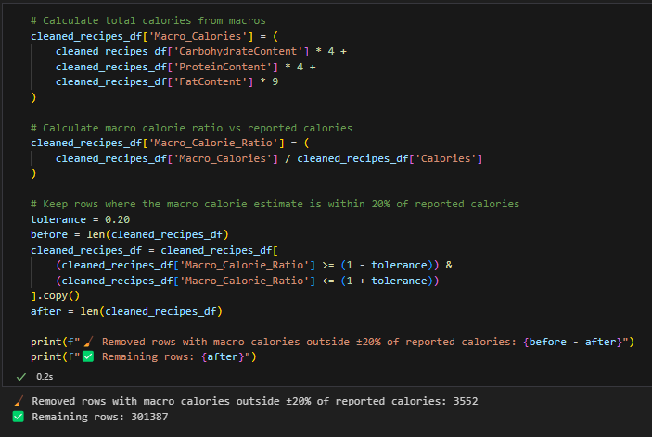

Figure : Code and output of removing data inconsistencies

This code snippet carries out an important validating step by checking that reported calorie counts in every recipe are reasonable compared to calculated calories from its macronutrients. A new column Macro_Calories is first created with the use of a standard energy conversion factor: 4 kcal/g for carbohydrate and proteins, and 9 kcal/g for fat. The ratio of these calculated calories to reported Calories is then calculated in a new column named Macro_Calorie_Ratio. Data reliability is enforced by only keeping recipes when this ratio lies within a ±20% boundary from the reported value to account for differences due to rounding or other low-energy-contributing ingredients like fiber. Larger discrepancies (3,552 rows) are not kept because they indicate inconsistent data. The final filtered dataset contains 301,387 rows, enhancing downstream modeling data quality by confirming macronutrient data is realistically comparable with total energy content.

### 4.4.4 Feature Engineering

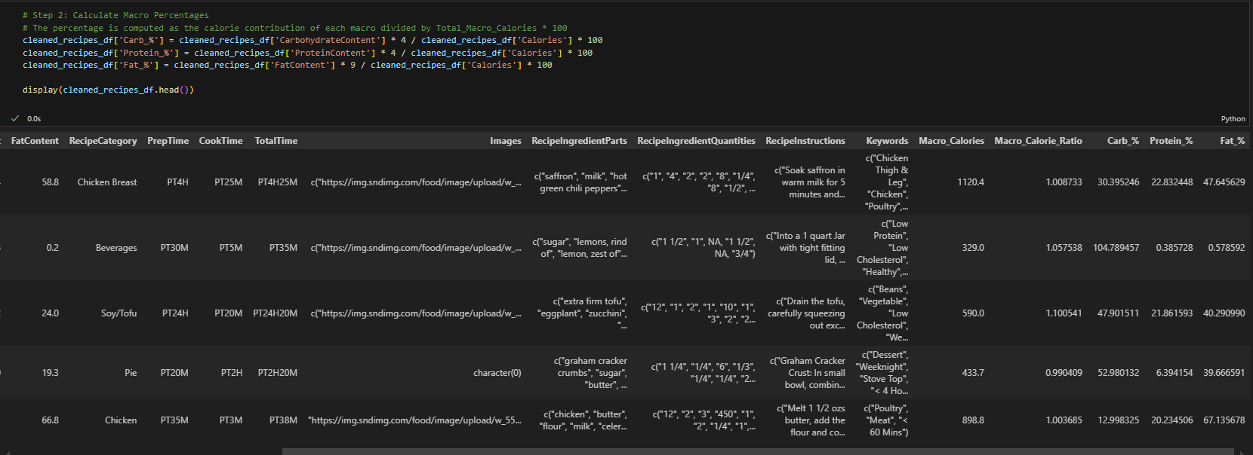

Figure : Code and output of calculating macronutrient percentage contributions

This step estimates the percentage breakdown by total calories that every macronutrient supplies in each recipe based on standard energy conversion rates. The Carb_%, Protein_%, and Fat_% columns then represent the distribution by macros in terms of energy compared to total calorie count by recipe. These normalized, percentage-based attributes provide an unambiguous, dimensionless representation for a recipe's nutritional landscape, facilitating recipe comparison on an even platform. This is especially useful for clustering, as it converts analysis from absolute levels of nutrients that may fluctuate significantly on the basis of portion size or meal type to relative ratios that better represent dietary features. For example, two meals with unequal calories but identical macro distributions will now become more similar in feature space, assisting the clustering algorithm in grouping nutritionally equivalent recipes. This renders resulting groups more interpretable and significant, particularly when one wants to discern patterns such as high-protein meals, low carbs, or balanced meals.

### 4.4.5 Data Integration

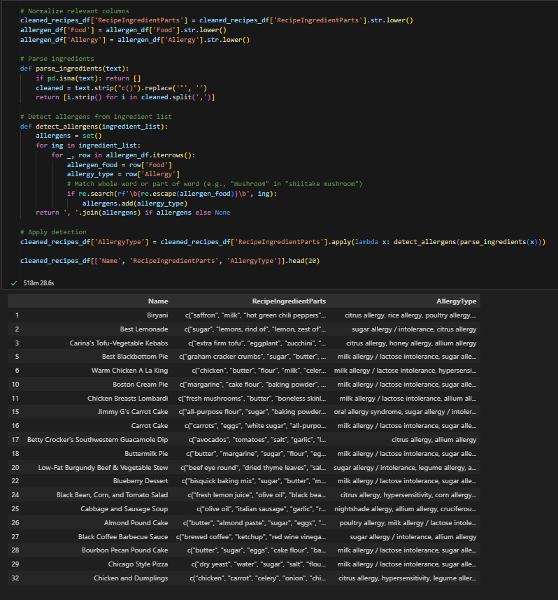

Figure : Code and output of integrating allergen information

This process includes the usage of an automated allergen detection system, in which recipes are tagged according to ingredients that might cause food allergies. The code begins by normalizing ingredient and allergen data by lowercasing the RecipeIngredientParts column in cleaned_recipes_df as well as the Food and Allergy columns in allergen_df to achieve case-insensitivity when matching. A function parse_ingredients() is created in order to clean and separate the ingredients into individual items. Another function detect_allergens() loops over each list of recipes and checks each piece of the ingredient list against known allergens in allergen_df. Using regular expression, it then searches for exact and partial matches and adds any identified allergens to a set to exclude duplicates. If allergens exist, they are joined and placed as a string in a new column titled AllergyType.

The last DataFrame preview indicates a total of 20 recipes along with the ingredient parts and the respective detected allergy types. For instance, the Best Blackbottom Pie recipe is marked with "milk allergy / lactose intolerance, sugar allergy / intolerance" owing to the presence of ingredients such as "milk" and "sugar". This automated matching comes in handy when developing personalized diet suggestion systems, especially for users who have food allergies or sensitivities. By detecting possible allergens in recipes, the system will be able to filter or mark hazardous choices, hence improving the inclusiveness and safety of meal suggestions.

### **4.4.6 Data Transformation and Standardization**

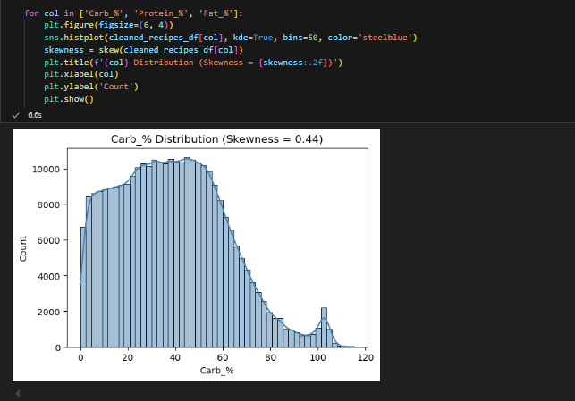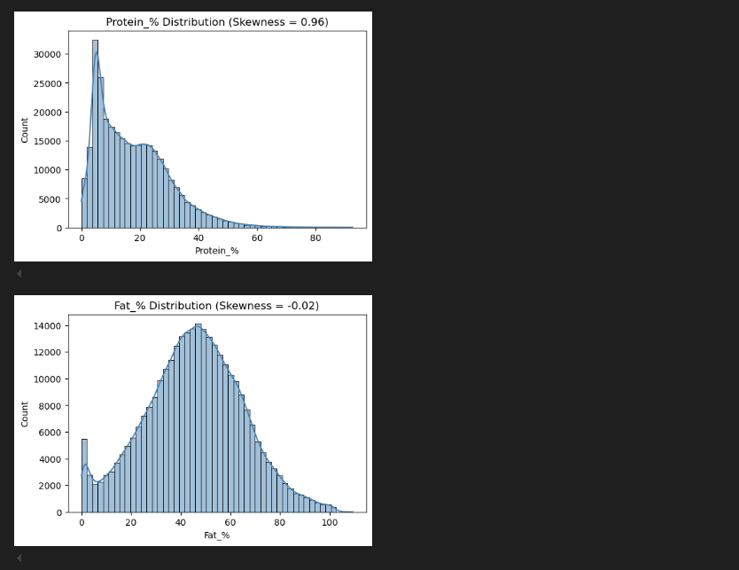

Figure : Output and code of checking distributions of macronutrients after a few data preprocessing steps

The above histograms plot the distribution of the carbohydrate (Carb_%), protein (Protein_%), and fat (Fat_%) contribution to total calories for each recipe after the necessary data preprocessing has been done. The graphs, produced with the use of Seaborn’s `histplot()` procedure with the KDE parameter enabled, provide a sense of the spread and the shape of each macronutrient feature, a key consideration prior to the use of clustering methods. Skewness measures are also calculated and exhibited to assist in deciding whether transformation will be necessary in order to minimize asymmetry and normalize the data.

The Carb_% has a positive skew with a skewness of 0.44. This indicates that most recipes in the dataset plot in a general carbohydrate contribution range but there exist some recipes with very high percentages of carbohydrates, building a long tail to the right. Although there isn't an extreme skew, it could benefit from a mild transformation like a log or power transformation to enhance symmetry, particularly for outlier-sensitive models based on distances.

The Protein_% feature exhibits stronger right skew (skewness = 0.96), meaning most of the recipes have comparatively lower protein percentages with some recipes yielding a disproportionately high contribution of calories from protein. This makes Protein_% a likely candidate to undergo transformation in order to minimize skewness and allow the feature to contribute in a more equitable manner to the clustering process.

Conversely, Fat_% comes very close to being symmetrical with a skew of -0.02, indicating its distribution is not in need of transformation. Its existing format is ready to be used for modeling and will not likely distort the results of clustering due to the equality of its spread.

All three characteristics remain to be standardized despite the disparity in skewness to make them all scale equally before clustering. Standardization is the key preprocessing, especially for such algorithms as K-Means and Gaussian Mixture Models, that depend on the distances and may be strongly impacted by scaling of the features. Conversion of Carb_% and Protein_% reduces the skewness, and standardization of all characteristics brings them to a common scale, hence supporting more accurate and interpretable results of the clusters.

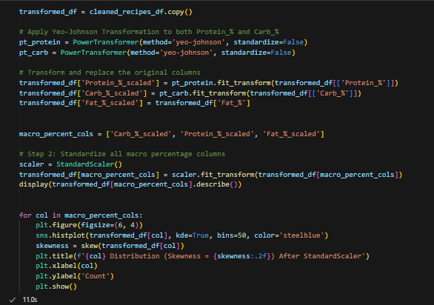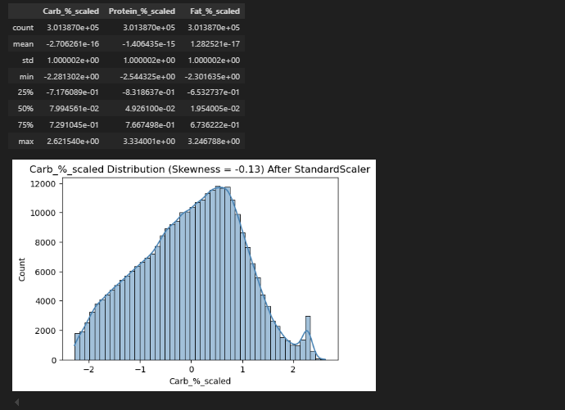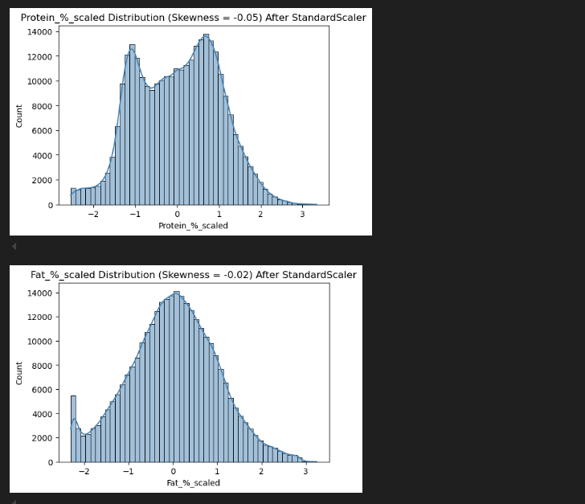

Figure : Code and output of applying data transformation and standardization

The preprocessing steps done above directly follow from previous distribution and skewness analysis, and involve preparing the macronutrient percentage features, namely Carb_%, Protein_%, and Fat_% in order to be efficient in clustering. Because previously analysis showed that Carb_% and Protein_% were positively skewed, the Yeo-Johnson transformation was used to each of them. This transformation was used in particular because it accommodates both positive and zero values, and thus it suits dietary data better than alternatives such as log1p, as it might over-compress variance and skew moderately-sized values. The transformation successfully decreased asymmetry in the distributions, getting them closer to being normally distributed, and better accommodating algorithms assuming or preferring approximately symmetrical data.

After the transforms were applied, all of the macronutrient characteristics (include Fat_% that already in close to symmetry) were then standardized with Scikit-learn’s StandardScaler. This ensures that all of the variables have a mean of 0 and standard deviation of 1, something that the K-Means and Gaussian Mixture Model, two distance-based clustering models, rely upon. Confirmation of post-transformation histograms indicates a high degree of skewness reduction: to 0.13 for Carb_%, to -0.05 for Protein_%, and to the near symmetry of -0.02 for Fat_. Collectively, these steps in transformation and scaling guarantee that all the characteristics contribute in proportion and in fairness to the act of clustering, enhancing the ability of the model to reveal significant patterns in recipe nutritional profiles.

### **4.4.7 Anomalies Removal**

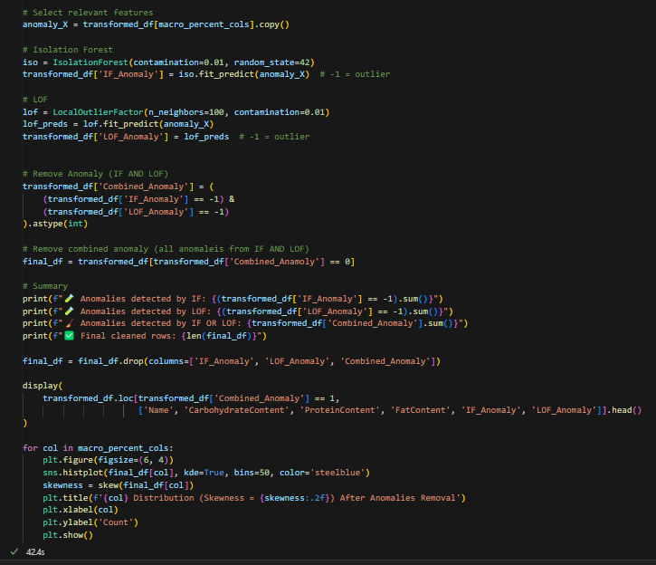

Figure : Code of removing anomalies

The above outlier identification step via Isolation Forest (IF) and Local Outlier Factor (LOF) aims at detecting recipes with very atypical macronutrient compositions, based only on the standardized percentages of macronutrients in the recipe. Because IF and LOF are sensitive to the distribution and scale of the input features, applying them after the transformation and standardization preserves the balance of input and the fairness of the anomaly scores on all features. Calories have been deliberately left out of consideration at this step, as the task of the clustering lies in the relative proportions of the macronutrients and not in the total energy. Yet, calorie-based anomalies were previously addressed in the preprocessing pipeline by excluding recipes with outlier energy levels (below 250 kcal and above 2000 kcal) to ensure the dataset consists of nutritionally plausible meals.

Based on these principles, the LOF and IF models run in tandem to identify outliers in the distribution of nutrients. Using each with a contamination parameter of 1%, means they will identify the most extreme 1% of entries and flag them as outliers, an entry will only be noted as an outlier if the two methods agree. This twin-detection approach maximizes reliance while reducing false positives while also allowing the capture of recipes with grossly unbalanced profiles like the case where over 90% of the calories derive from fat or when carbohydrates or proteins account for more than 95%. Eliminating just the outliers consistently singled out by both techniques reduces the dataset unnecessarily, but it fortifies the nutritional homogeneity of the data, eventually informing more meaningful, interpretable, and clean clustering results.

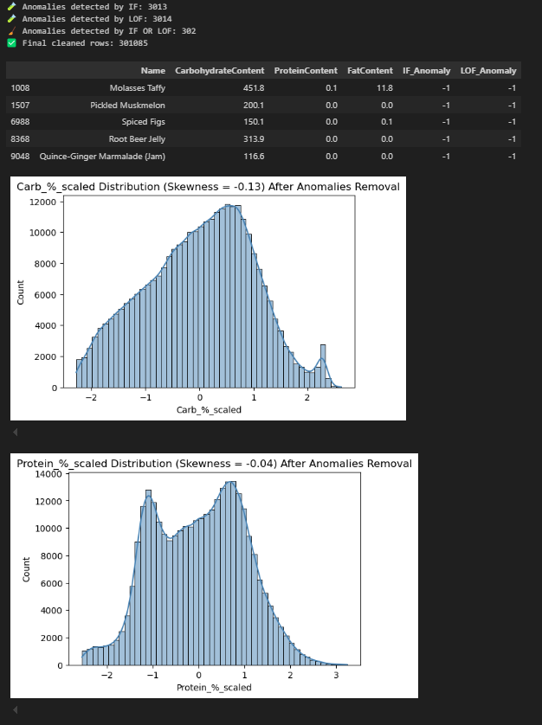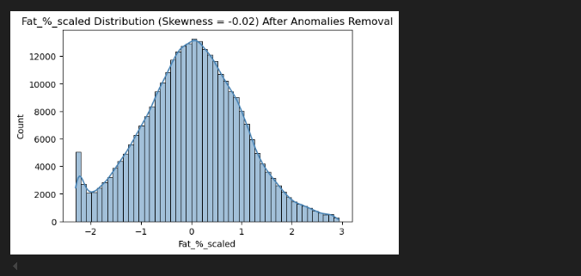

Figure : Output after removing anomalies

The output consists of the final result of the anomaly detection. Among these, IF detected 3013 entries, LOF detected 3014, and 302 entries were simultaneously detected as anomalies by the two methods. To guarantee high confidence in the anomaly detection, only such overlapping anomalies were eliminated, and the dataset of 301,085 recipes remained after refining.

At the top of the list of omitted entries were recipes like 'Molasses Taffy,' 'Pickled Muskmelon,' and 'Root Beer Jelly.' Such entries showed extreme nutrient imbalances, either containing virtually all of their calories from one macronutrient source such as carbohydrates, or containing little to no protein or fat. While such recipes might have special culinary merit, they lie beyond the standard of nutritionally proper meals and might bias the integrity of composition-based clustering models. The lower half of the output includes updated histograms of the standardized macronutrient percentage features after the removal of anomalies. The visualizations reflect tidy, almost symmetrical curves, corroborated by decreased skewness measures of –0.13 for carbohydrates, –0.04 for protein, and –0.02 for fat. The near-zero skewness scores verify that the macronutrient features now balance nicely and need not undergo further scaling. With the anomalies eliminated and the distribution normalized, the data now lies in the best possible position to undergo clustering, resulting in more interpretable and meaningful groupings according to nutritional composition.

### 4.4.8 Data Normalization

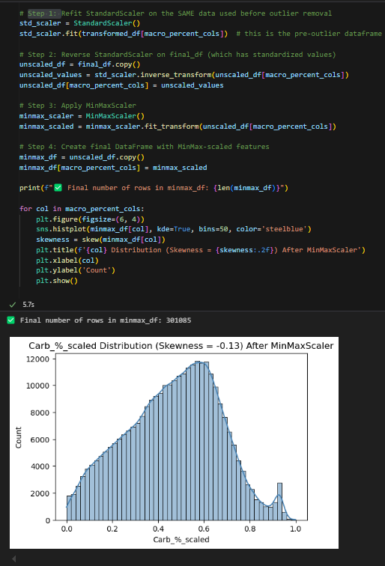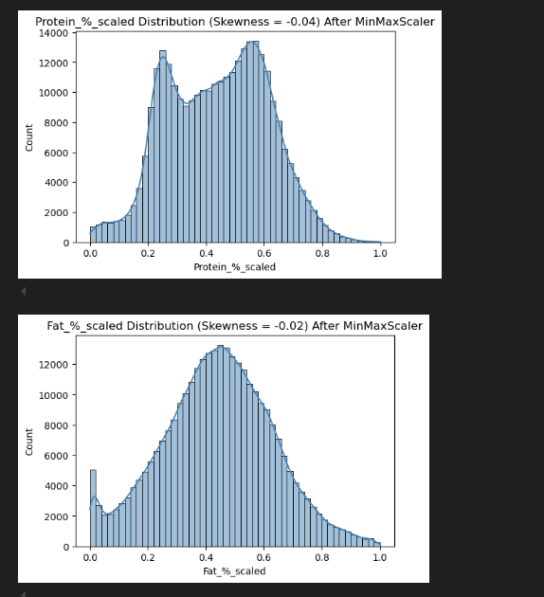

Figure : Code and output of normalizing data

Following the standardization with StandardScaler for dealing with anomalies and a few clustering algorithms initially, macronutrient percentage features were processed further with MinMaxScaler for scaling them into the [0,1] range. First, a StandardScaler is refitted over the original data for consistency post-outlier handling, and the transform is reverted to reverse the features back to their original shape. Next, MinMaxScaler is applied for feature normalization into the range of [0,1] as it is a prerequisite for models such as Self-Organizing Maps (SOM) where bounded inputs are needed for successful learning. While KMeans as well as MiniBatch KMeans can handle data which, while standardized, have been scaled with MinMaxScaler, the latter creates a point for comparing how varying preprocessing may affect clustering performance. For validation of the transform, the code also plots the feature distributions of the scaled features to show that MinMax scaling maintained the shape of the data as a whole, as well as the data balance. This rigorous preprocessing prevents a single feature from overwhelming the clustering so that all algorithms are provided with more stable and value-laden results.

## **4.5 Model Building**

### 4.5.1 Gaussian Mixture Model

The Gaussian Mixture Model (GMM) is a probabilistic clustering algorithm that represents the data in the form of a mixture of several Gaussian distributions, each of which corresponds to a possible cluster. It works on the basis of the Expectation-Maximization (EM) algorithm, wherein the parameters of the clusters get improved in each step iteratively. During the expectation step, the probability (responsibility) of each data point belonging to each Gaussian component according to the current estimates of means, covariances, and the mixing coefficients is calculated. During the maximization step, the parameters get updated through the use of the calculated responsibilities to re-estimate the means, covariance matrices, and the mixing proportions of each component. This iterates till the algorithm converges, usually when the likelihood of the data converges (GeeksforGeeks, 2025). GMM is different from hard clustering techniques as it yields soft assignments, i.e., each data point comes with a probability distribution over the clusters, and hence enables grouping based on the data's shape and spread in the feature space in a more flexible manner.

#### 4.5.1.1 Build GMM Base Model

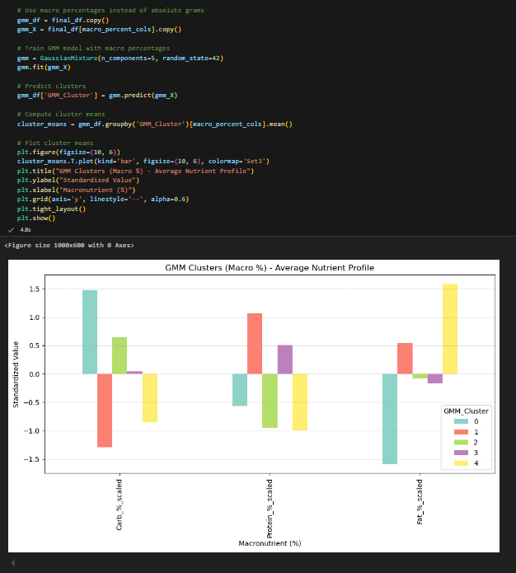

Figure : GMM Base Model

This code implements a Gaussian Mixture Model (GMM) to group recipes according to the standardized percentages of macronutrients instead of the absolute gram amounts. It is done on the standardized data only because GMM is feature variance-sensitive and its probabilistic models depend upon good estimates of covariances across attributes. Standardizing (using StandardScaler) ensures that all attributes have zero mean and unit variance, and thus they contribute equally to clustering. Normalized data like that from MinMax scaling doesn't guarantee equal variance and can shrink the natural variance across attributes, which may distort GMM's Gaussian assumptions and result in unstable or unbalanced clustering. The GMM training was done with five components, based on the assumption that the recipes could be sorted into five different nutritional profiles. Upon training the model, each recipe is classified into a group, and each group's mean macronutrient distribution is calculated. The grouped bar chart then represents the average standardized macro percentages per group, and the different dietary patterns like fat-dominant, protein-rich, or carbohydrate-dominant profiles emerge. This graph aids in interpreting the nutritional emphasis of each group and presents the manner in which GMM distinguishes recipes from each other on the basis of inherent dietary structure.

#### 4.5.1.2 Hyperparameters Tuning of GMM

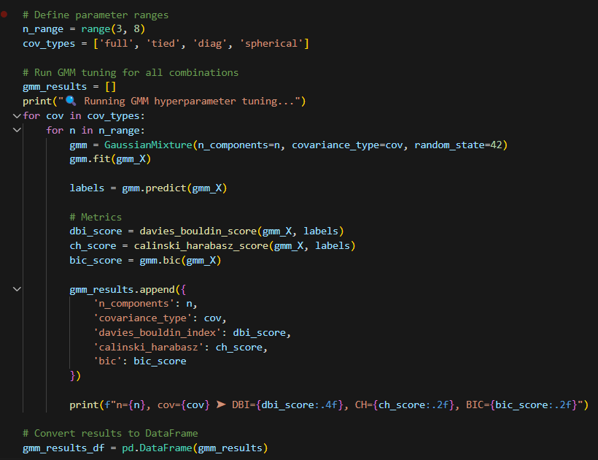

Figure : Code of tuning GMM hyperparameters

The above code tunes the hyperparameters of GMM by testing various combinations of the number of components (between 3 and 7) and types of covariances ('full', 'tied', 'diag', 'spherical'). For every configuration, GMM is trained on macronutrient percentage data after normalization gmm_X, and cluster labels are predicted. The quality of the model is then assessed by Davies-Bouldin Index (DBI), Calinski-Harabasz score (CH), and Bayesian Information Criterion (BIC). The outcome of every run, i.e., model configuration and metric scores, are stored within a dictionary and aggregated into a DataFrame to enable systematical comparison and choice of top-performing model for the next chapter.

### 4.5.2 K-Means Clustering

K-Means is a type of unsupervised learning algorithm used to divide data into a specified number of clusters (denoted by K) based on similarity. The algorithm operates in an iterative manner to allocate each data point to one of the K clusters such that the variance between the clusters is minimized. The algorithm commences by randomly choosing K initial centroids, representing the center of each of the clusters. Each data point is then allocated to the most similar centroid of the clusters, generally calculated in terms of Euclidean distance. After allocating all data points, the algorithm reassesses the centroids by determining the mean of all points in the clusters. This process of assignment and centroid update repeats if the centroids no longer change significantly or when a specified number of iterations is achieved. The goal of K-Means is to minimize the total of squared distances between the data points and the respective centroids of the clusters. This yields compact and separate clusters assuming the data points are well-separated and approximately spherical in nature (Sharma, 2025).

#### 4.5.2.1 Build K-Means Base Model Using Standardized Data

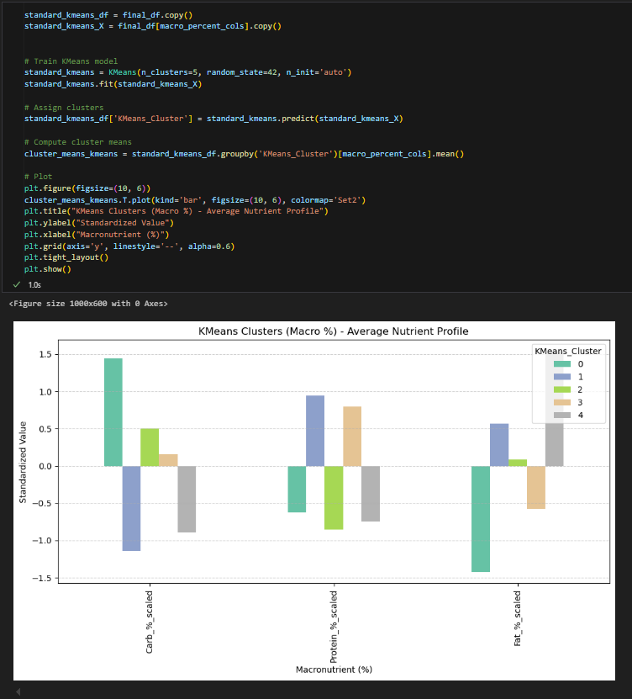

Figure : Build K-Means Base Model (Standardized Data)

The code applies a K-Means clustering algorithm to standardized macronutrient percentage characteristics to classify recipes into clusters according to nutritional composition. With the model defined with 5 clusters and then applied to preprocessed data, every recipe will be grouped into one of the clusters. The average macronutrient composition of each of the resulting clusters will be computed and plotted in a grouped bar plot. From the plot, clear patterns of nutrients emerge, like clusters with high carbohydrate, protein, or fat dominance, and it seems that K-Means correctly clusters recipes into useful nutritional categories according to macronutrient balance.

#### 4.5.2.2 Hyperparameters Tuning of K-Means (Standardized Data)

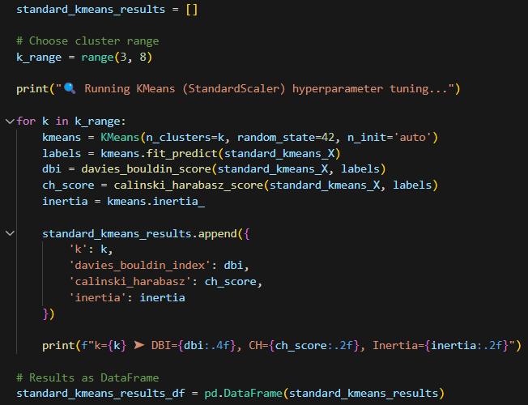

Figure : Code of tune hyperparameters of K-Means (Standardized Data)

This code block is designed to perform hyperparameter optimization of the K-Means algorithm on determining the number of clusters. The script iterates over a given range of k (from 3 to 7), training a new K-Means model for each candidate k. Upon each fit to the model, cluster labels are predicted and a set of internal validation metrics are computed, such as the Davies-Bouldin Index, the Calinski-Harabasz score, and the inertia. These metrics will be helpful for determining the value of the number of clusters without the need for external label knowledge.

In order to simplify downstream evaluation, each iteration's results are retained in a list and subsequently converted to a DataFrame. This formal output facilitates simple comparison over several different values of k, and the print statements give instant feedback regarding the model's performance for every number of clusters. This experiment lays the ground for the subsequent chapter in which the stored metrics will be evaluated to identify the most stable and interpretable number of clusters in accordance with trade-offs in compactness of the clusters, between the separation of the clusters, and between the consistency of the clusters.

#### 4.5.2.3 Build K-Means Base Model Using Normalized Data

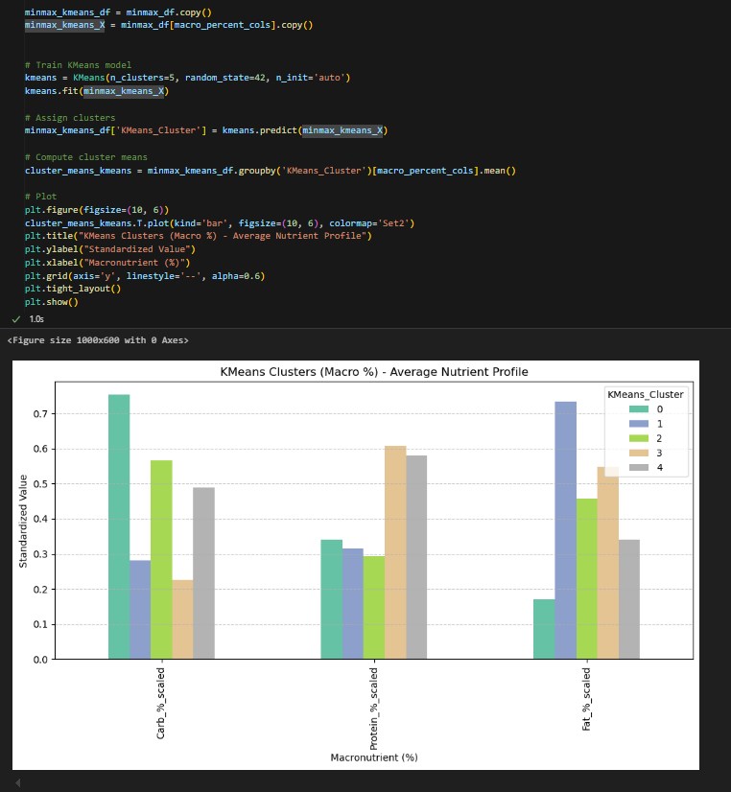

Figure : Build K-Means Base Model (Normalized Data)

This code block demonstrates the use of a K-Means clustering algorithm on macronutrient percentage features that have been normalized via MinMaxScaler. The procedure remains the same when using standardized data. This approach based on MinMax presents a different viewpoint compared to standardization, enabling comparison across different scaling techniques.

#### 4.5.2.4 Hyperparameters Tuning of K-Means (Normalized Data)

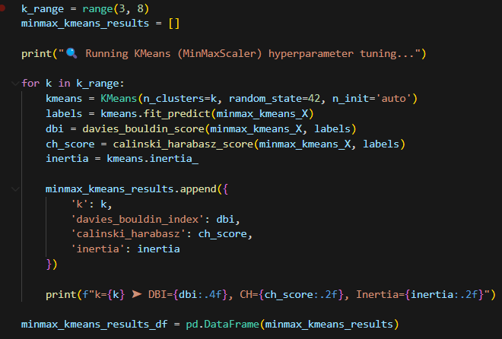

Figure : Code of tuning hyperparameters of K-Means (Normalized Data)

This code follows the hyperparameter tuning process for the K-Means model but applies it to data that was scaled via MinMaxScaler instead of StandardScaler. It creates a loop over the same range of clusters (k = 3 to 7), but it measures the clustering performance on the basis of internal metrics. Although the logic follows the previous tuning process, the decisive difference comes from the scaling of the input features, leaving the option open for direct comparison of the effect different scaling approaches could have on the structure of the clusters and the results of metrics. The metrics for each k value are stored and made into a DataFrame to maintain uniformity and simplicity of analysis in preparation for comparative analysis between methodologies in the next section.

### 4.5.3 Mini Batch K-Means Clustering

MiniBatch K-Means is a faster and more scalable version of the standard K-Means algorithm, especially adapted to larger datasets. Rather than using the entire dataset to compute the centroids in each step, it operates by picking random, fixed-size portions (mini-batch) of the data to update the centroids more often and incrementally. This reduces computational time considerably while converging to a similar solution to standard K-Means. The fundamental mechanism starts by initializing the `k` centroids. For each step, the mechanism first selects a random mini-batch of the data points and then, for every data point in the batch, finds the nearest centroid. Using a weighted average of the new mini-batch data, the centroids get updated, enabling faster convergence with reduced calculations per step. Although it loses some accuracy in relation to the full-batch version of K-Means, it provides significant gains in speed and memory usage, which comes in very handy when working with extremely large datasets (GeeksforGeeks, 2024).

#### 4.5.3.1 Build Mini Batch K-Means Base Model Using Standardized Data

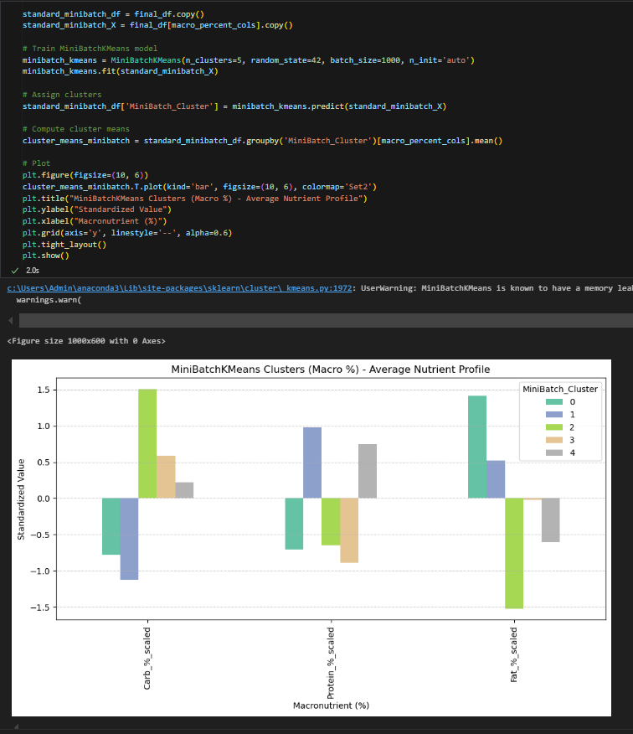

Figure : Build mini batch k-means model using standardized data

The above code illustrates the usage of Scikit-learn's MiniBatchKMeans algorithm on the standardized macronutrient percentage features. As opposed to regular K-Means, minibatch-style arguments like batch_size=1000 are used in this case to update centroids incrementally, reducing the computational requirements of each update and scaling the process to handle high-dimensional data. The model parameters include n_clusters=5 and a fixed random_state=42 to reproduce the results. After fit, each recipe receives assigned cluster labels and the average composition of each cluster is calculated and plotted as a bar chart. The outputs produced correspond to the observed patterns of the standard K-Means, indicating that MiniBatchKMeans maintains its status as a resource-effective and predictable means for discovering dietary patterns, whether in resource-limited or high-dataset environments.

#### 4.5.3.2 Hyperparameters Tuning of Mini Batch K-Means (Standardized Data)

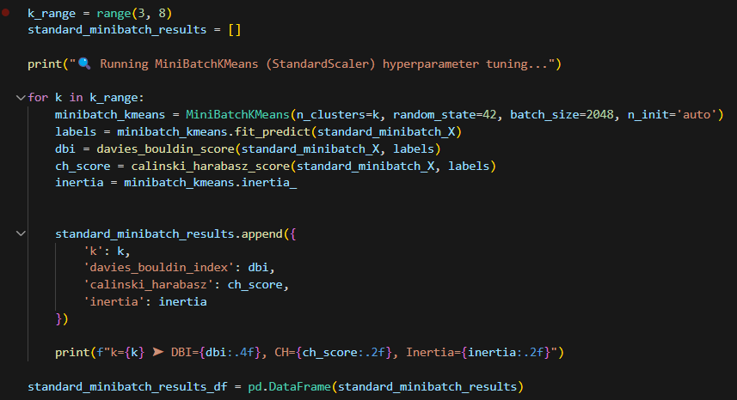

Figure : Code of tuning hyperparameters of Mini Batch K-Means (Standardized Data)

This code performs hyperparameter tuning of the MiniBatchKMeans algorithm by trying out different counts k of clusters between 3 and 7 and specifying a batch_size of 2048 to optimize training performance. For each of the configurations, the model is run and internal evaluation metrics like Davies-Bouldin Index, Calinski-Harabasz score, and the inertia are calculated. The metrics are accumulated in a list and summarized in a DataFrame to be compared systematically. The final evaluation of these results and the choice of the best-performing model will be covered in the next chapter.

#### 4.5.3.3 Build Mini Batch K-Means Base Model Using Normalized Data

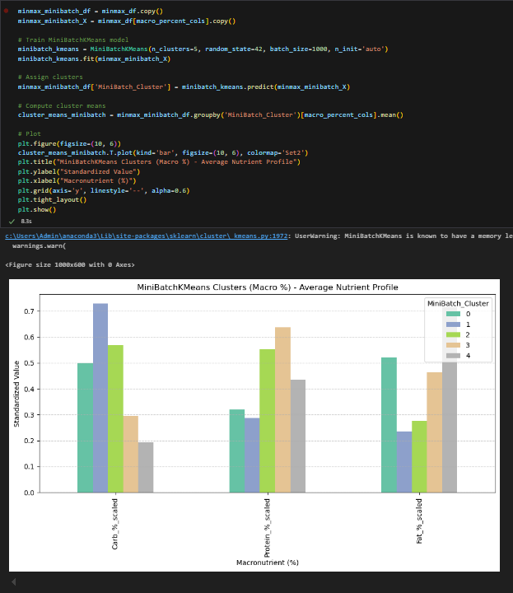

Figure : Build mini batch K-means base model (Normalized Data)

This code snippet performs the MiniBatchKMeans algorithm on macronutrient percentage data that has undergone MinMax normalization scaling. A copy of the normalized dataset is created, and the model is instantiated with 5 clusters along with a fixed random_state=42 to allow for reproducibility, and a batch_size=1000 to enhance computational efficiency. Once the mode is fit, it adds cluster labels and calculates the average composition of each group. The resulting cluster profiles are then visualized, enabling intuitive comparison of patterns across nutrients. This version also provides a useful comparison to the StandardScaler-based version, to see how different scaling techniques affect the results when the same algorithm is used.

#### 4.5.3.4 Hyperparameters Tuning of Mini Batch K-Means (Normalized Data)

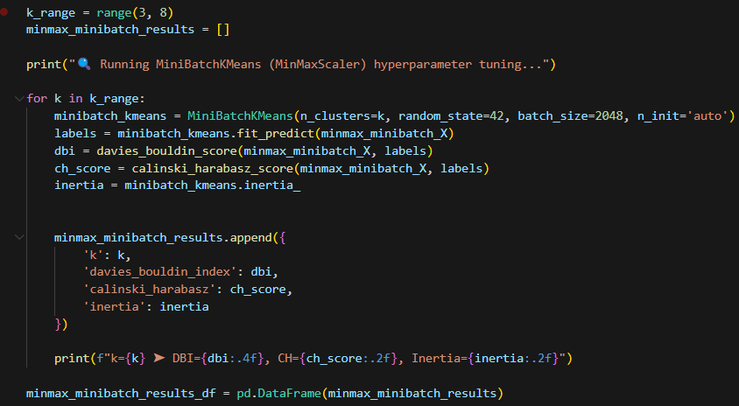

Figure : Code of tuning hyperparameters of mini batch K-means (Normalized Data)

The code conducts hyperparameter tuning for the MiniBatchKMeans algorithm applied to macronutrient percentage data that has been scaled using MinMaxScaler. While the tuning procedure mirrors the approach used with StandardScaler, iterating over different values of k and recording clustering metrics,it serves a distinct purpose by allowing direct comparison between scaling methods. Evaluating model performance under MinMax scaling provides insight into how the choice of normalization impacts clustering behavior. The resulting metrics will be systematically analyzed in the model evaluation phase to determine the most suitable configuration for both scaling strategies.

### 4.5.4 Self-Organizing Map

Self-Organizing Maps (SOMs) are high-performance clustering and dimensionality reduction methods used to map high-dimensional data to a low-dimensional representation, usually a grid in two-dimensional space. The mapping reduces complex issues to be more understandable, and patterns within the data are easier to identify. There are two principal layers within SOM: an input layer to which the high-dimensional data are fed and an output layer composed of grid-based neurons. Every input point is mapped to the neuron that best matches its attributes, known as the Best Matching Unit (BMU). While being trained, both the BMU and its vicinity update their weights to match the input more, incrementally organizing the map so that neighboring nodes represent similar input points (Nanda, 2024). The process of self-organization makes it easier for SOM to discover intrinsic patterns and accordingly cluster the data without the need for predefined labels, and thus it is particularly useful for clustering data points on the basis of intrinsic similarity in an unsupervised way.

#### 4.5.4.1 Build SOM Base Model

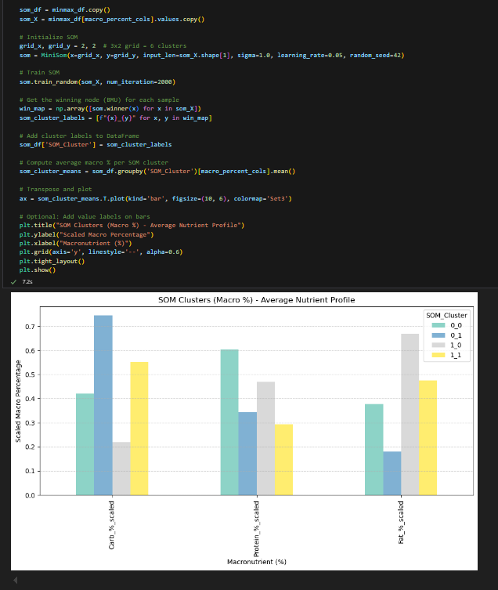

Figure : Build SOM base model

In this code snippet, a Self-Organizing Map (SOM) is trained to cluster MinMax-scaled percentage macronutrient data. The SOM is created using a 2x3 grid (6 neurons), learning rate 0.05, and fixed random state to produce reproducible results. Each data point is mapped to its Best Matching Unit (BMU) using minimal Euclidean distance, and labels are allocated accordingly. Final averages of clusters are plotted using a bar plot to visualize the macronutrient composition for each group. Normalized data was used for this task specifically and not standardized data because SOM makes significant use of absolute distances for neuron organization. MinMax scaling preserves all features within the identical [0, 1] domain, ensuring that the comparison of distances is fair and consistent across all nutrient axes. By using StandardScaler, however, one might introduce features within the domain of –3 to +3, and thus potentially bias the SOM learning process and create more difficult to interpret maps. Consequently, using MinMaxScaler ensures that all macronutrient features use positively valued, comparable scales to ultimately enable smoother and more reliable autonomous organization of the SOM grid.

#### 4.5.4.2 Hyperparameters Tuning of SOM

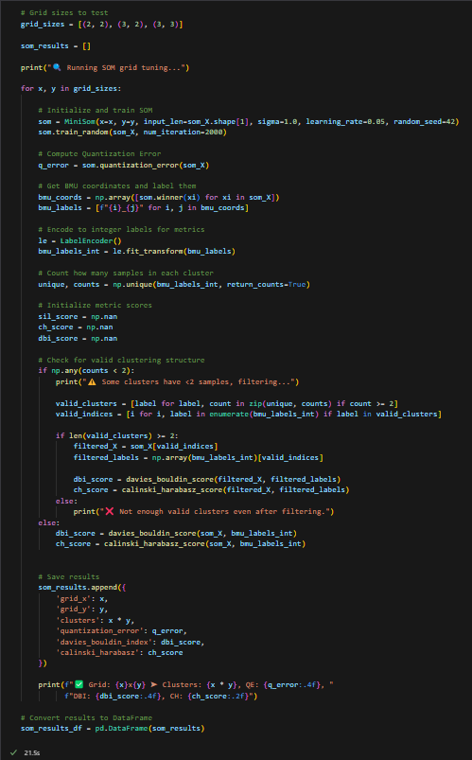

Figure : Code of tuning parameters of SOM

The code snippet above carries out hyperparameter tuning for the Self-Organizing Map (SOM) algorithm to vary grid configurations from (2x2), (3x2), to (3x3) to identify the best grid for clustering percentage macronutrient data. For every grid configuration size, a SOM is created and trained using a learning rate of 0.05 and a fixed random state for the sake of reproducibility. After training, it calculates the quantization error, which indicates how well the map captures the data. Every data point is mapped to its Best Matching Unit (BMU), and the obtained BMU labels are then converted to integers for consistency with clustering evaluation measures. To guarantee valid clustering analysis, the code verifies that there are adequate data points mapped to every neuron (excluding clusters for which there are fewer than two samples). When there are enough valid clusters, internal measures of evaluation—specifically the Davies-Bouldin Index (DBI), and the Calinski-Harabasz (CH) score—are computed; otherwise, the model skips metric assessment for that grid configuration. The outcomes, such as the quantization error, DBI, CH score, and grid configuration, are gathered into a list that is finally compiled to a DataFrame for easy comparison during the model evaluation step. This grid search facilitates systematic tuning of SOM architecture to identify an appropriate trade-off between compactness and separation of the data structure while achieving a useful clustering result.

## 4.6 Summary

Chapter 4 thoroughly documents the data journey starting with the acquisition of two essential datasets: RecipeData.csv, which provides over 500,000 nutritionally detailed recipes, and AllergenData.csv, which catalogs food allergens. These datasets were selected strategically to allow for a personalized, allergy-aware meal recommendation system aligned with public health objectives like SDG 3. Variables in each dataset were carefully explored to understand their structure and relevance to the project’s goals. Necessary libraries such as NumPy, Pandas, Matplotlib, Scikit-learn, and MiniSom were imported to facilitate data handling, visualization, preprocessing, and modeling.

The chapter proceeded with detailed exploratory data analysis (EDA), including duplication checks (none found), structure inspections, descriptive statistics generation, unique value assessment, and missing value analysis. Key observations included the discovery of missing values in columns like RecipeYield, ReviewCount, and AggregatedRating, as well as calorie-nutrient inconsistencies and the right-skewed distribution of nutritional variables. Correlation analysis revealed strong relationships between Calories and FatContent, and high interdependence between saturated fat and total fat, supporting feature selection decisions.

Data preprocessing was comprehensive: irrelevant columns were removed, missing non-critical values were imputed with placeholders, and critical missing allergen records were dropped. Outliers in calorie values were filtered by retaining only recipes between 250–2000 kcal, and consistency between reported calories and macronutrient-derived calories was enforced. Feature engineering introduced normalized macronutrient percentage columns (Carb_%, Protein_%, Fat_%) for improved comparability across recipes. An automated allergen detection mechanism was built to dynamically label recipes with potential allergens, enhancing safety and inclusivity.

Data transformation involved applying the Yeo-Johnson technique to reduce skewness in macronutrient percentage features, followed by standardization using StandardScaler to ensure consistent feature scaling. Anomalies were detected and removed using a dual approach of Isolation Forest and Local Outlier Factor, which pruned nutritionally extreme or logically invalid entries. Additionally, MinMaxScaler was used to normalize features into a [0,1] range, especially preparing the data for models like Self-Organizing Maps (SOM) that require bounded inputs.

Model building centered around four clustering techniques. K-Means clustering was a major method, conducted on both standardized and normalized datasets, with extensive hyperparameter tuning to identify the ideal number of clusters using evaluation metrics such as the Davies-Bouldin Index (DBI), Calinski-Harabasz (CH) Score, and Inertia. To address scalability for large datasets, MiniBatch K-Means was also implemented, maintaining clustering quality with faster computation. Gaussian Mixture Models (GMM) introduced soft probabilistic clustering, offering flexibility in handling recipes with mixed nutritional profiles. Finally, Self-Organizing Maps (SOM) were developed and fine-tuned using different grid configurations, focusing on minimizing quantization error while ensuring clear cluster separability.

In conclusion, Chapter 4 established a clean, validated, and properly transformed dataset and built optimized clustering models ready for integration into the personalized dietary recommendation system. The methodical handling of data quality, feature engineering, scaling strategies, anomaly detection, and clustering model design laid a robust groundwork to ensure the final system delivers safe, relevant, and actionable dietary recommendations to users.

# CHAPTER 5: RESULTS AND DISCUSSION

## 5.1 Introduction

This chapter provides the comparison and evaluation and deployment of the personalized diet recommendation system. Having constructed various clustering models such as Gaussian Mixture Model (GMM), K-Means, MiniBatch K-Means, and Self-Organizing Maps (SOM), a set of internal validation measures including the Davies-Bouldin Index (DBI), Calinski-Harabasz (CH) Score, Bayesian Information Criterion (BIC), Inertia, and Quantization Error (QE) were systematically utilized to evaluate the quality of the clusters. Subsequent sections of this chapter provide the results of the evaluations, choose the best-performing clustering model, and cover the deployment of the system as a friendly web application.

## 5.2 Model Evaluations and Discussion

### 5.2.1 Used Evaluation Metrics

1. **Davies-Bouldin Index**

The Davies-Bouldin Index (DBI) measures the quality of clustering by comparing both the tightness within clusters and between-cluster separation. For every cluster, it finds the closest neighboring cluster and computes a similarity ratio between their internal dispersion and how close they are to each other. The DBI will be the mean of these maximum similarity ratios for all clusters, and the measure will be higher for poorer clustering. Low DBI indicates that clusters are tight and highly coherent within themselves but also clearly separated from each other, and thus it is a useful measure for detecting the formation of well-separated, distinct groups (Lee, 2025).

1. **Calinski-Harabasz Index**

The Calinski-Harabasz Index (CH), also known as the Variance Ratio Criterion, measures the quality of clustering based on the comparison of the dispersion between clusters to that within clusters. A greater CH measure means better-separated clusters where within-cluster points are compact and clusters are separated from one another. The CH index also considers both the number of clusters and the overall number of data points and scales the score proportionally to the complexity of the model (GeeksforGeeks, 2022). This makes it especially useful for determining solutions where inter-cluster variance is maximized and intra-cluster variance is minimized, particularly where the clusters are fairly globular and separated.

1. **Bayesian Information Criterion**

The Bayesian Information Criterion (BIC) supports model selection by balancing the trade-off between model fit and complexity. It introduces a penalty for models with more parameters, helping to avoid overfitting and favoring simpler, more generalizable solutions. In the context of clustering, especially with Gaussian Mixture Models, BIC assesses how well the model explains the data while considering the number of clusters used. A lower BIC value indicates a model that fits the data effectively without unnecessary complexity. This makes BIC particularly valuable when not only evaluating clustering quality but also ensuring the model remains parsimonious and interpretable (Gomes et al., 2022).

1. **Inertia**

Inertia captures the sum of squared distances between all data points and their respective cluster centroids, and is one of the principal measures used to evaluate K-Means clustering. It captures the internal cohesion among clusters: low values of inertia indicate that data are close to their respective centroids, implying tight and well-separated clusters. Because more clusters always result in falling inertia due to more centroids lowering the average distance to the points, it must not be used alone to ascertain the ideal number of clusters. Rather, it is usually used in conjunction with other measures like the Davies-Bouldin Index or Calinski-Harabasz Score, or graphical tools like the elbow approach, to reach a trade-off between tightness and complexity of the model (Abrar, 2023).

1. **Quantization Error**

Quantization Error (QE) is one key metrics for Self-Organizing Maps (SOMs), which quantifies the average similarity between each input vector and its corresponding best-fitting neuron, or the Best Matching Unit (BMU). As the QE decreases, it shows that the SOM successfully managed to map the high-dimensional data to its reduced-dimensional grid and that there is a good fit between the map and the data. When using SOMs for clustering, minimising the Quantization Error is important since it ensures that significant patterns, similarities, and relationships between the original dataset are kept while mapping, and that more accurate representations and significant grouping are achieved (Awong & Zielinska, 2023).

### 5.2.2 Model Evaluations

#### 5.2.2.1 Evaluation of Gaussian Mixture Model

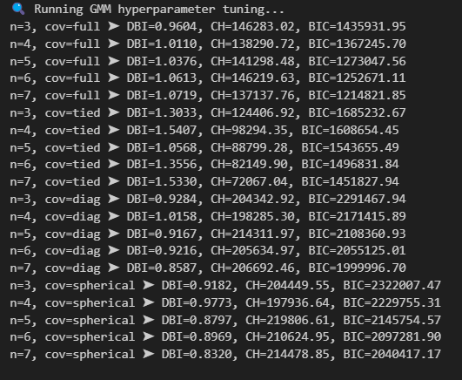

Figure : Result of GMM hyperparameters tuning

To identify the ideal configuration for the GMM, a comprehensive hyperparameter tuning was employed. Varying the number of clusters from 4 to 7 involved a search for four types of covariance structures: full, tied, diagonal, and spherical. Three main evaluation measures: DBI, CH and BIC guided the choice. By and large, a good model would result in a low DBI, which would show tight and well-separated clusters, a high value for the CH score that would represent high inter-cluster separation, and low BIC that would prefer simple and effective models.

Of all the models that were compared, the 7-cluster GMM that used a spherical covariance did best across all configurations. Not only did this model achieve the lowest value of DBI (0.8320), implying dense and well-separated clusters, it also achieved the highest CH score (214,478.85), which supports the high quality of the clusters. While other full covariance models did achieve slightly lower BIC value, they also achieved poorer clustering quality, indicated by larger DBI values and poorer CH scores, and are thus not the best option.

Although the BIC for the 7-cluster spherical model (2,040,417.17) wasn't the lowest, it fell within an extremely acceptable range. Far more importantly, significant enhancement of the DBI and CH measures made it easier to prefer this model even though its BIC was somewhat greater. It is noteworthy that BIC tends to decline as the number of clusters is larger; however, using only BIC without regard to clustering compactness and separation may result in overfitting and producing less interpretable structures of clusters.

In addition, the use of spherical covariance was especially fitting for the type of dataset, which included normalized macronutrient percentage attributes. Spherical covariance presumes that groups are isotropic, that is, have equivalent variance in all directions—a condition which corresponds nicely to normalized and balanced feature distributions. As a result, given high clustering quality, reasonable model complexity, and theoretical congruity to data characteristics, the GMM configuration of 7 clusters and spherical covariance was used for further investigation.

#### 5.2.2.2 Evaluation of K-Means Clustering

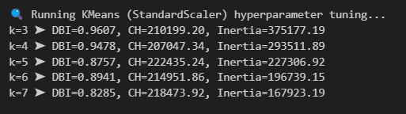

Figure : Result of K-means hyperparameters tuning on standardized data

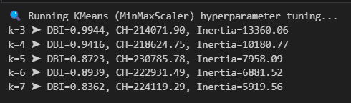

Figure : Result of K-means hyperparameters tuning on normalized data

For the best K-Means configuration, hyperparameter tuning was done using both StandardScaler and MinMaxScaler preprocessing methods. Three important measures were used to evaluate: DBI, CH and the inertia. The ideal model would have a low DBI, high CH score, and low inertia, which would have well-separated, compact, and tight clusters. Note that the values of the inertia are only comparable within models that use the same scaler since varying scalers differentiate the magnitude of the distances between the data points.

On closer look at the outcomes, it was noted that the K-Means model trained on MinMaxScaler and seven clusters (k=7) provided the best balanced performance. The low DBI value of 0.8362 by this model indicated high internal compactness of clusters. Moreover, the model registered a low value for inertia of 5,919.56 while using MinMax scaling, which meant that data points within every cluster were packed tightly together. While the best DBI was registered by the StandardScaler model also at seven clusters (0.8285), its intracluster inertia (167,923.19) was not comparable to that for MinMax scaling due to variations in feature scaling. Moreover, the high value of the CH Score for MinMaxScaler for k=7 (224,119.29) was very close to the best scores for all the cluster counts.

Furthermore, the MinMaxScaler approach demonstrated consistent improvements across the entire range of tested cluster values (k=3 to k=7), further supporting its reliability for this dataset. Thus, based on the synergy among a low DBI, high score for CH, low inertia (within the same scaling strategy), and overall clustering consistency, the K-Means model with MinMaxScaler for seven clusters was identified as the best configuration for further analysis.

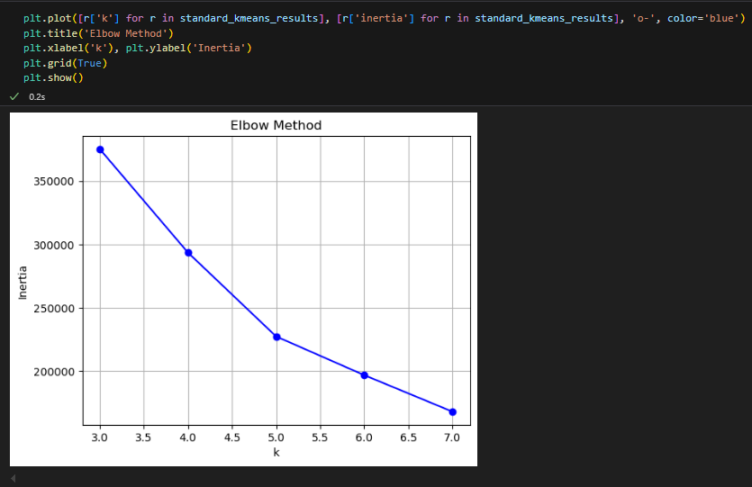

Figure : Elbow method of K-Means on standardized data

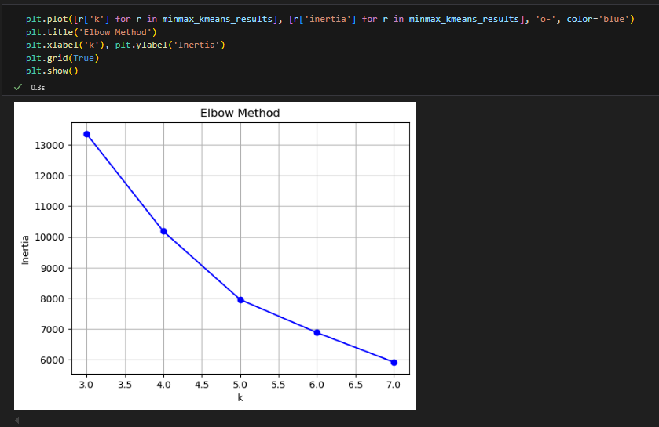

Figure : Elbow method of K-Means on normalized data

The elbow method was utilized by inspecting inertia plots derived from both scaling methods further substantiate the selection of the right number of clusters. As k increases, the within-cluster sum of squared residues (WCSS), otherwise referred to as inertia, typically declines because more clusters enable the model to capture underlying data patterns more accurately. More clusters, however, beyond a point, contribute only to minor decreases in inertia, reflecting decreasing marginal returns. This occurs graphically as an "elbow" shape where the rate of decline of WCSS becomes flat. Determination of the elbow point allows for a tradeoff between model complexity and tightness. In the current research, the elbow was noted for k=5 up to k=6 in both types of data scaling data, indicating that beyond this point, increments of k do not provide significant gains. Still, due to the steady improvement noted for clustering evaluation measures such as the DBI, as well as the CH, k=7 was finally chosen as the number of clusters for the K-Means model to guarantee increased quality as well as stability of the clusters.

#### 5.2.2.3 Evaluation of Mini Batch K-Means Clustering

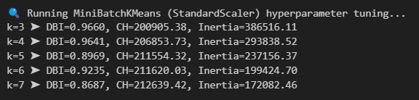

Figure : Result of mini batch K-means hyperparameters tuning on standardized data

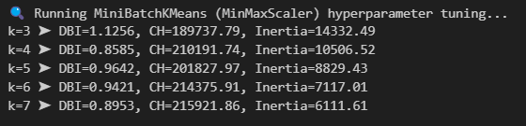

Figure : Result of mini batch K-means hyperparameters tuning on normalized data

Following optimization of hyperparameters, the MiniBatch K-Means model that was trained using MinMaxScaler and seven clusters (k = 7) showed the best performance out of all MiniBatch settings. It resulted in DBI 0.8953 and the highest score for CH of 215,921.86, reflecting high compactness and separation among clusters. It also registered the lowest value for inertia of 6,111.61 out of all the MinMax-scaled models, affirming the tight grouping of clusters.

While a somewhat reduced DBI was noted at k=4, the overall quality of clustering at k=7 was better. The greater CH value and reduced associated inertia at k=7 reflected better-separated, more defined, and more dense clusters than those evident at k=4. Furthermore, using seven clusters enabled a more nuanced and more significant discrimination of nutritional patterns, while using four clusters would have resulted in data representation that was overly simplistic. Thus, k=7 was used as the best value for the number of clusters.

Relative to the previously chosen K-Means model (also utilizing MinMaxScaler and seven clusters), the MiniBatch K-Means model showed somewhat poorer clustering quality. The regular K-Means was superior at both DBI and CH measures, indicating more separated and dense clusters. However, the MiniBatch K-Means methodology retained the comparable clustering performance while providing dramatic gains for computation. Thus, it is still a viable option for big data or for applications where being faster is crucial, even at the cost of tolerating a small degradation of clustering accuracy.

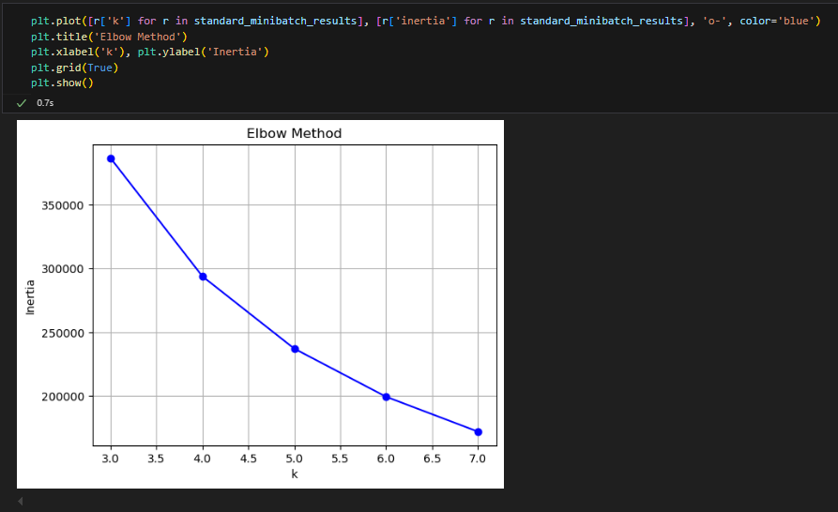

Figure : Elbow method of mini batch K-Means on standardized data

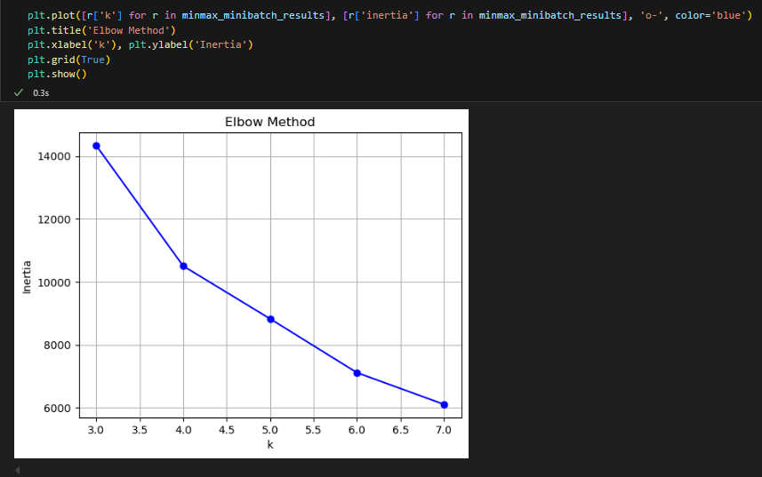

Figure : Elbow method of mini batch K-Means on normalized data

The elbow method was utilized to determine the number of clusters for the MiniBatch K-Means models. Plots of inertia for both MinMaxScaler and StandardScaler revealed a similar trend where inertia saw a sharp drop from k=3 to k=5, with a distinct flattening for k=5 to k=6. This elbow point suggested that a greater number of clusters beyond six provided diminishing returns in the form of a more compact structure. This elbow around k=5–6 was corroborated with readings from the standard K-Means clustering, attestating to the consistency of the clustering structure with algorithms.

Even though the elbow visualization indicated that a lesser number of clusters may be acceptable, additional internal validation through clustering quality measures, such as the DBI and CH, reinforced the k=7 as the chosen number. Using this number permitted a better separation of the clusters, tightness of the clusters, as well as a sharper discrimination of nutritional patterns, with the final clustering solution conforming to the general project goals.

#### 5.2.2.4 Evaluation of Self-Organizing Map



Figure : Result of SOM hyperparameters tuning

Throughout the SOM hyperparameter tuning, three grid configurations (2×2, 3×2, and 3×3) were assessed using QE, DBI, and CH. Ideally, the best model would have a low QE, low DBI, and high CH score, reflecting correct mapping, tight clusters, and high inter-cluster separation.

Of all the configurations that were tested, the 3×2 grid, which created six clusters, displayed the overall best performance. It registered the lowest DBI at 0.8763 and the best CH score at 217,632.66, which signified highest compactness and separation of clusters. While the 3×3 grid provided a better data representation due to a reduced Quantization Error of 0.1147 against 0.1377, its clustering quality due to a higher DBI and lower CH score was not as good. Hence, while 3×3 was marginally more effective for data representation, 3×2 grid provided the overall best clustering quality and would be the ideal configuration to continue analysis.

### 5.2.3 Comparisons and Discussions

|  |  |  |  |
| --- | --- | --- | --- |
| Model | The Best Configuration | DBI | CH Score |
| GMM | n_components=7, covariance=7, random_state=42 | 0.8320 | 214,478.85 |
| K-Means | n_clusters=7, random_state=42, n_init='auto', MinMaxScaler | 0.8362 | 224,119.29 |
| MiniBatch K-Means | n_clusters=5, random_state=42, batch_size=2048, n_init='auto', MinMaxScaler | 0.8953 | 215,921.86 |
| SOM | grid=3x2, sigma=1.0, learning_rate=0.05, random seed=42, num_iteration=2000 | 0.8763 | 217,632.66 |

Table : Comparison between different models with their best performance configurations

Among these models, the GMM model registered the lowest DBI measure of 0.8320, implying its clusters were somewhat tighter than those of the other models. K-Means was very close behind with a DBI of 0.8362, an infinitesimal deviation that still left it one of the tighter models. MiniBatch K-Means and SOM, which registered 0.8953 and 0.8763 for their DBI scores, showed relatively loose clustering patterns.

However, when viewed from the perspective of cluster separation on the basis of the CH score, K-Means registered the highest measure of 224,119.29. This measure best expressed the best compromise between cluster compactness and inter-cluster separation. The CH measures of all other models like SOM (217,632.66), MiniBatch K-Means (215,921.86), and GMM (214,478.85) were significantly low, reflecting that their groups of clusters were not so defined or separated compared to those created by K-Means.

Although GMM did gain a minimal lead regarding compactness among clusters, the better separation between clusters seen from K-Means is more important to the adoption for actual application, especially for an individualized dietary recommendation system where nutritional profile separation is paramount. Taking both compactness and separation into account, K-Means using MinMaxScaler and seven clusters offered the best-rounded and best-performing clustering result, and thus it was ultimately chosen to be the model for future development.

## 5.3 Model Deployment

### 5.3.1 Model, Scaler, and Data Saving

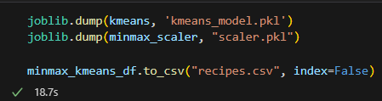

Figure : Code of saving model, scaler, and dataset

The code shown is used to save the vital elements for deploying the personalized recommendation system for diets. It first saves the trained K-Means clustering model ('kmeans_model.pkl') and the MinMaxScaler object ('scaler.pkl') using joblib.dump(), so both the clustering computations and the scaling function can be loaded and used later without requiring retraining. It also exports the end processed recipes DataFrame, including the cluster assignment, to a CSV file ('recipes.csv') for easy lookup while generating recommendations. By saving the model, scaler, and recipe data, the system is able to efficiently scale new user input, predict its cluster, and fetch corresponding recipes, making for effective, quick, and consistent recommendations.

### 5.3.2 Loading of Model, Scaler, and Data

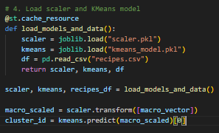

Figure : Code of loading necessary components

The load_models_and_data() function is defined and decorated with @st.cache_resource to cache the loading step so that these files are not loaded multiple times, speeding up the application. Within the function, the previously trained and saved MinMaxScaler (scaler.pkl) as well as KMeans clustering model (kmeans_model.pkl) are loaded with joblib.load(). The recipe dataset (recipes.csv) is read into a pandas DataFrame. All three of these are returned and set to scaler, kmeans, and recipes_df. Finally, the user’s chosen macro ratio (dependent upon health goal) is scaled using the loaded scaler so that it’s the same as the training data’s. This scaled input is sent to the kmeans.predict() method to see what the cluster_id is, i.e., the cluster that most closely resembles the user’s target macronutrient split. This assignment of clusters allows the app to provide personalized recipe suggestions that suit the user's diet goals.

### 5.3.3 User Profile Collection Interface

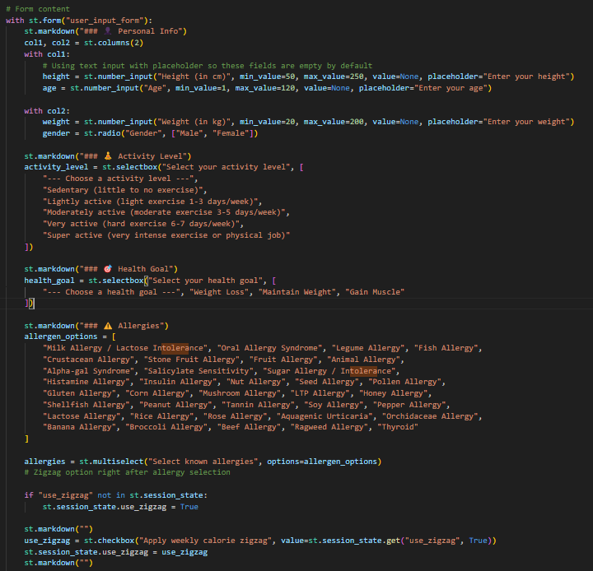

Figure : Code of user profile collection



Figure : User interface form of the web application

The shown piece of code creates a structured form to obtain key user information that will subsequently power the personalized recommendation engine. Users are asked for their personal data including height, weight, age, and gender, through basic numeric input fields and a radio button. Then, users choose their activity level (sedentary to super active) and health target (e.g., weight loss, maintenance, or muscle gain) through dropdown menus. Subsequently, the system also retrieves known allergies through a multi-select box with a complete set of common allergen items. Users are also provided with a checkbox option to toggle the zigzag calorie cycling approach off/on. Notably, all form inputs are arranged very neatly using columns, making the form clean and user-friendly. Each form entry enjoys inherent validation (e.g., max/min for age and weight) to guarantee safe, clean data collection prior to actioning for personalized recipe recommendations.

### 5.3.4 TDEE Calculation

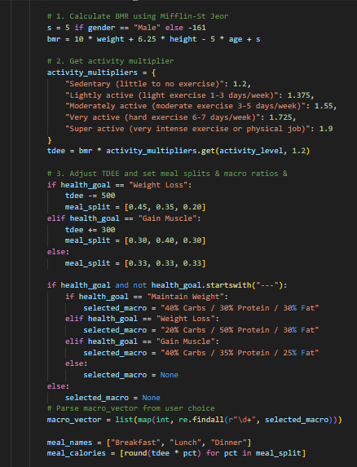

Figure : Code of calculating TDEE

The system calculates each user's Total Daily Energy Expenditure (TDEE) dynamically to provide personalized nutritional recommendations. This commences with the estimation of the Basal Metabolic Rate (BMR) through the Mifflin-St Jeor Equation, a method prominently emphasized through literature for its higher accuracy compared to previous models. Subsequently, the system adjusts caloric intake according to the user's TDEE as determined and chosen health goal. For users who want to lose weight, caloric intake is reduced by 500 as suggested by nutritional science to provide a safe and sustainable reduction of fat. For users who want to gain muscle, a 300-caloric surplus is added to provide the anabolic condition for building muscles, whereas for users who decide to keep at the current weight, no adjustment is applied.

Aside from establishing overall daily caloric requirements, the system sensibly allocates the intake of calories over several meals spread throughout the day to sustain consistent levels of energy, promote satiety, as well as facilitate efficient metabolism, consistent with recommendations found previously within literature reviews of the appropriate meal frequency. Finally, the caloric intake for each day is broken down into evidence-based percentages of carbohydrates, proteins, as well as fats according to the user’s individual health target, making the recommendations individualized as well as science-based.

### 5.3.5 Optimal Recipe Selection

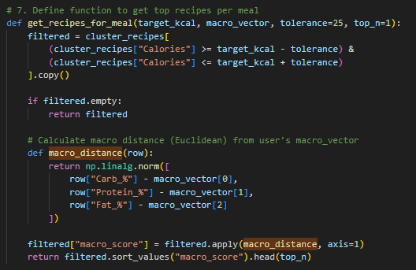

Figure : Code of choosing the optimal recipe

A dedicated function is implemented to provide meal recipe suggestions that are compatible with the user's target macronutrient content as well as caloric intake. The get_recipes_for_meal function first filters the recipes within clusters (cluster_recipes) to choose those that are within ±25 calories of the user's target_kcal for flexible matching without compromising nutritional appropriateness. If there are no matching recipes, the function merely returns an empty result for the sake of efficiency.

For the qualified recipes, the system computes how well each aligns with the user’s macronutrient requirements by establishing a macro_distance function. This macro distance function computes the Euclidean distance between the user’s targeted macronutrient composition (Carb_%, Protein_%, Fat_%) and each recipe’s composition. Recipes are subsequently rated by macro distance, placed in order from lowest to highest, and the highest matching examples are chosen. This tiered filtering first for calories, secondly for nutrient profile makes sure that users are given extremely personalized meal recommendations, a procedure aligned with contemporary research into personalized nutrition and diet optimization.

### 5.3.6 Comparison Between Macronutrient Targets and Recipe Macronutrient Profiles

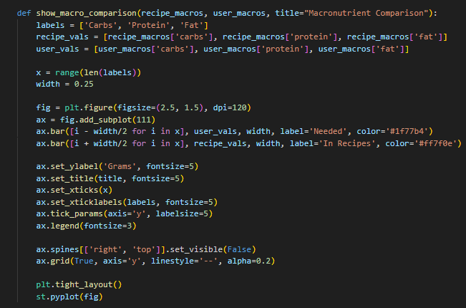

Figure : Code of macronutrients comparison between needed and in recipe

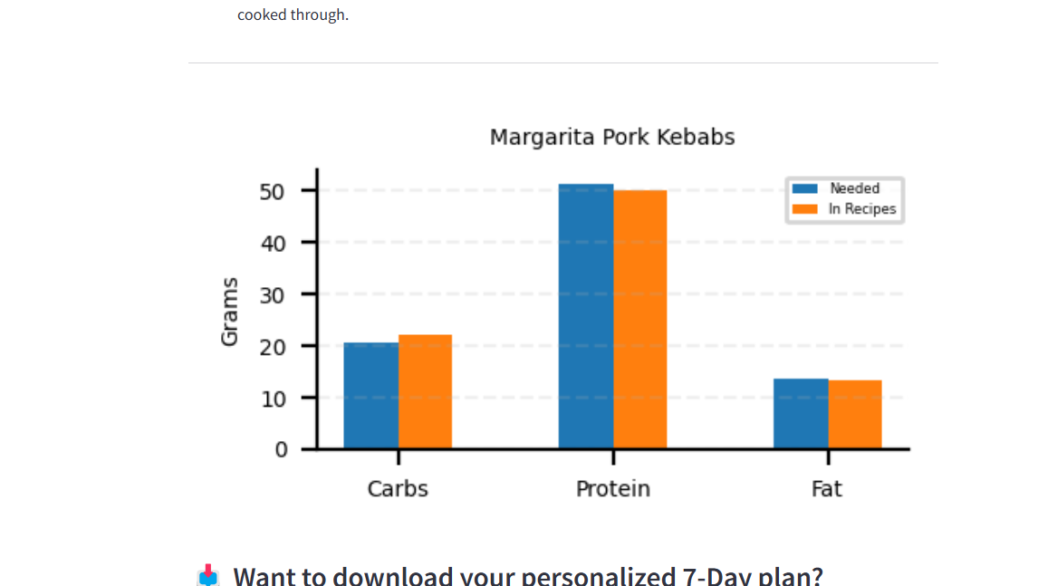

Figure : Comparison chart in web app

The show_macro_comparison function graphically compares user macronutrient requirements with the macronutrient breakdown of the chosen recipe by creating a side-by-side bar chart. It separately aligns carbohydrate, protein, and fat content for the user and recipe, and plots these using Matplotlib with separate colors for readability. Each macronutrient places user requirements alongside recipe content for easy identification of discrepancies.

### 5.3.7 Displaying Recipe Details

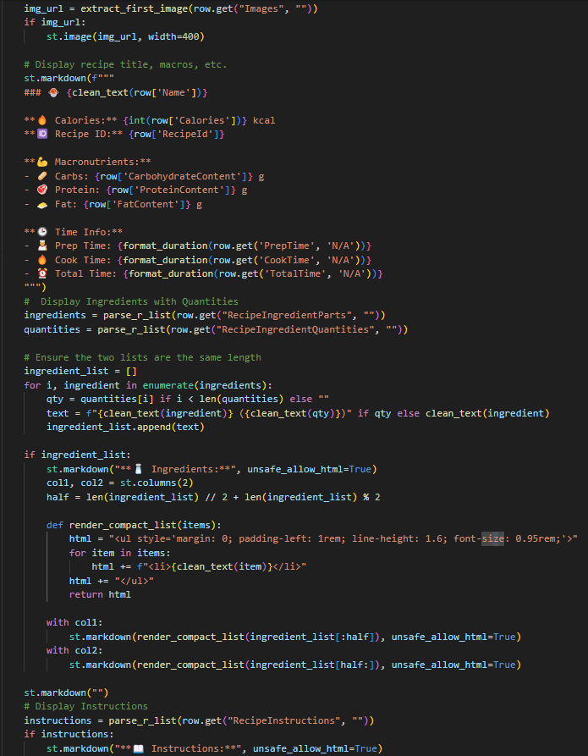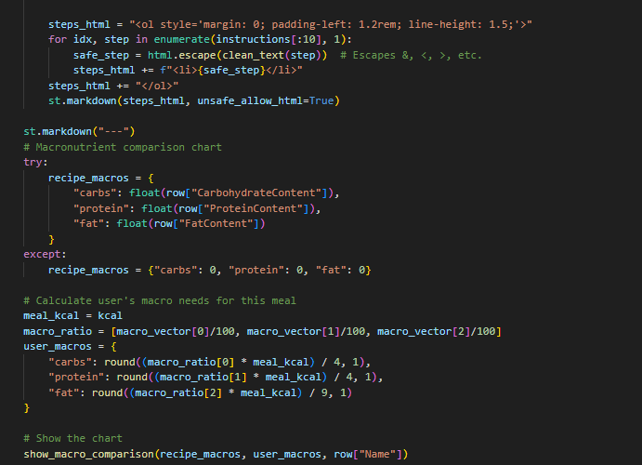

Figure : Code of displaying recipes

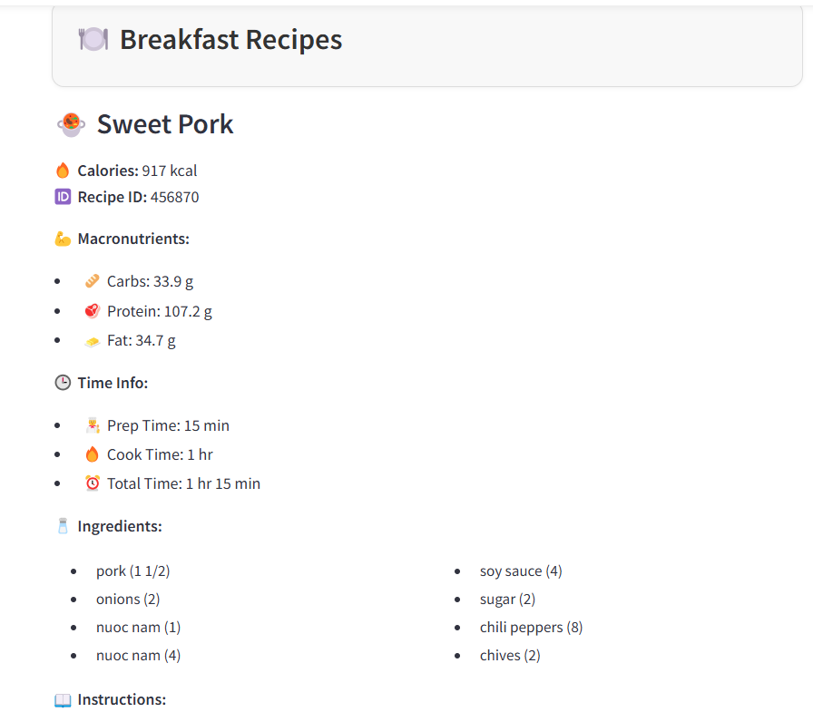

Figure : An example that showing recipes in web app

The code displays detailed information for each selected recipe, including its image, title, calories, ID, macronutrient breakdown (carbs, protein, fat), and cooking times. It parses and presents the ingredients and quantities in two columns for readability, and formats the cooking instructions into a clean, numbered list. Then, it calculates the recipe’s actual macronutrient values and compares them against the user’s personalized nutritional targets.

### 5.3.8 Download the 7 Days Recipes

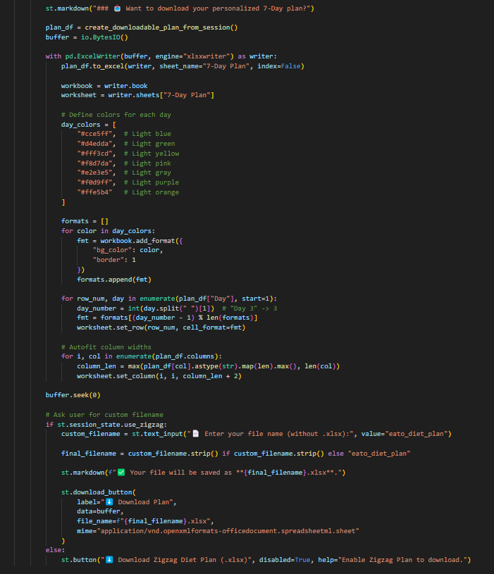

Figure : Code of downloading the recipes of zigzag diet plan



Figure : Button is disable when didn't utilize zigzag diet plan



Figure : Button is able to use when utilizing zigzag diet plan

This portion of the code generates a personalized 7-day meal plan as a DataFrame (plan_df) that combines all the recipe choices chosen by the user, meal timings for the day, nutritional information, and cooking steps. Rather than saving the file to a physical storage area, a BytesIO buffer is employed that stores the Excel data momentarily in memory, resulting in a seamless download within the web application.

Using the pandas module with the xlsxwriter engine, the meal plan gets exported to an Excel spreadsheet named "7-Day Plan." To enhance user experience as well as readability, varying background colors are allocated for the rows according to the day of the week, i.e., light blue for Day 1, light green for Day 2, and so on. Apart from that, column widths are auto-sized so that all content will fit snugly without needing to be manually adjusted.

Once the Excel document is generated, the application asks users to specify a user-defined filename if they have activated zigzag cycling of calories. Once a filename is entered, a download option becomes clickable, enabling users to download their plan with a correctly formatted filename. If zigzag cycling is inactive, downloading is unavailable, with a suggestion from the application for users to turn zigzag cycling on if they want to have the option to download.

### 5.3.9 Integration with Gemini AI



Figure : Configuration of Google Gemini AI API

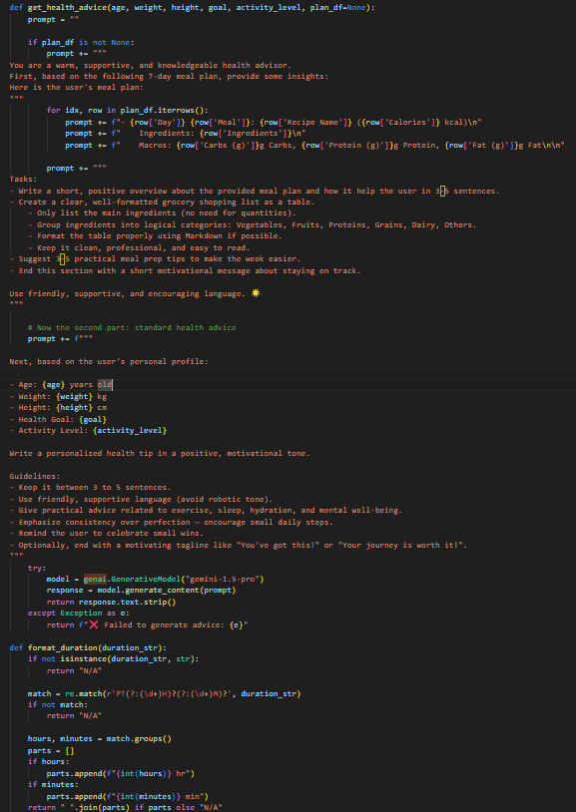

Figure : Prompt for Gemini AI



Figure : Tips from Gemini AI in web app

The above code incorporates Google Gemini AI to provide users with personalized health suggestions. To begin, the Gemini API key is set up to enable access to the Generative AI service. It defines a function named get_health_advice to provide customized recommendations based on user-specific data, such as age, weight, height, health goals, and activity levels. If a 7-day meal plan is provided, the system first provides a summary of meal plan content, including recipes alongside ingredients and macronutrient composition. It then asks Gemini to generate an overview, a categorized grocery list, practical meal prep advice, and a motivational closing statement, each with a friendly, supportive voice.

Upon review of the meal plan, the function gives Gemini the prompt to create a second piece of advice that is solely dependent on the user's personal profile. It asks for practical suggestions regarding exercise, hydration, mental health, and work-life balance, expressed positively and as encouragement. It highlights the importance of consistency over perfection and reminds the user to enjoy small victories. If the Gemini model is able to create a response, it is provided as text; otherwise, an error message is shown. This incorporation of AI makes the user experience richer as it not only provides recommendations for diet but also for overall lifestyle.

## 5.4 Summary

The model evaluation step included a lot of hyperparameter tuning as well as the measurement of performance over four clustering methods. The K-Means clustering algorithm with seven clusters and MinMaxScaler had the best overall trade-off among the models, having the topmost CH and a close-to-minimum DBI and thus being the best solution for clustering the dietary profiles. GMM created the tightest of the groups but lost just a touch on cluster separability, MiniBatch K-Means provided computational effectiveness at a small cost on clustering quality, and SOM gave good visual interpretability at the cost of somewhat looser groups.

After model selection, the K-Means model was implemented within a personalized web application. The system calculates a user's TDEE dynamically, predicts the user's diet cluster, and suggests recipes aligning with the user's caloric and macronutrient needs while preventing allergen hazards. It features side-by-side comparison of nutrients, presentation of detailed recipes, and a downloadable 7-day zigzag calorie-cycling meal plan. In addition, Google Gemini AI was integrated to provide personalized wellbeing advice, meal planning strategies, and motivational encouragement beyond simply suggesting foods. Overall, the deployment was effective at bringing advanced clustering methods into a usable instrument consistent with health promotion and individualized nutrition objectives.

# CHAPTER 6: CONCLUSION

## 6.1 Critical Evaluation

The project was able to achieve its set objectives successfully, leading the creation of a complete personalized diet recommendation system. The CRISP-DM guided the system sequentially through phases of business understanding, data preparation, modeling, evaluation, and deployment. The personalized recommendation system grouped more than 300,000 recipes by macro-nutrient content and dynamically suggested suitable meals for the user based on caloric needs, macro-nutrient targets, and allergen tolerances. Model selection was carefully verified by rigorous evaluation measures, where the K-Means clustering model (with MinMaxScaler and 7 clusters) proved the most effective model by having a minimal Davies-Bouldin Index (0.8362) and maximum Calinski-Harabasz Score (224,119.29).

The initiative contributed greatly not just to knowledge of a technical nature but also to welfare of a community and industry-based innovation. For the consumer, the system represents a useful and accessible tool for facilitating improved eating habits and supporting the reduction of non-communicable diseases caused by inferior diet and uncontrolled allergic conditions. For industry stakeholders, the system represents a live example of the application of machine learning and good nutritional science towards the creation of tangible value. The initiative illustrated the potential of digital health software to be scaled up into fitness businesses, insurance-based wellness programs, and telemedicine platforms through the offering of individualised nutrition strategies that are cost-friendly and scalable.

A number of significant strengths supported the success of this project. Rigorous handling of the data was especially noteworthy, including thorough cleaning and anomaly removal through the application of Isolation Forest and Local Outlier Factor, along with thoughtful feature engineering centered on significant nutrition-based metrics. Scientifically founded methods for the computation of TDEE complementing allergen detection further assured the reliability of the system. The addition of Google Gemini AI added richness to the user experience by providing motivational and educational recommendations beyond the simple offering of meals. In addition, the creation of a fully functional Streamlit web application illustrated a great deal of technical maturity by enabling smooth interaction between the machine-learning backend and the users within a transparent, user-friendly display. The project as a whole represents a fine integration of web technology, nutrition science, and data science for effective application to public health.

## 6.2 Limitation

Despite its many achievements, the project encountered several limitations that present opportunities for future refinement. One major limitation was the system’s focus solely on macronutrients like carbohydrates, proteins, and fatswithout incorporating micronutrient analysis such as vitamins and minerals. As a result, while users may meet their caloric and macronutrient targets, essential aspects of complete nutrition could still be overlooked. Furthermore, allergen detection was performed using basic keyword matching techniques, which may fail to capture allergens embedded within compound ingredients or derivatives, potentially exposing users to unidentified risks.

Another limitation arose from the nature of the dataset itself. Since the recipes were predominantly from Western cuisines, the system may not adequately serve users from other cultural backgrounds, limiting its global applicability. In addition, the user profiling was static; once users entered their data, it did not update dynamically with time or changing health conditions, missing an opportunity for longitudinal personalization. Moreover, although the models were internally validated with clustering metrics, the system has not been clinically validated with healthcare professionals, which could affect the trustworthiness of recommendations for users with specific medical conditions. Finally, the system currently lacks a feedback loop mechanism, meaning it cannot learn or adapt over time based on user preferences, success rates, or satisfaction.

## 6.3 Recommendation

To make the system even better and eliminate the noted shortcomings, a number of recommendations have been put forward. Future versions of the system should include micronutrient analysis by broadening feature engineering to cover key vitamins and minerals for a fuller picture of adequacy. For better allergen detection, more powerful natural language processing methods could be implemented to parse and interpret ingredient lists even more sensibly and detect hidden allergens and provide enhanced user safety.

Additionally, the recipe database needs to be diversified across a wider variety of global cuisines, thereby enhancing the system's broadness and cultural appeal. Enabling user profiling for regular updating or syncing via wearable equipment would make the system more sensitive to the changing needs of the user. Clinical validation involving consultation with dietitians and health professionals is highly advised for enhancing user trust, especially among people with complex health profiles.

Adding a real-time feedback loop would let the system learn from user satisfaction and actions, enabling it to dynamically personalize and improve recommendations. Last but not least, integrating the role of Google Gemini AI or another AI assistant could introduce layers of personalized coaching, workout advice, hydration reminders, and mental health coaching, establishing a complete lifestyle recommendation system. If the user follows these recommendations, the system could develop into a very smart, culture-aware, medically sound, and user-adaptive health assistant.

# References

Abdelazeem, I., Zhang, W., Chuan, M., Khader, A., Mohamedsalih, A., Abdalwohab, M., & Abuobieda, A. (2024). Optimization of Adaptive Lossless Quantization based on Genetic Algorithm-enhanced K-meansClustering for Secret Key Sharing in Vehicular AdHoc Networks. *Research Square (Research Square)*. https://doi.org/10.21203/rs.3.rs-5416935/v1

Åberg, F., Byrne, C. D., Pirola, C. J., Männistö, V., & Sookoian, S. (2022). Alcohol consumption and metabolic syndrome: Clinical and epidemiological impact on liver disease. *Journal of Hepatology*, *78*(1), 191–206. https://doi.org/10.1016/j.jhep.2022.08.030

Abrahams, M., & Matusheski, N. V. (2020). Personalised nutrition technologies: a new paradigm for dietetic practice and training in a digital transformation era. *Journal of Human Nutrition and Dietetics*, *33*(3), 295–298. https://doi.org/10.1111/jhn.12746

Abrar, M. A. (2023, July 13). Understanding Clustering: Unveiling the principles and techniques of K-Mean clustering | Medium. *Medium*. https://medium.com/@abdullahabrar/understanding-clustering-unveiling-the-principles-and-techniques-of-k-mean-clustering-a4659029acbf

Adan, R. A., Van Der Beek, E. M., Buitelaar, J. K., Cryan, J. F., Hebebrand, J., Higgs, S., Schellekens, H., & Dickson, S. L. (2019). Nutritional psychiatry: Towards improving mental health by what you eat. *European Neuropsychopharmacology*, *29*(12), 1321–1332. https://doi.org/10.1016/j.euroneuro.2019.10.011

Ahmad, Z., Yaacob, S., Ibrahim, R., & Fakhruddin, W. F. W. (2022). The review for Visual Analytics Methodology. *2022 International Congress on Human-Computer Interaction, Optimization and Robotic Applications (HORA)*, *3*, 1–10. https://doi.org/10.1109/hora55278.2022.9800100

Ai, T. A. (2024, September 23). *Data Science Lifecycle*. Applied AI Blog. https://www.appliedaicourse.com/blog/data-science-lifecycle/

Alok, Y. (2025, March 18). *Top 20+ Python Libraries for Data Science in 2025*. Analytics Vidhya. https://www.analyticsvidhya.com/blog/2024/12/python-libraries-for-data-science/

Amballa, D. P. (2021). Personalized Nutrition: Generating Tailored Diet Plans for Individuals with Specific Health Goals Using the Zig-Zag Method and Indian Food Composition Data. *European Journal of Advances in Engineering and Technology*, *8*(7), 87-92. https://doi.org/10.5281/zenodo.11908585

Antonio, J., Ellerbroek, A., Silver, T., Orris, S., Scheiner, M., Gonzalez, A., & Peacock, C. A. (2015). A high protein diet (3.4 g/kg/d) combined with a heavy resistance training program improves body composition in healthy trained men and women – a follow-up investigation. *Journal of the International Society of Sports Nutrition*, *12*(1). https://doi.org/10.1186/s12970-015-0100-0

Aranganayagi, S., & Thangavel, K. (2007). *Clustering categorical data using silhouette coefficient as a relocating measure*. Proceedings of the International Conference on Computational Intelligence and Multimedia Applications (ICCIMA 2007). https://doi.org/10.1109/iccima.2007.328

Arciero, P. J., Miller, V. J., & Ward, E. (2015). Performance enhancing diets and the PRISE protocol to optimize athletic performance. *Journal of Nutrition and Metabolism*, *2015*, 1–39. https://doi.org/10.1155/2015/715859

Asenso-Okyere, K., Chiang, C., Thangata, P., Andam, K., & Mekonnen, D. A. (2011). Understanding the interaction between farm labor productivity, and health and nutrition: A survey of the evidence. *Journal of development and agricultural economics*, *3*(3), 80-90.

Ashikuzzaman, M. (2024, November 8). *What is an Operating System (OS)?* Library & Information Science Education Network. https://www.lisedunetwork.com/what-is-an-operating-system-os/

Ashtary-Larky, D., Bagheri, R., Bavi, H., Baker, J. S., Moro, T., Mancin, L., & Paoli, A. (2021). Ketogenic diets, physical activity and body composition: a review. *British Journal of Nutrition*, *127*(12), 1898–1920. https://doi.org/10.1017/s0007114521002609

Astudillo, C. A., & Oommen, B. J. (2013). Self-organizing maps whose topologies can be learned with adaptive binary search trees using conditional rotations. *Pattern Recognition*, *47*(1), 96–113. https://doi.org/10.1016/j.patcog.2013.04.012

Awong, L. E. E., & Zielinska, T. (2023). Comparative Analysis of the clustering quality in Self-Organizing Maps for Human Posture Classification. *Sensors*, *23*(18), 7925. https://doi.org/10.3390/s23187925

Backlinkworks. (2024, January 27). *Boost Your Data Science Workflow with Jupyter and Visual Studio Code*. Topics on SEO & Backlinks. https://blogs.backlinkworks.com/boost-your-data-science-workflow-with-jupyter-and-visual-studio-code/

Balakrishna, Y., Manda, S., Mwambi, H., & Van Graan, A. (2023). Determining classes of food items for health requirements and nutrition guidelines using Gaussian mixture models. *Frontiers in Nutrition*, *10*. https://doi.org/10.3389/fnut.2023.1186221

Balakrishna, Y., Manda, S., Mwambi, H., & Van Graan, A. (2023). Determining classes of food items for health requirements and nutrition guidelines using Gaussian mixture models. *Frontiers in Nutrition*, *10*. https://doi.org/10.3389/fnut.2023.1186221

Bandaru, N. G. (2023, September 28). SEMMA: Simplifying Model Development in Data Mining. *Medium*. https://medium.com/@Gayatri2410/semma-simplifying-model-development-in-data-mining-17911ac27306

Bartoň, T., & Kordík, P. (2015). Evaluation of relative indexes for multi-objective clustering. In *Lecture notes in computer science* (pp. 465–476). https://doi.org/10.1007/978-3-319-19644-2_39

Battersby, J., Brown-Luthango, M., Fuseini, I., Gulabani, H., Haysom, G., Jackson, B., Khandelwal, V., MacGregor, H., Mitra, S., Nisbett, N., Perera, I., Lintelo, D. T., Thorpe, J., & Toriro, P. (2023). *Living Off-Grid Food and Infrastructure Collaboration Working Paper 1: Concepts and Assumptions*. https://doi.org/10.19088/logic.2023.001

Beebe, C. A., Van Cauter, E., Shapiro, E. T., Tillil, H., Lyons, R., Rubenstein, A. H., & Polonsky, K. S. (1990). Effect of temporal distribution of calories on diurnal patterns of glucose levels and insulin secretion in NIDDM. *Diabetes Care*, *13*(7), 748–755. https://doi.org/10.2337/diacare.13.7.748

Bekri, M. E. (2023). Dynamic inertia weight particle swarm optimization for anomaly detection: A case of precision irrigation. *Journal of Internet Services and Information Security*, *13*(2), 157–176. https://doi.org/10.58346/jisis.2023.i2.010

Ben Shatwan, A., Abdalla, A., Mohammed, H., Bin Ismaeil, E., & Mami, A. M. (2024). On model selection criterion for finite Gaussian mixture models. *International Journal of Sciences: Basic and Applied Research (IJSBAR)*, *73*(1), 68–89. https://www.gssrr.org/index.php/JournalOfBasicAndApplied/article/view/16792

Bennett, J. E., Stevens, G. A., Mathers, C. D., Bonita, R., Rehm, J., Kruk, M. E., Riley, L. M., Dain, K., Kengne, A. P., Chalkidou, K., Beagley, J., Kishore, S. P., Chen, W., Saxena, S., Bettcher, D. W., Grove, J. T., Beaglehole, R., & Ezzati, M. (2018). NCD Countdown 2030: worldwide trends in non-communicable disease mortality and progress towards Sustainable Development Goal target 3.4. *The Lancet*, *392*(10152), 1072–1088. https://doi.org/10.1016/s0140-6736(18)31992-5

Bhagavan, N., & Ha, C. (2011). Carbohydrate metabolism II. In *Elsevier eBooks* (pp. 151–168). https://doi.org/10.1016/b978-0-12-095461-2.00014-x

Bharadiya, J. P. (2023). The role of machine learning in transforming business intelligence. *International Journal of Computing and Artificial Intelligence*, *4*(1), 16–24. https://doi.org/10.33545/27076571.2023.v4.i1a.60

Biswal, A. (2024, July 29). *What is exploratory data analysis? Steps and market analysis*. Simplilearn.com. https://www.simplilearn.com/tutorials/data-analytics-tutorial/exploratory-data-analysis#:~:text=EDA%20helps%20data%20scientists%20identify,various%20statistical%20and%20graphical%20techniques.

Bouchrika, I. (2024, November 19). *Top 10 qualities of Good Academic Research in 2024*. Research.com. https://research.com/research/top-10-qualities-of-good-academic-research

Boudreau, E. (2024, February 11). Should you learn SAS in 2021? - Analytics Vidhya - Medium. *Medium*. https://medium.com/analytics-vidhya/should-you-learn-sas-in-2021-453597a4387f

Braga, D. C. (2019). *Field Drilling Data Cleaning and Preparation for Data Analytics Applications*. Louisiana State University and Agricultural & Mechanical College.

Byrne, N. M., Sainsbury, A., King, N. A., Hills, A. P., & Wood, R. E. (2017). Intermittent energy restriction improves weight loss efficiency in obese men: the MATADOR study. International Journal of Obesity, 42(2), 129–138. https://doi.org/10.1038/ijo.2017.206

Cazacu, M., & Titan, E. (2020). Adapting CRISP-DM for social Sciences. *BRAIN BROAD RESEARCH IN ARTIFICIAL INTELLIGENCE AND NEUROSCIENCE*, *11*(2sup1), 99–106. https://doi.org/10.18662/brain/11.2sup1/97

Chander, S., & Vijaya, P. (2021). Unsupervised learning methods for data clustering. In *Elsevier eBooks* (pp. 41–64). https://doi.org/10.1016/b978-0-12-820601-0.00002-1

Chang, J., & Kashyap, S. R. (2014). The protein-sparing modified fast for obese patients with type 2 diabetes: What to expect. *Cleveland Clinic Journal of Medicine*, *81*(9), 557–565. https://doi.org/10.3949/ccjm.81a.13128

Cheuvront, S. N. (2003). The Zone Diet Phenomenon: A Closer Look at the Science behind the Claims. *Journal of the American College of Nutrition*, *22*(1), 9–17. https://doi.org/10.1080/07315724.2003.10719271

Chumbar, S. (2023, September 22). SEMMA Methodology in Data Mining: A Deep Dive - Shawn Chumbar - Medium. *Medium*. https://medium.com/@shawn.chumbar/semma-methodology-in-data-mining-a-deep-dive-c8874cb4239

Chung, N., Park, M., Kim, J., Park, H., Hwang, H., Lee, C., Han, J., So, J., Park, J., & Lim, K. (2018). Non-exercise activity thermogenesis (NEAT): a component of total daily energy expenditure. *Physical Activity and Nutrition*, *22*(2), 23–30. https://doi.org/10.20463/jenb.2018.0013

Cite this lesson as: Gomes, C. G., & Boisvert, J. & Deutsch, C.V. (2022). Gaussian Mixture Models. In J. L. Deutsch (Ed.), *Geostatistics Lessons*. Retrieved from http://www.geostatisticslessons.com/lessons/gmm

Clandinin, M. T., Cheema, S., Field, C. J., Garg, M. L., Venkatraman, J., & Clandinin, T. R. (1991). Dietary fat: exogenous determination of membrane structure and cell function. *The FASEB Journal*, *5*(13), 2761–2769. https://doi.org/10.1096/fasebj.5.13.1916101

Clifford, J., Maloney, K., Anderson, J., & Young, L. (2016). Sugar and sweeteners. *Fact sheet (Colorado State University. Extension). Food and nutrition series*, (9.301).

Codecademy. (n.d.). *How to use Jupyter notebooks*. Codecademy. https://www.codecademy.com/article/how-to-use-jupyter-notebooks

Coniglio, S., Shumskaya, M., & Vassiliou, E. (2023). Unsaturated fatty acids and their immunomodulatory properties. *Biology*, *12*(2), 279. https://doi.org/10.3390/biology12020279

Conroy, M. (2023, May 17). *CRISP-DM, Phase 2: Data Understanding*. Data Lab Notes. https://datalabnotes.com/data-understanding-crisp-dm/

Conroy, M. (2023, May 17). *CRISP-DM, Phase 3: Data preparation*. Data Lab Notes. https://datalabnotes.com/data-preparation-crisp-dm/

Costa, S. M. M., Horta, P. M., & Santos, L. C. D. (2013). Analysis of television food advertising on children’s programming on “free-to-air” broadcast stations in Brazil. *Revista Brasileira De Epidemiologia*, *16*(4), 976–983. https://doi.org/10.1590/s1415-790x2013000400017

*CRISP-DM - (Statistical Methods for Data Science) - Vocab, Definition, Explanations | Fiveable*. (n.d.). https://fiveable.me/key-terms/statistical-methods-for-data-science/crisp-dm

Das, S., Dey, A., Pal, A., & Roy, N. (2015). Applications of Artificial Intelligence in Machine Learning: Review and prospect. *International Journal of Computer Applications*, *115*(9), 31–41. https://doi.org/10.5120/20182-2402

De Hoogh, I. M., Winters, B. L., Nieman, K. M., Bijlsma, S., Krone, T., Van Den Broek, T. J., Anderson, B. D., Caspers, M. P. M., Anthony, J. C., & Wopereis, S. (2021). A Novel Personalized Systems Nutrition Program Improves Dietary Patterns, Lifestyle Behaviors and Health-Related Outcomes: Results from the Habit Study. *Nutrients*, *13*(6), 1763. https://doi.org/10.3390/nu13061763

Dhaka, V., Gulia, N., Ahlawat, K. S., & Khatkar, B. S. (2011). Trans fats—sources, health risks and alternative approach - A review. *Journal of Food Science and Technology*, *48*(5), 534–541. https://doi.org/10.1007/s13197-010-0225-8

Dideriksen, K., Reitelseder, S., & Holm, L. (2013). Influence of amino acids, dietary protein, and physical activity on muscle mass development in humans. *Nutrients*, *5*(3), 852–876. https://doi.org/10.3390/nu5030852

Donato_TH. (2023, April 12). CRISP-DM: Business Understanding as the foundation of data mining. *Medium*. https://medium.com/donato-story/crisp-dm-business-understanding-as-the-foundation-of-data-mining-e2d854f8c05a

Dubetcky, O. (2024, November 20). Project management for data science: KDD, SEMMA and CRISP-DM. *Medium*. https://oleg-dubetcky.medium.com/project-management-for-data-science-kdd-semma-and-crisp-dm-fe9d03d3ab6c

Dyńka, D., Rodzeń, Ł., Rodzeń, M., Pacholak-Klimas, A., Ede, G., Sethi, S., Łojko, D., Bartoń, K., Berry, K., Deptuła, A., Grzywacz, Ż., Martin, P., Unwin, J., & Unwin, D. (2025). Ketogenic Diets for Body Weight Loss: A Comparison with Other Diets. *Nutrients*, *17*(6), 965. https://doi.org/10.3390/nu17060965

Economou, P. (2023). A clustering algorithm for overlapping Gaussian mixtures. *Research in Statistics*, *1*(1). https://doi.org/10.1080/27684520.2023.2242337

Elechi, J. O. G., Sirianni, R., Conforti, F. L., Cione, E., & Pellegrino, M. (2023). Food System Transformation and Gut Microbiota Transition: Evidence on Advancing Obesity, Cardiovascular Diseases, and Cancers—A Narrative Review. *Foods*, *12*(12), 2286. https://doi.org/10.3390/foods12122286

Elkabalawy, M., Al-Sakkaf, A., Abdelkader, E. M., & Alfalah, G. (2024). CRISP-DM-Based Data-Driven Approach for Building Energy Prediction utilizing indoor and environmental factors. *Sustainability*, *16*(17), 7249. https://doi.org/10.3390/su16177249

El-Zayat, S. R., Sibaii, H., & El-Shamy, K. A. (2019). Physiological process of fat loss. *Bulletin of the National Research Centre/Bulletin of the National Research Center*, *43*(1). https://doi.org/10.1186/s42269-019-0238-z

Emb, T. (2024, July 26). What is Knowledge Discovery in Databases (KDD)? *EMB Blogs*. https://blog.emb.global/knowledge-discovery-in-databases-kdd/

Escobar, K. A., VanDusseldorp, T. A., & Kerksick, C. M. (2016). Carbohydrate intake and resistance-based exercise: are current recommendations reflective of actual need? *British Journal of Nutrition*, *116*(12), 2053–2065. https://doi.org/10.1017/s0007114516003949

Fahey, M. T., Ferrari, P., Slimani, N., Vermunt, J. K., White, I. R., Hoffmann, K., Wirfält, E., Bamia, C., Touvier, M., Linseisen, J., Rodríguez-Barranco, M., Tumino, R., Lund, E., Overvad, K., De Mesquita, B. B., Bingham, S., & Riboli, E. (2012). Identifying dietary patterns using a normal mixture model: application to the EPIC study. *Journal of Epidemiology & Community Health*, *66*(1), 89–94. https://doi.org/10.1136/jech.2009.103408

Fayyad, U., Piatetsky-Shapiro, G., & Smyth, P. (1996). The KDD process for extracting useful knowledge from volumes of data. *Communications of the ACM*, *39*(11), 27-34.

Fazayeli, F., Wang, L., & Mandziuk, J. (2008). Feature selection based on the rough set theory and Expectation-Maximization clustering Algorithm. In *Lecture notes in computer science* (pp. 272–282). https://doi.org/10.1007/978-3-540-88425-5_28

Ferrie, S., & Ward, M. (2007). Back to basics: Estimating energy requirements for adult hospital patients. *Nutrition & Dietetics*, *64*(3), 192–199. https://doi.org/10.1111/j.1747-0080.2007.00124.x

Freeland-Graves, J. H., & Nitzke, S. (2013). Position of the Academy of Nutrition and Dietetics: Total Diet Approach to Healthy Eating. *Journal of the Academy of Nutrition and Dietetics*, *113*(2), 307–317. https://doi.org/10.1016/j.jand.2012.12.013

Gangopadhyay, A. (2023). Ultraprocessed foods and cancer in Low-Middle-Income countries. *Nutrition and Cancer*, *75*(10), 1863–1873. https://doi.org/10.1080/01635581.2023.2272814

Garcia, M. B. (2019, November 1). *Plan-Cook-Eat: A Meal Planner App with Optimal Macronutrient Distribution of Calories Based on Personal Total Daily Energy Expenditure*. IEEE Xplore. https://doi.org/10.1109/HNICEM48295.2019.9073490

Garn, S. M. (1990). Diet and health: Implications for reducing chronic disease risk. Committee on Diet and Health, National Research Council, xiv + 768 pp. Washington, D.C.: National Academy Press. 1989, $49.95 (cloth). *American Journal of Human Biology*, *2*(5), 587–588. https://doi.org/10.1002/ajhb.1310020514

gBrown, M. S. (2016, March 26). *Phase 2 of the CRISPDM Process Model Data Understanding  dummies*. Dummies.

GeeksforGeeks. (2022, April 25). *CalinskiHarabasz Index – Cluster Validity indices | Set 3*. GeeksforGeeks. https://www.geeksforgeeks.org/calinski-harabasz-index-cluster-validity-indices-set-3/

GeeksforGeeks. (2023, June 12). *SAS vs R vs Python*. GeeksforGeeks. https://www.geeksforgeeks.org/sas-vs-r-vs-python/

GeeksforGeeks. (2023, May 23). *KDD process in data mining*. GeeksforGeeks. https://www.geeksforgeeks.org/kdd-process-in-data-mining/

GeeksforGeeks. (2023, May 6). *Introduction to dimensionality reduction*. GeeksforGeeks. https://www.geeksforgeeks.org/dimensionality-reduction/

GeeksforGeeks. (2024, June 2). *ML | Mini Batch Kmeans clustering algorithm*. GeeksforGeeks. https://www.geeksforgeeks.org/ml-mini-batch-k-means-clustering-algorithm/

GeeksforGeeks. (2024, May 13). *How Much RAM is Recommended for Machine Learning?* GeeksforGeeks. https://www.geeksforgeeks.org/how-much-ram-is-recommended-for-machine-learning/

GeeksforGeeks. (2025, February 27). *Gaussian Mixture Model*. GeeksforGeeks. https://www.geeksforgeeks.org/gaussian-mixture-model/

Glatzel, K., Ameye, H., Hülsen, V., & Qaim, M. (2024). *Changing food environments in Africa’s urban and peri-urban areas: Implications for diets, nutrition, and policy*. https://hdl.handle.net/10419/304435

Gorini, S., Camajani, E., Feraco, A., Armani, A., Karav, S., Filardi, T., Aulisa, G., Cava, E., Strollo, R., Padua, E., Caprio, M., & Lombardo, M. (2025, January 20). Exploring gender differences in the effects of diet and physical activity on metabolic parameters. *Nutrients*, *17*(2), 354. https://doi.org/10.3390/nu17020354

Greve, B., Pigeot, I., Huybrechts, I., Pala, V., & Börnhorst, C. (2015). A comparison of heuristic and model-based clustering methods for dietary pattern analysis. *Public Health Nutrition*, *19*(2), 255–264. https://doi.org/10.1017/s1368980014003243

Guérin, A., Chauvet, P., & Saubion, F. (2024). A Survey on Recent Advances in Self-Organizing Maps. *arXiv (Cornell University)*. https://doi.org/10.48550/arxiv.2501.08416

Gul, M., & Rehman, M. A. (2023). Big data: an optimized approach for cluster initialization. *Journal of Big Data*, *10*(1). https://doi.org/10.1186/s40537-023-00798-1

Gurina, T. S., & Mohiuddin, S. S. (2022, December 11). *Biochemistry, protein catabolism*. StatPearls - NCBI Bookshelf. https://www.ncbi.nlm.nih.gov/books/NBK556047/

Haidar, L. (2022, May 5). K-Means Clustering with Scikit-learn - Lina Haidar - Medium. *Medium*. https://medium.com/@haidarlina4/k-means-clustering-with-scikit-learn-70c805230646

Hassan, B. A., Tayfor, N. B., Hassan, A. A., Ahmed, A. M., Rashid, T. A., & Abdalla, N. N. (2024). From A-to-Z review of clustering validation indices. *Neurocomputing*, *601*, 128198. https://doi.org/10.1016/j.neucom.2024.128198

Hillesheim, E., Ryan, M. F., Gibney, E., Roche, H. M., & Brennan, L. (2020). Optimisation of a metabotype approach to deliver targeted dietary advice. *Nutrition & Metabolism*, *17*(1). https://doi.org/10.1186/s12986-020-00499-z

Hiol, A. N., Von Hurst, P. R., Conlon, C. A., & Beck, K. L. (2023). Associations of protein intake, sources and distribution on muscle strength in community-dwelling older adults living in Auckland, New Zealand. *Journal of Nutritional Science*, *12*. https://doi.org/10.1017/jns.2023.76

Ikotun, A. M., Habyarimana, F., & Ezugwu, A. E. (2025). Cluster validity indices for automatic clustering: A comprehensive review. *Heliyon*, *11*(2), e41953. https://doi.org/10.1016/j.heliyon.2025.e41953

Isamail, N., Said, R., Ismail, N. W., & Haron, S. A. (2024). Non-Communicable diseases impact Low-Income households in Malaysia. Malaysian Journal of Medical Sciences, 31(1), 124–139. https://doi.org/10.21315/mjms2024.31.1.11

Jain, A. K., Murty, M. N., & Flynn, P. J. (1999). Data clustering. *ACM Computing Surveys*, *31*(3), 264–323. https://doi.org/10.1145/331499.331504

Jasim, M. N., & Hamid, A. B. (2022). Food recommendation system based on nutritional needs of human beings and user preferences. *International Journal of Health Sciences*, 4025–4038. https://doi.org/10.53730/ijhs.v6ns4.9031

Jinnette, R., Narita, A., Manning, B., McNaughton, S. A., Mathers, J. C., & Livingstone, K. M. (2021). Does personalized nutrition advice improve dietary intake in healthy adults? A Systematic review of randomized controlled trials. *Advances in Nutrition*, *12*(3), 657–669. https://doi.org/10.1093/advances/nmaa144

Jodha, R. (2023, June 12). KDD in data mining- scaler topics. *Scaler Topics*. https://www.scaler.com/topics/data-mining-tutorial/kdd-in-data-mining/

Jonna, V. (2024, July 8). The role of R in Python: Its purpose and benefits - Ellow.io. *Ellow Talent*. https://ellow.io/the-role-of-r-in-python-its-purpose-and-benefits/

Jung, M., Davoli, M., Cavalcante, T., O'Connor, L., D'Alessio, A., Cimatti, M., Pacifici, M., Beher, J., Visconti, P., Di Marco, M., & Kujala, H. (2024). *Report on network problem formulations, targets, and preferences, including guidance and data on targets and optimal TEN-N design criteria*. *ARPHA Preprints*. https://doi.org/10.3897/arphapreprints.e138574

Karagun, B., & Baklaci, N. (2024b). Comparative analysis of basal metabolic rate measurement methods in overweight and obese individuals: A retrospective study. *Medicine*, *103*(35), e39542. https://doi.org/10.1097/md.0000000000039542

Kasa, S. R., & Rajan, V. (2023). Avoiding inferior clusterings with misspecified Gaussian mixture models. *Scientific Reports*, *13*(1). https://doi.org/10.1038/s41598-023-44608-3

Katya, E. (2023). Exploring Feature Engineering Strategies for Improving Predictive Models in Data Science. *Research Journal of Computer Systems and Engineering*, *4*(2), 201-215.

Kaur, N., Chugh, V., & Gupta, A. K. (2012). Essential fatty acids as functional components of foods- a review. *Journal of Food Science and Technology*, *51*(10), 2289–2303. https://doi.org/10.1007/s13197-012-0677-0

Kihato, P. K. (2013, February 19). *Analysis and visualization of metabolic syndrome using Self Organizing Maps (SOM)*. http://ir.jkuat.ac.ke/handle/123456789/608

Kirchner, K., Zec, J., & Delibašić, B. (2015). Facilitating data preprocessing by a generic framework: a proposal for clustering. *Artificial Intelligence Review*, *45*(3), 271–297. https://doi.org/10.1007/s10462-015-9446-6

Kohonen, T. (2001). Self-Organizing Maps. In *Springer series in information sciences*. https://doi.org/10.1007/978-3-642-56927-2

Krebs, N. F., Gao, D., Gralla, J., Collins, J. S., & Johnson, S. L. (2010). Efficacy and safety of a high protein, low carbohydrate diet for weight loss in severely obese adolescents. *The Journal of Pediatrics*, *157*(2), 252–258. https://doi.org/10.1016/j.jpeds.2010.02.010

Krishnan, V. (2024). Editorial: Millets: superfood of the century – challenges and opportunities. *Frontiers in Nutrition*, *11*. https://doi.org/10.3389/fnut.2024.1462567

Kwon, Y., Lee, H. S., Park, J., & Lee, J. (2020). Associating Intake Proportion of Carbohydrate, Fat, and Protein with All-Cause Mortality in Korean Adults. *Nutrients*, *12*(10), 3208. https://doi.org/10.3390/nu12103208

Lachance, L., & Ramsey, D. (2015). Food, mood, and brain health: implications for the modern clinician. *Missouri medicine*, *112*(2), 111–115.

Lago-Fernández, L. F., Aragón, J., & Sánchez-Montañés, M. (2019). Validation of unimodal Non-Gaussian clusters. In *Lecture notes in computer science* (pp. 601–611). https://doi.org/10.1007/978-3-030-20518-8_50

Lagus, K., Vatanen, T., Kettunen, O., Heikkilä, A., Heikkilä, M., Pantzar, M., & Honkela, T. (2012). Paths of Wellbeing on Self-Organizing Maps. In *Advances in intelligent systems and computing* (pp. 345–352). https://doi.org/10.1007/978-3-642-35230-0_35

Layman, D. K. (2024). Impacts of protein quantity and distribution on body composition. *Frontiers in Nutrition*, *11*. https://doi.org/10.3389/fnut.2024.1388986

Lee, S. (2025, March 13). *Optimizing Machine Learning Clusters: Efficient Strategies with Davies-Bouldin Metrics*. https://www.numberanalytics.com/blog/optimizing-machine-learning-clusters-davies-bouldin-metrics

Li, L., Sun, N., Zhang, L., Xu, G., Liu, J., Hu, J., Zhang, Z., Lou, J., Deng, H., Shen, Z., & Han, L. (2020). Fast food consumption among young adolescents aged 12–15 years in 54 low- and middle-income countries. *Global Health Action*, *13*(1). https://doi.org/10.1080/16549716.2020.1795438

Li, Z., Li, L., Chen, R., Zhang, Y., Cui, Y., & Wu, N. (2023). A novel scheme based on modified hierarchical time-shift multi-scale amplitude-aware permutation entropy for rolling bearing condition assessment and fault recognition. *Measurement*, *224*, 113907. https://doi.org/10.1016/j.measurement.2023.113907

Lieber, C. S. (2003). Relationships between nutrition, alcohol use, and liver disease. *Alcohol Research & Health*, 27(3), 220–231. https://www.ncbi.nlm.nih.gov/pmc/articles/PMC6668875/

Limketkai, B. N., Mauldin, K., Manitius, N., Jalilian, L., & Salonen, B. R. (2021). The Age of Artificial Intelligence: Use of digital technology in clinical nutrition. *Current Surgery Reports*, *9*(7). https://doi.org/10.1007/s40137-021-00297-3

Lobov, A., & Lastra, J. L. M. (2007). Data mining of systems state spaces. *ResearchGate*. https://www.researchgate.net/publication/316432474_Data_Mining_of_Systems_State_Spaces#pf3

Mahmoudi, A., & Jemielniak, D. (2024). Proof of biased behavior of Normalized Mutual Information. *Scientific Reports*, *14*(1). https://doi.org/10.1038/s41598-024-59073-9

Margolis, L. M., Allen, J. T., Hatch-Mcchesney, A., & Pasiakos, S. M. (2020). Coingestion of Carbohydrate and Protein on Muscle Glycogen Synthesis after Exercise: A Meta-analysis. *Medicine & Science in Sports & Exercise*, *53*(2), 384–393. https://doi.org/10.1249/mss.0000000000002476

Martin, B., Golden, E., Carlson, O. D., Egan, J. M., Mattson, M. P., & Maudsley, S. (2008). Caloric restriction: Impact upon pituitary function and reproduction. *Ageing Research Reviews*, *7*(3), 209–224. https://doi.org/10.1016/j.arr.2008.01.002

Mas’ud, A. A., Sundaram, A., Ardila-Rey, J. A., Schurch, R., Muhammad-Sukki, F., & Bani, N. A. (2021). Application of the Gaussian mixture model to classify stages of electrical tree growth in epoxy resin. *Sensors*, *21*(7), 2562. https://doi.org/10.3390/s21072562

Maxtang. (2024, February 4). *AMD Ryzen 7 vs Intel i7: Which CPU should you choose – Maxtang PC Retail Store*. https://store.maxtangpc.com/amd-ryzen-7-vs-intel-i7/

McCormick, K., & Salcedo, J. (2017). *IBM SPSS Modeler essentials: Effective techniques for building powerful data mining and predictive analytics solutions*. Packt Publishing Ltd.

McCrory, M., & Thomas, S. A. (2024). Cluster metric sensitivity to irrelevant features. *arXiv (Cornell University)*. https://doi.org/10.48550/arxiv.2402.12008

Metzger, L. E., & Nielsen, S. S. (2017). Nutrition labeling. In *Food science text series* (pp. 35–43). https://doi.org/10.1007/978-3-319-45776-5_3

Michalakopoulos, V., Sarmas, E., Papias, I., Skaloumpakas, P., Marinakis, V., & Doukas, H. (2024). A machine learning-based framework for clustering residential electricity load profiles to enhance demand response programs. *Applied Energy*, *361*, 122943. https://doi.org/10.1016/j.apenergy.2024.122943

Mitchell, E. G., Heitkemper, E. M., Burgermaster, M., Levine, M. E., Miao, Y., Hwang, M. L., Desai, P. M., Cassells, A., Tobin, J. N., Tabak, E. G., Albers, D. J., Smaldone, A. M., & Mamykina, L. (2021). From Reflection to Action: Combining Machine Learning with Expert Knowledge for Nutrition Goal Recommendations. *International Journal of Creative Research Thoughts (IJCRT)*. https://doi.org/10.1145/3411764.3445555

Mohan, P. (2019, March 15). *A beginner’s guide to surviving in the Linux Shell*. FreeCodeCamp. https://www.freecodecamp.org/news/a-beginners-guide-to-surviving-in-the-linux-shell-cda0f5a0698c/

Moyo, H. N. (2024). The impact of food processing techniques on nutrient retention and bioavailability. *IRE Journals*, 8(2), 435–443.

Nanda, A. (2024, December 18). *Self-Organizing Maps: An Intuitive Guide with Python Examples*. https://www.datacamp.com/tutorial/self-organizing-maps

National Academies of Sciences, Engineering, and Medicine. (2023). Dietary reference intakes for energy.  
Levine, J. A. (2005). Measurement of energy expenditure. *Public Health Nutrition*, *8*(7a), 1123–1132. https://doi.org/10.1079/phn2005800

Noor, N. M. M., & Hamid, S. H. A. (2016). Visualization of crime data using Self-organizing Map (SOM) and Improvement in SOM: a review and available tools. *Journal of Computer Science & Computational Mathematics*, *6*(2), 37–43. https://doi.org/10.20967/jcscm.2016.02.003

Nowak-Brzezińska, A., & Gaibei, I. (2022). How the Outliers Influence the Quality of Clustering? *Entropy*, *24*(7), 917. https://doi.org/10.3390/e24070917

Ntelemis, F., Jin, Y., & Thomas, S. A. (2022). Information maximization clustering via multi-view self-labelling. *Knowledge-Based Systems*, *250*, 109042. https://doi.org/10.1016/j.knosys.2022.109042

O’Hara, C., O’Sullivan, A., & Gibney, E. R. (2022). A clustering approach to Meal-Based analysis of dietary intakes applied to population and individual data. *Journal of Nutrition*, *152*(10), 2297–2308. https://doi.org/10.1093/jn/nxac151

Ostendorf, D. M., Caldwell, A. E., Creasy, S. A., Pan, Z., Lyden, K., Bergouignan, A., MacLean, P. S., Wyatt, H. R., Hill, J. O., Melanson, E. L., & Catenacci, V. A. (2019). Physical activity energy expenditure and total daily energy expenditure in successful weight loss maintainers. *Obesity*, *27*(3), 496–504. https://doi.org/10.1002/oby.22373

Paeschke, T. M., & Aimutis, W. R. (Eds.). (2011). *Nondigestible carbohydrates and digestive health*. Wiley-Blackwell. https://doi.org/10.1002/9780470958186

Palacios, H. J. G., Toledo, R. A. J., Pantoja, G. A. H., & Navarro, Á. A. M. (2017). A comparative between CRISP-DM and SEMMA through the construction of a MODIS repository for studies of land use and cover change. *Adv. Sci. Technol. Eng. Syst. J*, *2*(3), 598-604.

Parsons, L., Haque, E., & Liu, H. (2004). Subspace clustering for high dimensional data. *ACM SIGKDD Explorations Newsletter*, *6*(1), 90–105. https://doi.org/10.1145/1007730.1007731

Patel, E., & Kushwaha, D. S. (2020). Clustering Cloud Workloads: K-Means vs Gaussian Mixture Model. *Procedia Computer Science*, *171*, 158–167. https://doi.org/10.1016/j.procs.2020.04.017

Patel, M., & Patel, N. (2019). Exploring research methodology. *International Journal of Research and Review*, *6*(3), 48-55.

Patel, R., & Mueller, M. (2023, July 13). *Alcohol-Associated liver Disease*. StatPearls - NCBI Bookshelf. https://www.ncbi.nlm.nih.gov/books/NBK546632/

Paul, S. (2024, October 9). *Visual Studio Code: multi-language integrated DE (VSC)*. Data Science Workbook. https://datascience.101workbook.org/04-devel-environment/01a-vscode-basics/#gsc.tab=0

Pescari, D., Mihuta, M. S., Bena, A., & Stoian, D. (2024). Quantitative analysis of the caloric restriction versus isocaloric diets models based on macronutrients composition: impacts on body weight regulation, anthropometric, and bioimpedance parameters in women with obesity. *Frontiers in Nutrition*, *11*. https://doi.org/10.3389/fnut.2024.1493954

Polivy, J. (2014, January 9). *Two kinds of overeating: Can we distinguish between disinhibited eating in restrained eaters and simple overeating that occurs in everyone?* TSpace Repository. https://tspace.library.utoronto.ca/handle/1807/43568

Poortmans, J., Carpentier, A., Pereira-Lancha, L., & Lancha, A., Jr. (2012). Protein turnover, amino acid requirements and recommendations for athletes and active populations. *Brazilian Journal of Medical and Biological Research*, *45*(10), 875–890. https://doi.org/10.1590/s0100-879x2012007500096

Popkin, B. M., Adair, L. S., & Ng, S. W. (2012). Global nutrition transition and the pandemic of obesity in developing countries. *Nutrition Reviews*, *70*(1), 3–21. https://doi.org/10.1111/j.1753-4887.2011.00456.x

Poston, L. (2022, July 18). *How hormones can affect your weight loss efforts*. https://www.signos.com/blog/hormones-and-weight-loss

Pykes, K. (2023, June 12). *How to Build an Instant Machine Learning Web Application with Streamlit and FastAPI | NVIDIA Technical Blog*. NVIDIA Technical Blog. https://developer.nvidia.com/blog/how-to-build-an-instant-machine-learning-web-application-with-streamlit-and-fastapi/

Quantum News. (2024, September 23). Jupyter Notebooks. Amazing tools for data science. *Quantum Zeitgeist*. https://quantumzeitgeist.com/jupyter-notebooks/

*R Language Definition*. (n.d.). https://cran.r-project.org/doc/manuals/r-devel/R-lang.html

Rahaman, S., Samuel, R., & Neamtiu, I. (2021). *Quantifying nondeterminism and inconsistency in self-organizing map implementations*. *2021 IEEE International Conference on Artificial Intelligence Testing (AITest)*, Oxford, United Kingdom, 2021, pp. 85-92. https://doi.org/10.1109/AITEST52744.2021.00026

Ramyaa, R., Hosseini, O., Krishnan, G. P., & Krishnan, S. (2019). Phenotyping women based on dietary macronutrients, physical activity, and body weight using machine learning tools. *Nutrients*, *11*(7), 1681. https://doi.org/10.3390/nu11071681

Reddy, P., & Jialal, I. (2022, September 19). *Biochemistry, fat soluble vitamins*. StatPearls - NCBI Bookshelf. https://www.ncbi.nlm.nih.gov/books/NBK534869/

Rein, M., Ben-Yacov, O., Godneva, A., Shilo, S., Zmora, N., Kolobkov, D., Cohen-Dolev, N., Wolf, B., Kosower, N., Lotan-Pompan, M., Weinberger, A., Halpern, Z., Zelber-Sagi, S., Elinav, E., & Segal, E. (2022). Effects of personalized diets by prediction of glycemic responses on glycemic control and metabolic health in newly diagnosed T2DM: a randomized dietary intervention pilot trial. *BMC Medicine*, *20*(1). https://doi.org/10.1186/s12916-022-02254-y

Rome. (2003). *Food energy – methods of analysis and conversion factors* (FAO Food and Nutrition Paper 77). Food and Agriculture Organization of the United Nations.  
https://www.fao.org/3/y5022e/y5022e00.htm

Rostami, M., Berahmand, K., Forouzandeh, S., Ahmadian, S., Farrahi, V., & Oussalah, M. (2024). A novel healthy food recommendation to user groups based on a deep social community detection approach. *Neurocomputing*, *576*, 127326. https://doi.org/10.1016/j.neucom.2024.127326

Rostami, M., Oussalah, M., & Farrahi, V. (2022). A novel Time-Aware Food Recommender-System based on deep learning and graph clustering. *IEEE Access*, *10*, 52508–52524. https://doi.org/10.1109/access.2022.3175317

Ruddick-Collins, L. C., Morgan, P. J., Fyfe, C. L., Filipe, J. A., Horgan, G. W., Westerterp, K. R., Johnston, J. D., & Johnstone, A. M. (2022). Timing of daily calorie loading affects appetite and hunger responses without changes in energy metabolism in healthy subjects with obesity. *Cell Metabolism*, *34*(10), 1472-1485.e6. https://doi.org/10.1016/j.cmet.2022.08.001

Ruel, M. T., Garrett, J. L., & Haddad, L. (2008). Rapid urbanization and the challenges of obtaining food and nutrition security. In *Humana Press eBooks* (pp. 639–656). https://doi.org/10.1007/978-1-59745-464-3_22

Saitta, S., Raphael, B., & Smith, I. (2008). A comprehensive validity index for clustering. *Intelligent Data Analysis*, *12*(6), 529–548. https://doi.org/10.3233/ida-2008-12602

*SAS Health Analytics Framework*. (n.d.). https://www.sas.com/en_ae/software/health.html#:~:text=Adopt%20an%20end%2Dto%2Dend,decisions%20in%20governed%2C%20regulated%20environments.

Schoenfeld, B. J., & Aragon, A. A. (2018). How much protein can the body use in a single meal for muscle-building? Implications for daily protein distribution. *Journal of the International Society of Sports Nutrition*, *15*(1). https://doi.org/10.1186/s12970-018-0215-1

Seidelmann, S. B., Claggett, B., Cheng, S., Henglin, M., Shah, A., Steffen, L. M., Folsom, A. R., Rimm, E. B., Willett, W. C., & Solomon, S. D. (2018). Dietary carbohydrate intake and mortality: a prospective cohort study and meta-analysis. *The Lancet Public Health*, *3*(9), e419–e428. https://doi.org/10.1016/s2468-2667(18)30135-x

Sharma, P. (2025, April 10). *K-Means Clustering Algorithm*. Analytics Vidhya. http://analyticsvidhya.com/blog/2019/08/comprehensive-guide-k-means-clustering/

Shen, Z., Shehzad, A., Chen, S., Sun, H., & Liu, J. (2020). Machine learning based approach on food recognition and nutrition estimation. *Procedia Computer Science*, *174*, 448–453. https://doi.org/10.1016/j.procs.2020.06.113

Sidik, M. M. (2024, November 17). The Importance of business understanding in Data Science: A Deep dive. *Medium*. https://python.plainenglish.io/in-the-rapidly-evolving-world-of-data-science-technical-proficiency-alone-is-not-sufficient-to-171f18d91fae

Singh, P., Kesharwani, R. K., & Keservani, R. K. (2017). Protein, carbohydrates, and fats. In *Elsevier eBooks* (pp. 103–115). https://doi.org/10.1016/b978-0-12-805413-0.00006-5

Slavin, J. (2013). Fiber and Prebiotics: Mechanisms and health benefits. *Nutrients*, *5*(4), 1417–1435. https://doi.org/10.3390/nu5041417

Smeets, A. J., Soenen, S., Luscombe-Marsh, N. D., Ueland, Ø., & Westerterp-Plantenga, M. S. (2008). Energy Expenditure, Satiety, and Plasma Ghrelin, Glucagon-Like Peptide 1, and Peptide Tyrosine-Tyrosine Concentrations following a Single High-Protein Lunch. *Journal of Nutrition*, *138*(4), 698–702. https://doi.org/10.1093/jn/138.4.698

Smith, A., & Creighton, S. (2020)*. Food First: Advice for eating well if you have lost weight or are underweight*. Buckinghamshire Healthcare NHS Trust. https://www.buckshealthcare.nhs.uk/pifs/food-first-advice-for-eating-well-if-you-have-lost-weight-or-are-underweight/#:~:text=To%20treat%20malnutrition%20our%20bodies,extra%20500%20calories%20per%20day.

Smolic, H. (2024, September 6). Data Preparation - No-code AI tool for data analysts. *No-code AI tool for data analysts - Our no-code AI tool automatically transforms data into key drivers, predictions, and next-best actions.* https://graphite-note.com/a-comprehensive-guide-to-data-preparation-in-ml/

*Snetselaar, L. G., De Jesus, J. M., DeSilva, D. M., & Stoody, E. E. (2021). Dietary Guidelines for Americans, 2020–2025. Nutrition Today, 56(6), 287–295.* https://doi.org/10.1097/nt.0000000000000512

Snetselaar, L. G., De Jesus, J. M., DeSilva, D. M., & Stoody, E. E. (2021). Dietary Guidelines for Americans, 2020–2025. *Nutrition Today*, *56*(6), 287–295. https://doi.org/10.1097/nt.0000000000000512

Sreekumar, D. (2024, September 2). *What is Research Methodology? Definition, Types, and Examples*. Paperpal Blog. https://paperpal.com/blog/academic-writing-guides/what-is-research-methodology#:~:text=Helps%20other%20researchers%20who%20may,of%20their%20time%20and%20resources.

Sridharan, M. A. (2024, October 13). *CRISP-DM*. Think Insights. https://thinkinsights.net/data/crisp-dm/

*SSD vs HDD - Difference Between Data Storage Devices*. (n.d.). Amazon Web Services, Inc. https://aws.amazon.com/compare/the-difference-between-ssd-hard-drive/

Stefanovskyi, O. (2023, March 16). The most important phase of CRISP-DM you need to get right: Business understanding | Medium. *Medium*. https://medium.com/@stefanovskyi/business-understanding-crisp-dm-1111bfbc7b8d

Subha. (2024, February 21). Handling missing values in dataset — 9 methods that you need to know. *Medium*. https://medium.com/@pingsubhak/handling-missing-values-in-dataset-7-methods-that-you-need-to-know-5067d4e32b62

Takyar, A. (2023, May 6). *Exploratory Data Analysis - a Comprehensive guide to EDA*. LeewayHertz - AI Development Company. https://www.leewayhertz.com/what-is-exploratory-data-analysis/

Talaviya, A. (2023, October 31). CRISP-DM framework: A foundational data mining process model. *Medium*. https://medium.com/@avikumart_/crisp-dm-framework-a-foundational-data-mining-process-model-86fe642da18c

Tarekegn, A. N. (2025). Uncovering Chronic Conditions using Featured-based Clustering Approach. *International Journal of Information Technology*. https://doi.org/10.1007/s41870-025-02455-7

Taylor, C. A., Tobias, D., Abrams, S. A., Booth, S. L., Byrd-Bredbenner, C., Eicher-Miller, H. A., Fung, T., Jernigan, V. B., Talegawkar, S. A., Adler, M., Kuczynski, K., McClain, V., Richardson, L. A., & Pannucci, T. (2024, November). *Can nutrient goals be met when carbohydrate-containing foods and beverages are reduced in the Healthy U.S.-Style Dietary Pattern for ages 2 years and older?: Food Pattern Modeling Report*. U.S. Department of Agriculture, Food and Nutrition Service, Center for Nutrition Policy and Promotion, Nutrition and Economic Analysis Branch. https://doi.org/10.52570/DGAC2025.FPM09

Trexler, E. T., Smith-Ryan, A. E., & Norton, L. E. (2014). Metabolic adaptation to weight loss: implications for the athlete. *Journal of the International Society of Sports Nutrition*, *11*(1). https://doi.org/10.1186/1550-2783-11-7

Tú, L. A. (2015). Improving the quality of Self-Organizing Map by “Different elements” competitive strategy. *Journal of Computer Science and Cybernetics*, *31*(3). https://doi.org/10.15625/1813-9663/31/3/6452

Tufail, T., Saeed, F., Ain, H. B. U., Niaz, B., Afzaal, M., Din, A., & Suleria, H. a. R. (2019). Cashew nut allergy; immune health challenge. *Trends in Food Science & Technology*, *86*, 209–216. https://doi.org/10.1016/j.tifs.2019.02.014

Turishcheva, P., Hansel, L., Ritzert, M., Weis, M. A., & Ecker, A. S. (2024). MNIST-Nd: a set of naturalistic datasets to benchmark clustering across dimensions. *arXiv (Cornell University)*. https://doi.org/10.48550/arxiv.2410.16124

U.S. Food and Drug Administration. (2013). *Guidance for Industry: A Food Labeling Guide (Appendix H)*. https://www.fda.gov/media/81606/download

Uluğbekovna, J. M., & Nabiyevna, M. M. (2024). EATING HABITS. *Ta'lim innovatsiyasi va integratsiyasi*, *23*(1), 70-81.

Van Dessel, K., Verrijken, A., De Block, C., Verhaegen, A., Peiffer, F., Van Gaal, L., De Wachter, C., & Dirinck, E. (2024b). Basal Metabolic Rate using indirect calorimetry among individuals living with overweight or obesity: The accuracy of predictive equations for basal metabolic rate. *Clinical Nutrition ESPEN*, *59*, 422–435. https://doi.org/10.1016/j.clnesp.2023.12.024

Vanegas, C. E. D., Mejía, J. C. G., Agudelo, F. a. V., & Duran, D. E. S. (2023). A representation based on essence for the CRISP-DM methodology. *Computación Y Sistemas*, *27*(3). https://doi.org/10.13053/cys-27-3-3446

Villablanca, P. A., Alegria, J. R., Mookadam, F., Holmes, D. R., Wright, R. S., & Levine, J. A. (2015). Nonexercise activity thermogenesis in obesity management. *Mayo Clinic Proceedings*, *90*(4), 509–519. https://doi.org/10.1016/j.mayocp.2015.02.001

Vogliano, C., Raneri, J. E., Coad, J., Tutua, S., Wham, C., Lachat, C., & Burlingame, B. (2021). Dietary agrobiodiversity for improved nutrition and health outcomes within a transitioning indigenous Solomon Island food system. *Food Security*, *13*(4), 819–847. https://doi.org/10.1007/s12571-021-01167-7

Wani, A. A. (2024). Comprehensive analysis of clustering algorithms: exploring limitations and innovative solutions. *PeerJ Computer Science*, *10*, e2286. https://doi.org/10.7717/peerj-cs.2286

Waraich, K. (2024, August 7). The best operating system for programming. *2024 Naukri.com*. https://www.naukri.com/code360/library/the-best-operating-system-for-programming

Weka. (2023, July 19). *6 Reasons to Re-Architect your SAS Analytics for large datasets*. WEKA. https://www.weka.io/blog/database/architect-your-sas-analytics/

West, H. (2017, January 30). *5 ways Restricting calories can be harmful*. Healthline. https://www.healthline.com/nutrition/calorie-restriction-risks

*Windows OS vs Mac OS: Which Is Better For Your Business*. (n.d.). Jera IT. https://jerait.co.uk/articles/windows-os-vs-mac-os/

Wirth, R., & Hipp, J. (2000, April). CRISP-DM: Towards a standard process model for data mining. In *Proceedings of the 4th international conference on the practical applications of knowledge discovery and data mining* (Vol. 1, pp. 29-39).

World Cancer Research Fund International. (2014). The Link between Food, Nutrition, Diet and Non-Communicable Diseases.

Wororomi, J. K., Allo, C. B. G., & Paranoan, N. R. (2023). Performance of K-Means and DBSCAN algorithm in clustering gross regional domestic product. *Journal of International Conference Proceedings*, *6*(5), 179–193. https://doi.org/10.32535/jicp.v6i5.2710

Yie, G., Kyeong, W., Song, S., Kim, Z., Youn, H. J., Cho, J., Min, J. W., Kim, Y. S., & Lee, J. E. (2025). Plasma metabolite based clustering of breast cancer survivors and identification of dietary and health related characteristics: an application of unsupervised machine learning. *Nutrition Research and Practice*, *19*(2), 273. https://doi.org/10.4162/nrp.2025.19.2.273

You, J., Li, Z., & Du, J. (2023). A new iterative initialization of EM algorithm for Gaussian mixture models. *PLoS ONE*, *18*(4), e0284114. https://doi.org/10.1371/journal.pone.0284114

Zhao, Y., Shrivastava, A. K., & Tsui, K. L. (2018). Regularized Gaussian Mixture Model for High-Dimensional Clustering. *IEEE Transactions on Cybernetics*, *49*(10), 3677–3688. https://doi.org/10.1109/tcyb.2018.2846404

# Appendices

## Appendix A: PPF

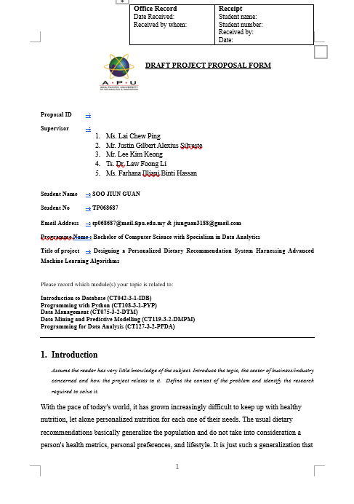

Figure : PPF Page 1



Figure : PPF Page 2

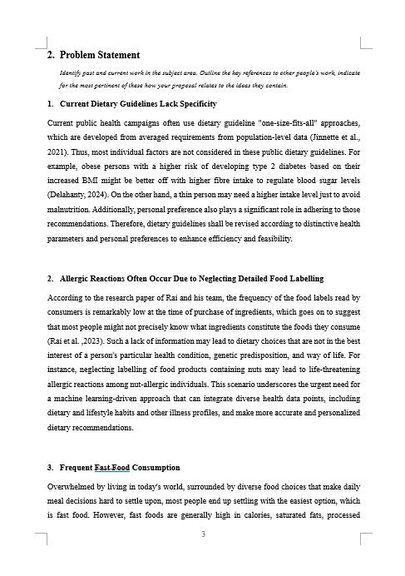

Figure : PPF Page 3

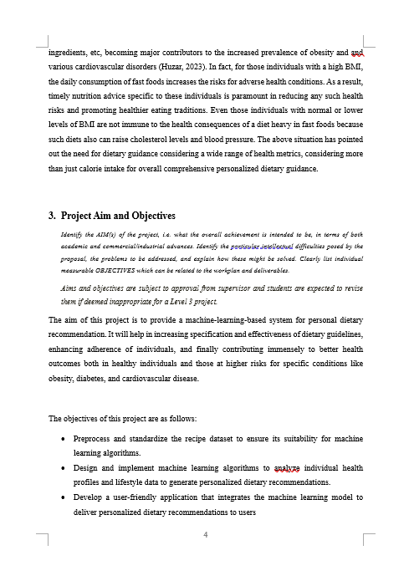

Figure : PPF Page 4

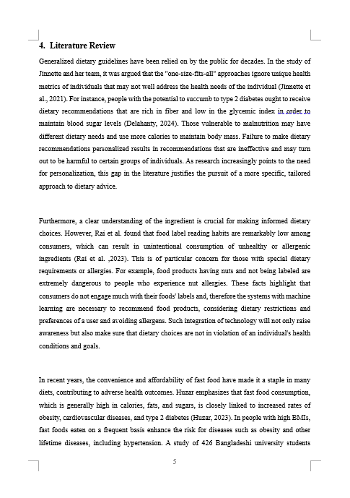

Figure : PPF Page 5

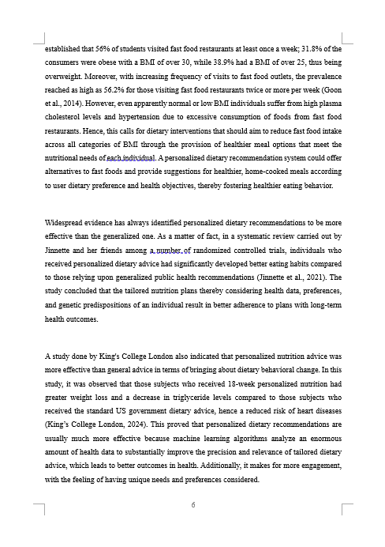

Figure : PPF Page 6

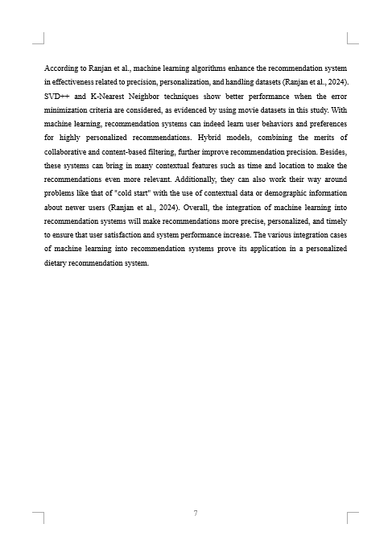

Figure : PPF Page 7

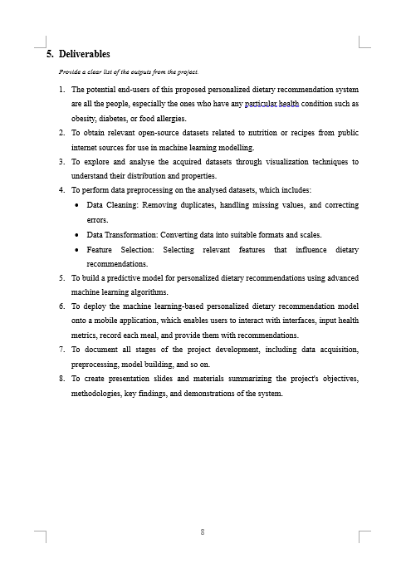

Figure : PPF Page 8

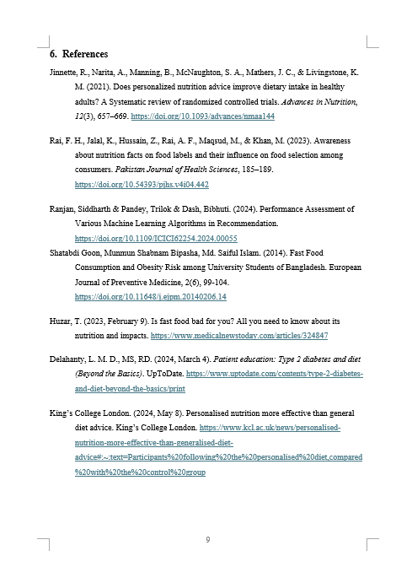

Figure : PPF Page 9

## Appendix B: Ethics Forms (Fast Track / Full Track)



Figure : Fast Track Form Page 1

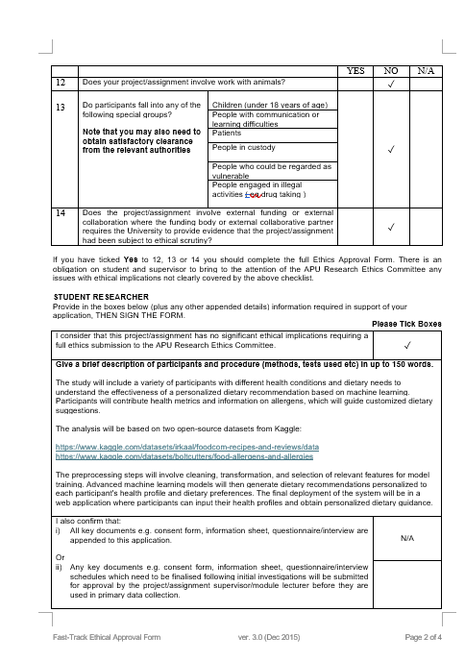

Figure : Fast Track Form Page 2

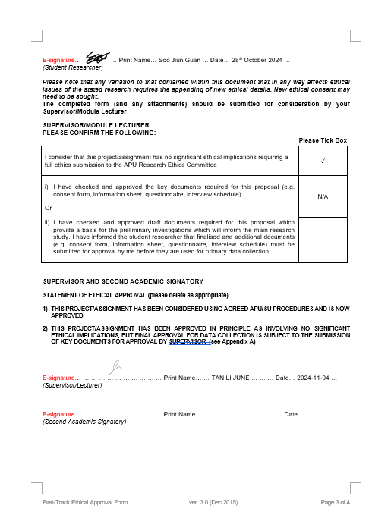

Figure : Fast Track Form Page 3

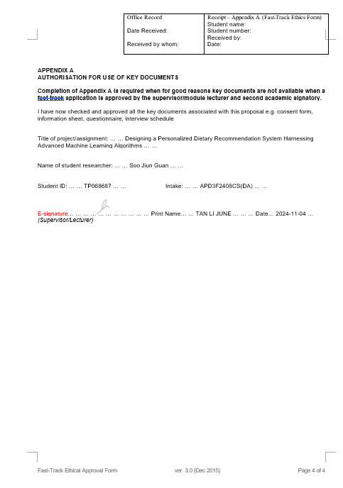

Figure : Fast Track Form Page 4

## Appendix C: Log Sheets (6 log sheets)



Figure : Project Log Sheet of 1st Meeting



Figure : Project Log Sheet of 2nd Meeting



Figure : Project Log Sheet of 3rd Meeting



Figure : Project Log Sheet of 4th Meeting



Figure : Project Log Sheet of 5th Meeting



Figure : Project Log Sheet of 6th Meeting

## Appendix D: Poster

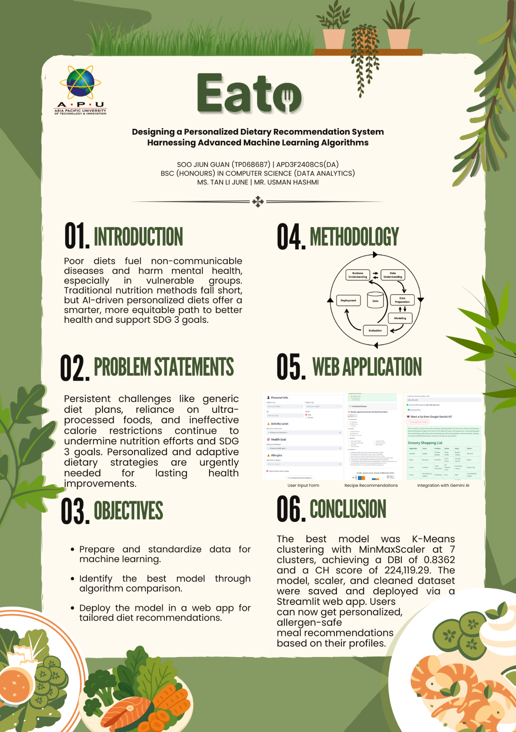

Figure : Poster

## Appendix E: Gantt Chart

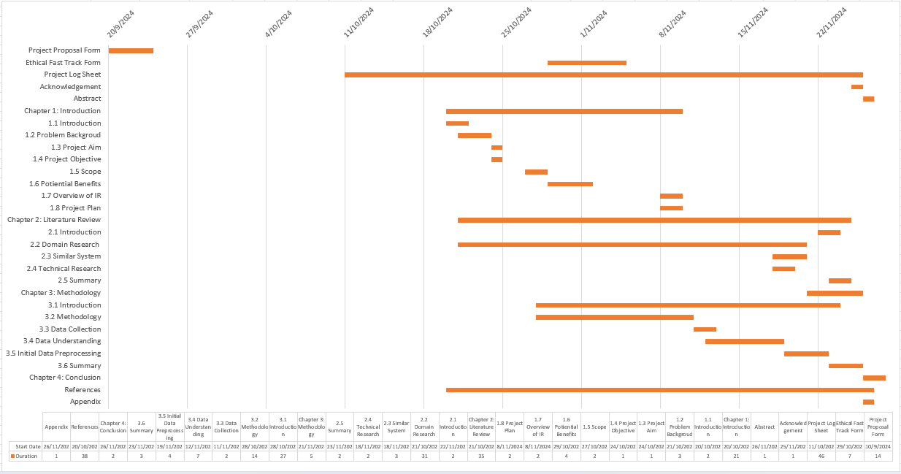

Figure : Gantt Chart of IR

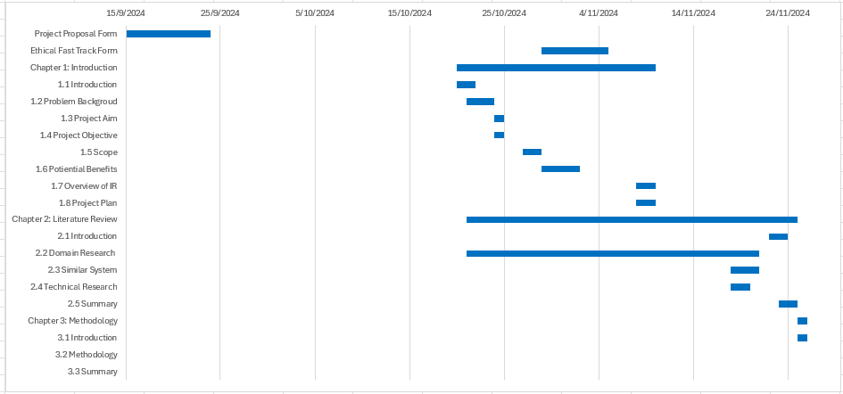

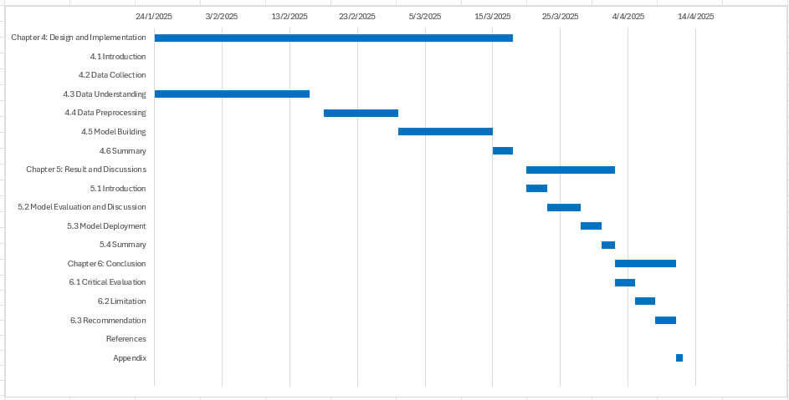

Figure : Gantt Chart of FYP

## Appendix G: Turnitin Similarity Report



Figure : Turnitin similarity report page 1



Figure : Turnitin similarity report page 2